Cyber Defense Competition (CDC): Sponsorship Opportunities
2024 – 2025

Cyber Defense Competitions provide a hands-on environment for students to learn about practical information assurance in a fast-paced and real-world environment. Competitors have several weeks prior to the competition to build and secure a network that provides required services. A team (Red Team) of security practitioners from a wide spectrum of industries across the Midwest then attack these networks. We welcome employees from companies to participate as a member of the Red Team during the Saturday attack phase. The goal of the Red Team is to compromise the student networks. Real-time scoring is based on the security of their networks, quality of their documentation, usability of their systems (as scored by competition guests on the Green Team), and their participation in other fun events during the competition. The CDC starts at noon on Friday, where the students finish their setup. At 8 am on Saturday, the competition starts, and Red Team begins their attack. The competition ends around 4 pm on Saturday.
Iowa State’s Center for Cybersecurity Innovation & Outreach hosts four collegiate CDCs every year: two ISU-only; a community college competition; and an international competition, in which teams from other schools along with the top teams from ISU, community college competitions and teams from Kosovo compete. The ISU-only CDCs typically have close to 100 students from various academic departments participating. The Center for Cybersecurity Innovation & Outreach has opportunities for you to support the student-centered activities. The generous support of our sponsors enables the Center to provide real-world educational opportunities through cyber defense experiences. It costs about $60,000 per year to run the four CDCs. Sponsorship money supports the student organizers and provides food and prizes for the student participants. We need your help to continue hosting these events.

CDC Sponsorship
We offer two sponsorship levels for our four collegiate CDCs. We recognize both levels of sponsorship throughout the competitions. We dedicate Friday evening to sponsor interaction with the student participants. Sponsors are encouraged to set up a table to showcase their employment opportunities on both Friday and Saturday. All sponsors can display their company logo on our CDC website and scoreboard. Gold-level sponsors may present on Saturday during one of the break times. We are still exploring other ways to do this. Companies may provide items for random drawings during the competition.
- Gold Level (All four collegiate CDCs): $3,000
- Cardinal Level (A single collegiate CDC): $1,000

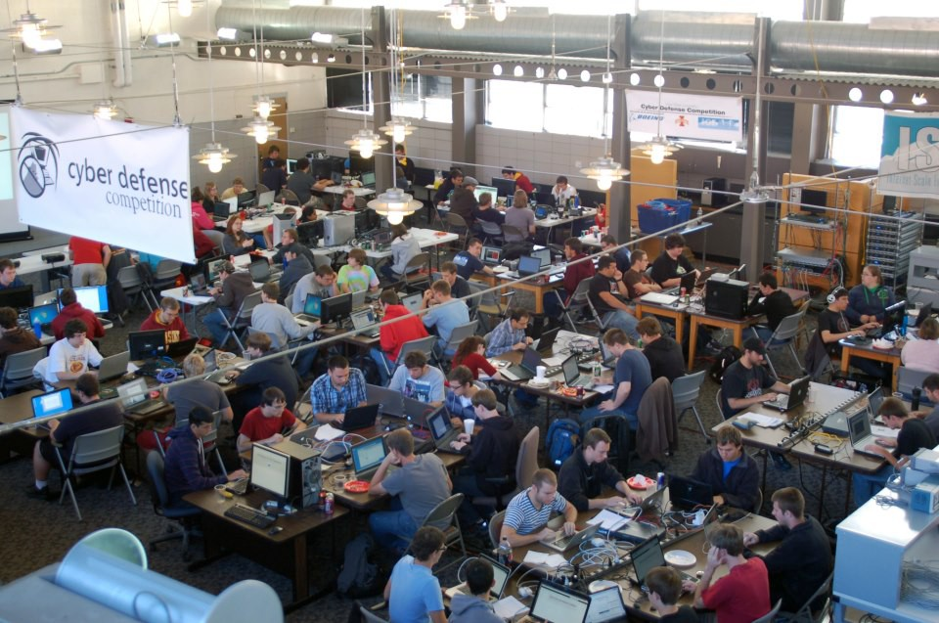
2022-2023 CDC Dates
- ISU CDC: September 27-28, 2024
- Community College CDC: December 6-7, 2024
- International CDC: February 22, 2025
- ISU CDC: March 28-29, 2025

Please Contact
For additional information or to become a sponsor, please contact: Dr. Doug Jacobson, University Professor, ECpE
Director, ISU Center for Cybersecurity Innovation & Outreach Email: dougj@iastate.edu
Phone: 515-294-8307

