E-mail
Module 7 | Activity 1
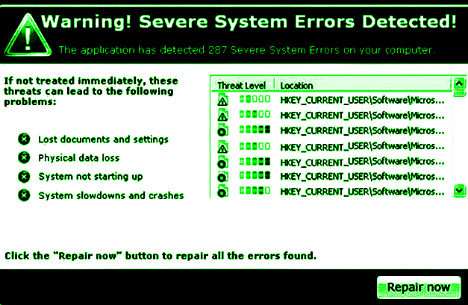
Introduction
This activity is all about adding an email server to your virtual machine. After this lab, you should be able to communicate with your peers across your network. We will be using Postfix to set up our server. Postfix is a free and open source mail transfer agent that was released a little over twenty years ago, but it still continues to have a lot of support as of 2021.
Getting Started
Before diving into this activity, it would be wise to take a snapshot of your machine if you have not already done so. It is recommended that you do this after each module. Snapshots serve as a sort of checkpoint just in case you make a mistake in the future and want to revert back to a previous state of your machine. Refer back to Module 3 Activity 2 to review how to accomplish this.

Setting Up Your E-mail Server

https://www.tecmint.com/setup-postfix-mail-server-in-ubuntu-debian/
Open up 230 manual

