Hide and Seek
Module 4 | Activity 2
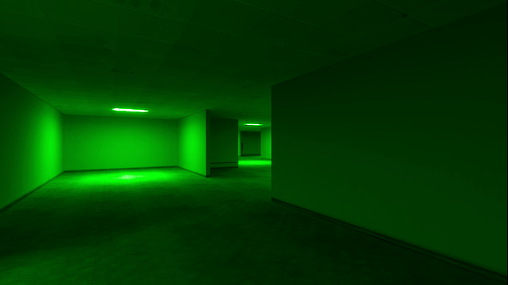

Introduction

Practicing the commands that you have learned will help you memorize them. Not everything will sense the first time around, so if you are having trouble understanding what a command does and how it works, do not worry. Memorize its definition as a fact for now and research it on Google or watch a YouTube tutorial. With enough effort the pieces will start coming together.
The following exercises are meant to help you feel comfortable navigating the Linux file system environment.
If you need help, remember Google is your best friend!

Practice Your Commands:

Log in to your VM

As a team, find your “Home” directory [/home/<user>] on the Desktop and create a new folder manually. Name this folder “Student”

Open up a terminal window.

Now create another folder within the “Student” directory using the mkdir commands called “studentfiles”.
  - Input: mkdir /home/eve18/Student/studentfiles

Check if the folder was successfully created by using the ls command. This will dump or display the contents of the Student directory.
  - Input: ls /home/eve18/Student

Now, make a file. Name it something unique but school appropriate. Remember the command “touch” is used to create a new empty file.
  - Input: touch filename.txt

It is time to move your newly created file into the “studentfiles” directory.
  - Input: mv filename.txt /home/eve18/Student/studentfiles

While we are on a roll, let’s make another folder in the “Student” directory. Name is directory “Copies”.

Let's make a copy of the previous file. Place this copy in the “Copies” folder you just created. Do this by using the cp command. Please note that you need to be within the directory where the file is contained to copy the file over elsewhere. And you need to specify the path of the destination.

  - Input: cp filename.txt /home/eve18/Student/Copies
  - Go to your “Copies” folder to see if the command was completed.

After all that hard work, let's delete the “Copies” directory and all its content. Use the rm -r command, but be careful because you can not undo this.
  - Input: rm -r Copies

Time to play Hide and Seek!
- Have each team member take turns in completing steps 1-6 below.
Using your commands, create a brand new directory anywhere you please. Please keep folder names school appropriate.

Create two new files within your new directory. Remember the name of your files. Write a fun fact about yourself in each of the documents.

Use that cat command to combine these two files into a new combined file.
  - Input: cat filename_1 filename_2 > filename_3

Create another directory using the mkdir command. Move the newly combined files (filename_3) into this directory. Use the mv command.

Once all your documents are created, clear your command terminal by using the clear command. Close all your tabs as well.

Switch computers with one of your teammates and give each other the title of your documents. Use the locate command to try and find each other's files.
  - Using the less/more command, view their documents.
  - After finding each other’s documents, switch computers and share the fun facts you discovered about each other.

- Once you have received your computer back, together let's seek how using >> with the cat command differs from the >.
  - Input: cat filename_1 >> filename2.
  - Write down what this does on your commands cheat sheet.

- After, you may delete these previous directories and files using the rmdir commands.

- Time to seek and discover some new commands using the man command. Discover what the tail, which, head, and grep commands do.
  - tail:
  - which:
  - head:

  - grep:
*Add these commands to your commands cheat sheet

10.
Now cd your way back to the top of the file hierarchy with “cd /”. Run the tree command “tree home”, what you should see is a record of all the files you created and moved around. Note that you can’t be IN the home directory while running the tree command on it.
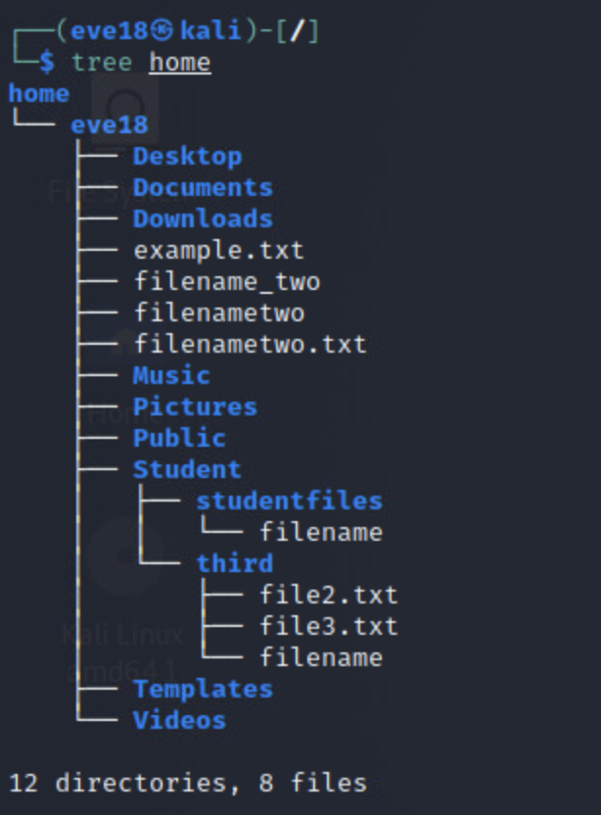

- Finally, try out this udderly amoosing command!
  - Input: fortune | cowsay

Note: You may have to install cowsay and fortune with apt-get install cowsay and apt-get install fortune.

Feel free to keep creating, discovering, researching, and practicing your commands!

