Configuring Network Settings
Module 4 | Activity 1
Introduction
At the present moment, your Kali virtual machine does not have access to the internet. We will have to configure a connection manually. That is what we will be doing during this activity. Before you begin, ensure that you have read through the slides for this module. It serves as a good introduction to the following topics. If you need help, ask your fellow classmates first then your instructor. Google can also be incredibly helpful.
In a previous module it was explained why your virtual environment feels like it is closed off from the rest of the internet. The reason behind this is that we don’t want anything harmful to be “leaking out”. In order to access the internet we first need to connect to a proxy, this serves as a gateway between users and the internet. And it only lets certain types of traffic through, namely http, https and ftp.

Configuration
On one team’s computer, sign in to ISELab and power on the virtual machine that you created last time. Launch a web console from the VSphere Client and log in with your credentials. This is what you should be seeing:
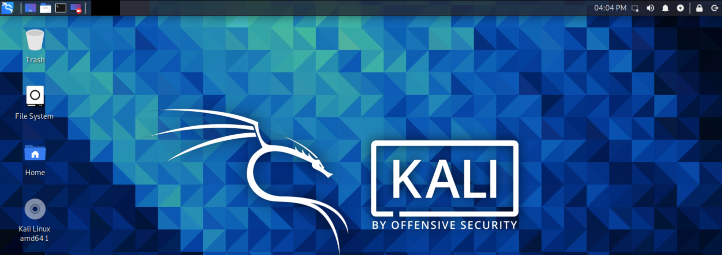
If you look back at the VSphere Client real quick you should see that your Kali machine should be connected to the Playground DVS option, which is visible under the Summary tab.
Listed under Networks.
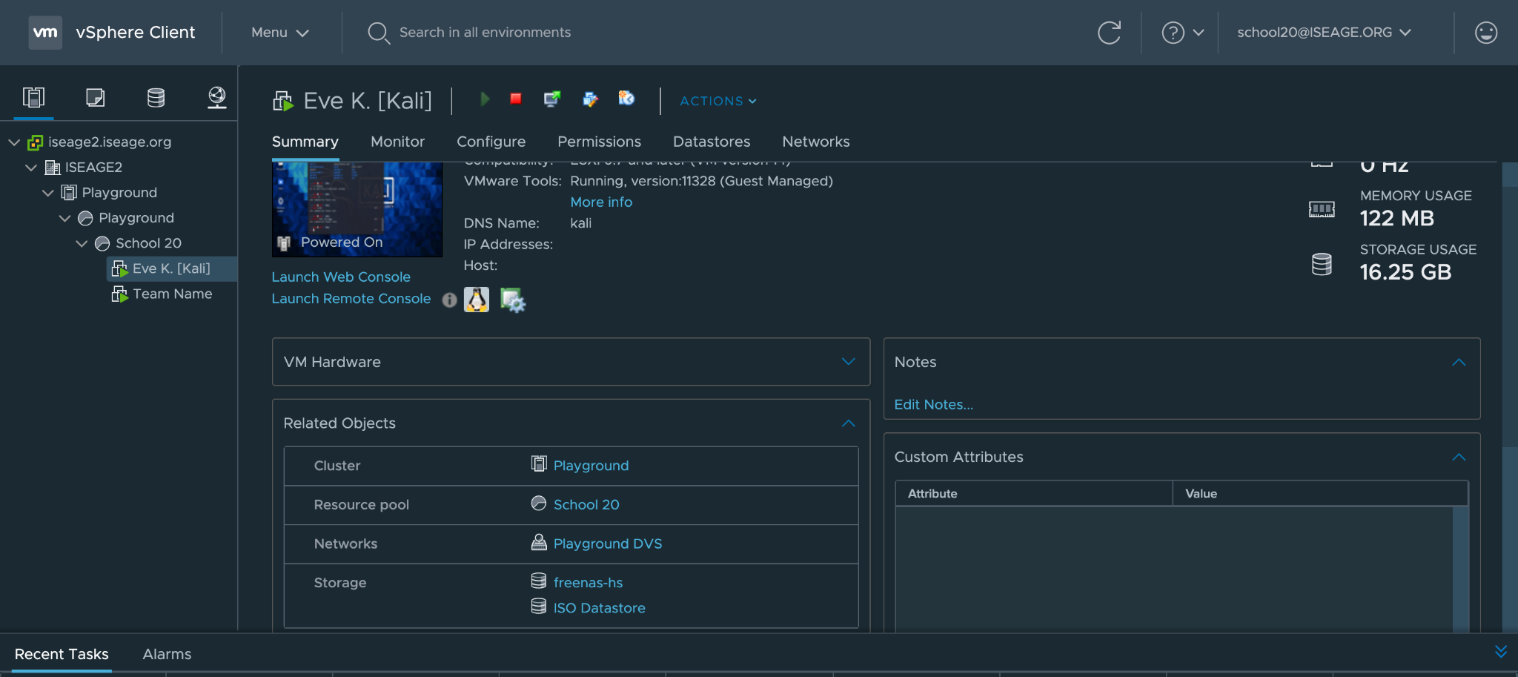

At the moment you do not have an IP address for your machine. And IPs are necessary if you want to connect to the internet.
If you run the command ip addr which usually has your IP address listed along with other information we can see that it is not there. *You will see what it is supposed to look like soon.
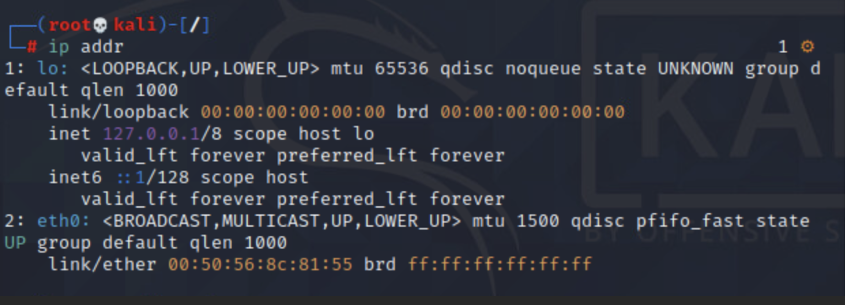
Login as root user
Our first step is going to be to use the text editor “nano” in order to edit the interface file. Open a commands terminal by clicking on the black box in the top left hand corner.
Before you edit a file ensure that you are a “root” user otherwise you will be unable to save your changes. To obtain root privileges simply use the command “sudo -s”, after which you will be asked to provide your password.
Also note that whenever you type a password no characters show up. Not even asterisks (****). But I assure you that you are indeed typing. Press Enter to submit password. Once you see “root 💀 kali” followed by a “#” symbol next to the cursor you are a root user.
- Edit the Interface file
Run the nano command.

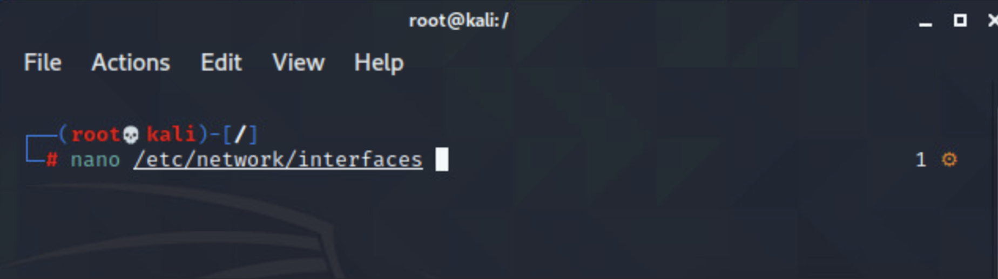

- Once you press enter you will be able to view the following from the text editor. Most of the lines of “code” will already be there. Especially the comments, in blue. If your file is empty you probably misspelled the filename or file path. Make sure it is typed exactly as shown above.
Add the remaining lines to your /etc/network/interfaces file by scrolling down with the arrow keys. Be aware that your school has its own unique IP address, provided by our people at ISEAGE. So do not type in the first three numbers “41.8.80” as the first part of the address and gateway as shown below. You will have your own set of XX.XX.XX numbers.
Since we are doing this manually do not pick the same final digit for your “address” as your friends. The netmask and gateway can be the same but the fourth digit on the address field must be different.
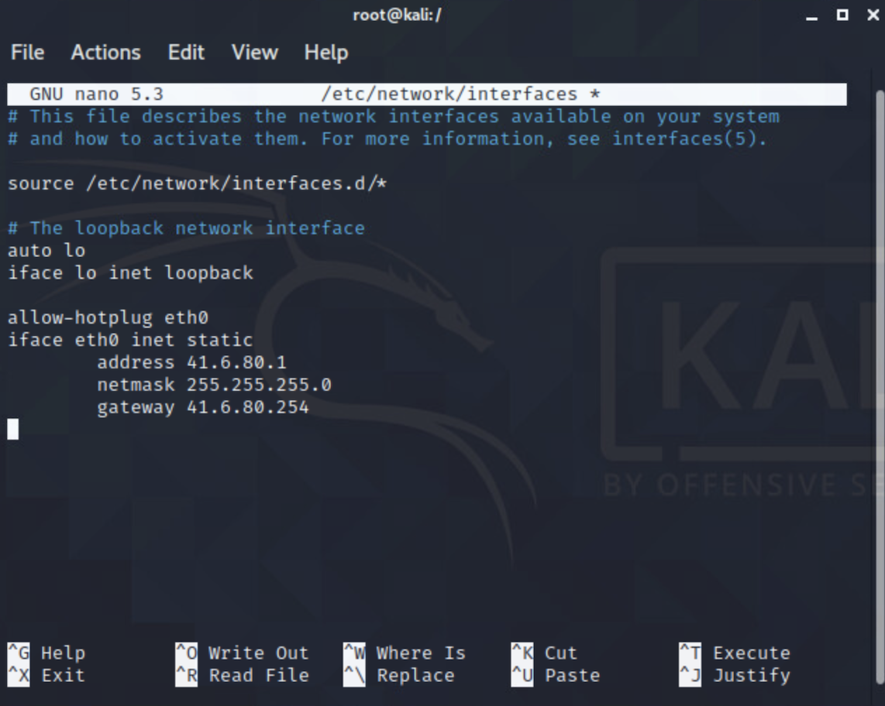

- Once it looks good. Exit the file by pressing Control + X. Once you press Control + X, you will be asked “Save modified buffer?” Press Y to confirm this action. Finally simply press Enter to confirm the name of the file.
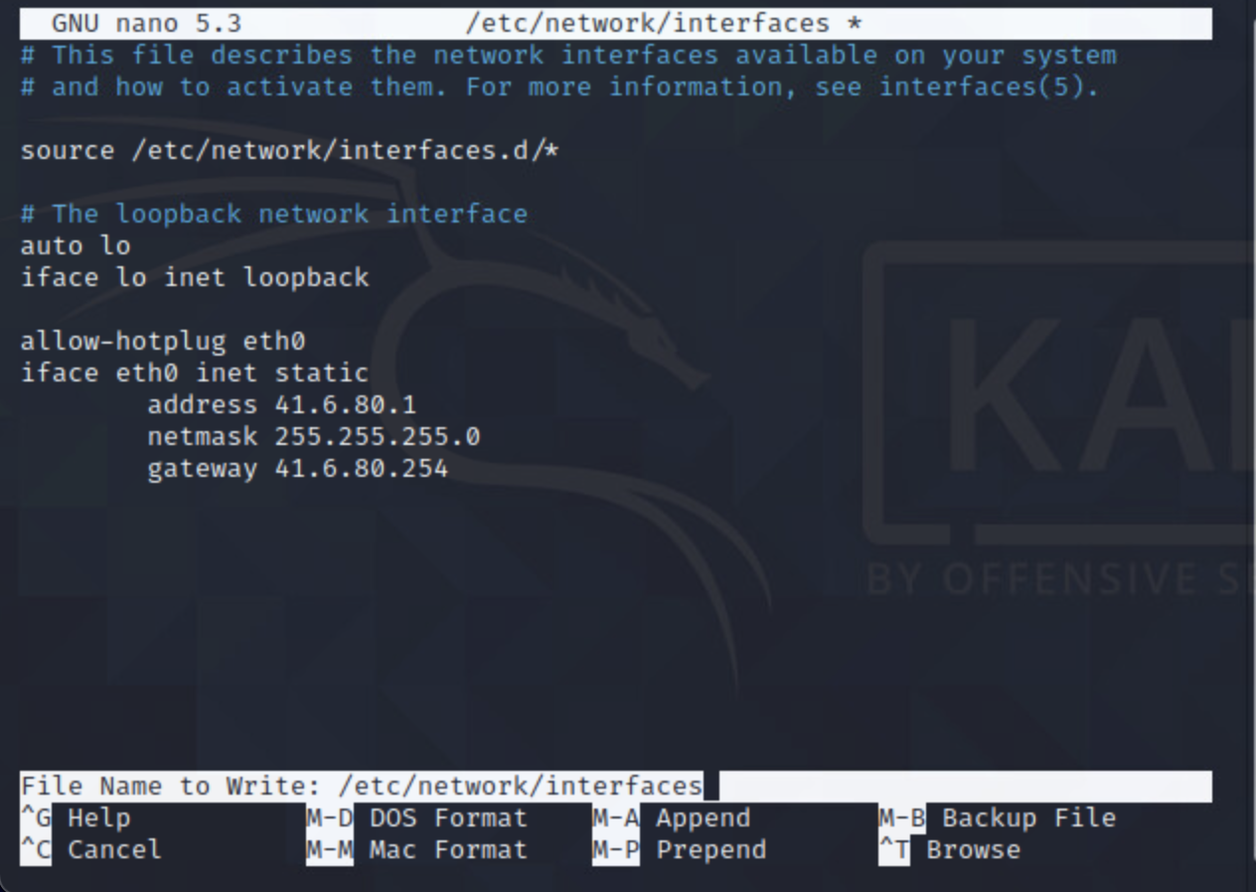
C. Applying the Changes
- To get our most recent changes to apply we need to bring down the interface and then bring it back up as shown below. I had already done this before so my results might differ from your but that is A-OK!
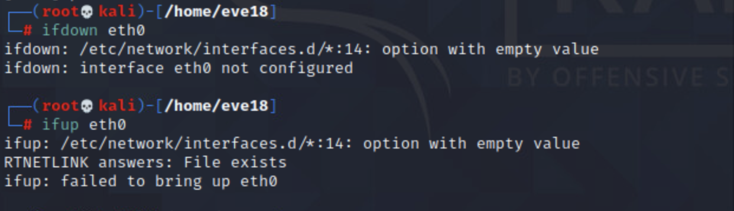
Input ifdown then input ifup.

- Now if we run our ip addr command once again we can see that our machine has now been assigned an IP-address. As shown next to “inet”.
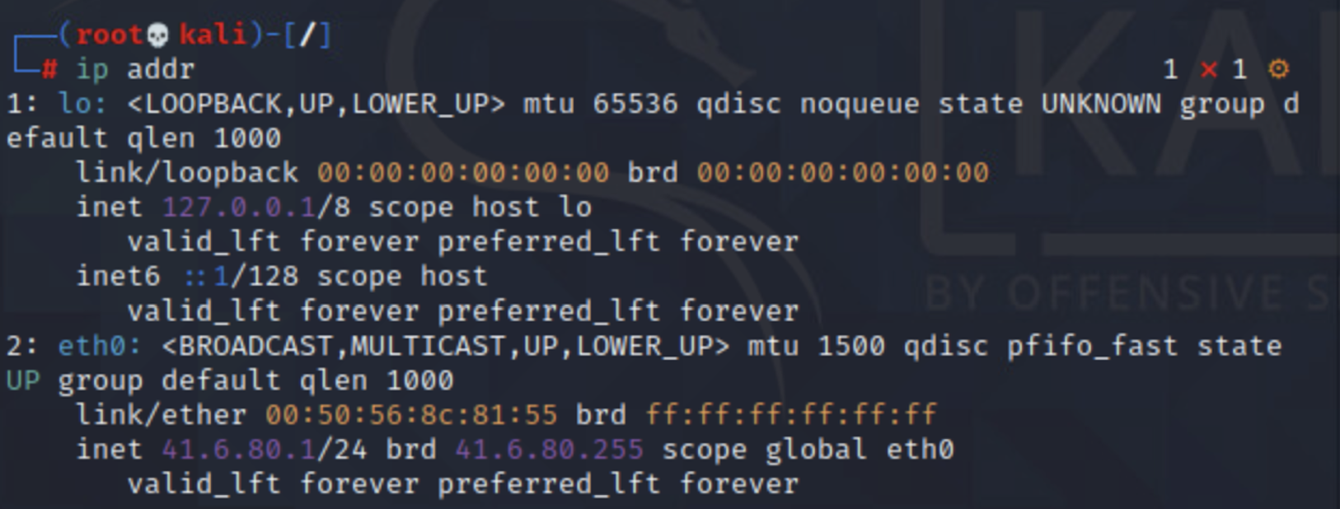
- We’re almost there.
D. Adding a Proxy Environment
- Due to the way the ISELab environment is set-up, we can't access the normal internet just yet. We need to go through a proxy that only allows certain types of traffic through the ISELab “Air Gap”. Namely the http, https and ftp protocols.
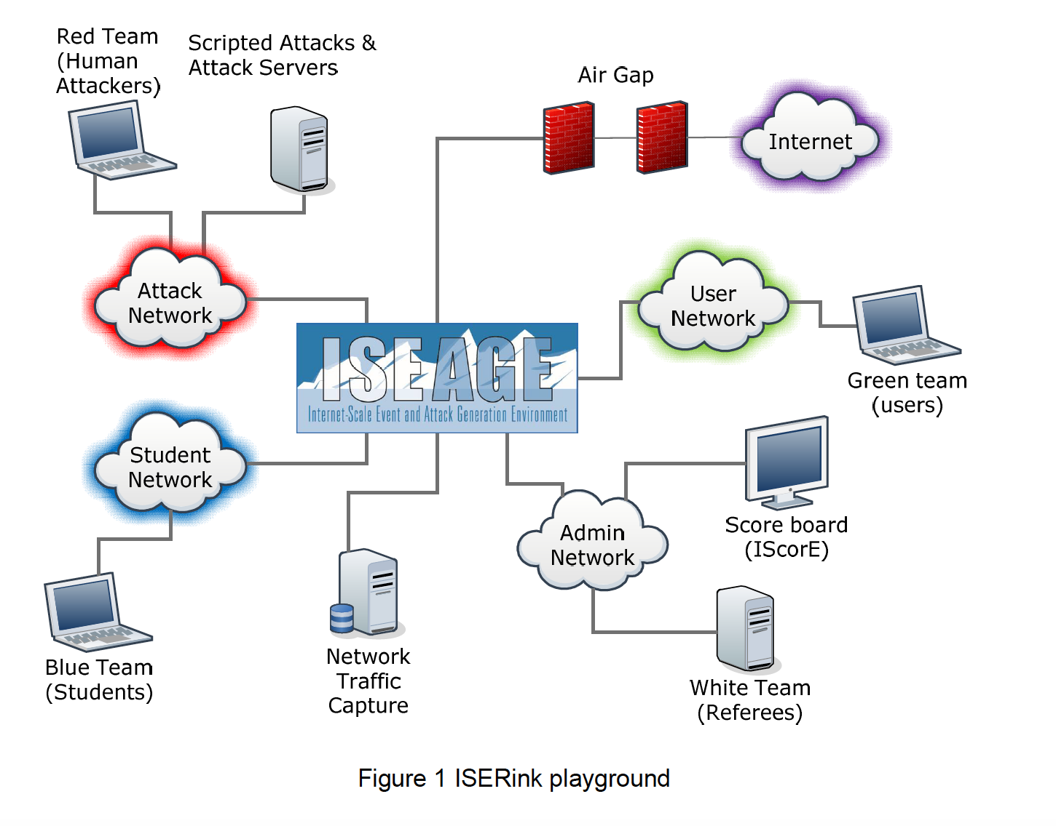

- We need to add proxy environment variables to our system. To do this we need to edit another file that will continue to come up in future modules. I am referring to the /etc/profile file.
We will use our text editor nano to help us out with this. Run the command “nano /etc/profile” and the corresponding file contents will be displayed.
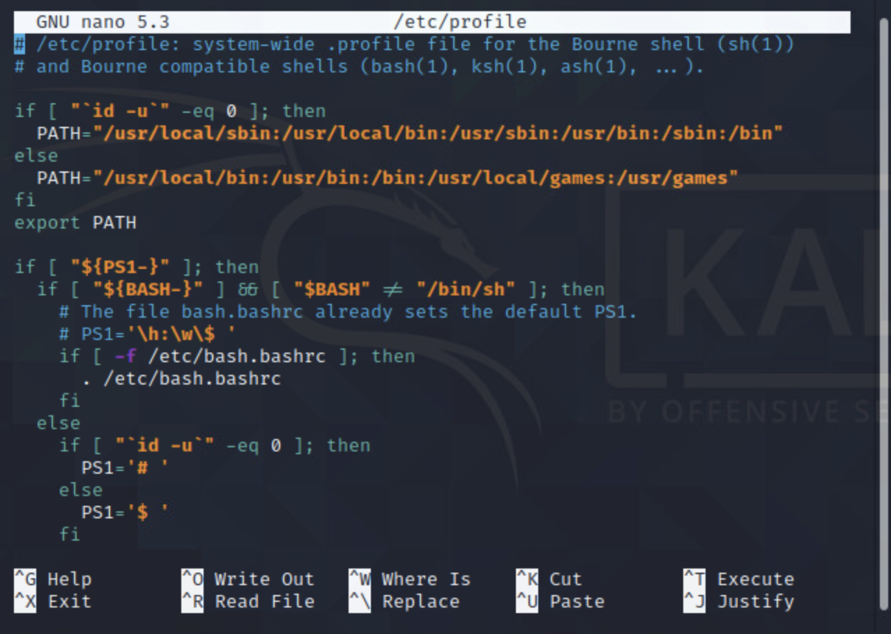
- Scroll all the way to the bottom by using the arrow keys and enter the following final three lines.(no you can not copy and paste here) We need to tell our machine where our proxy server is located. The IP address corresponds to our proxy server and the 3128 is the port number being used. Exit and save the file as shown previously.
*More on ports in the future.

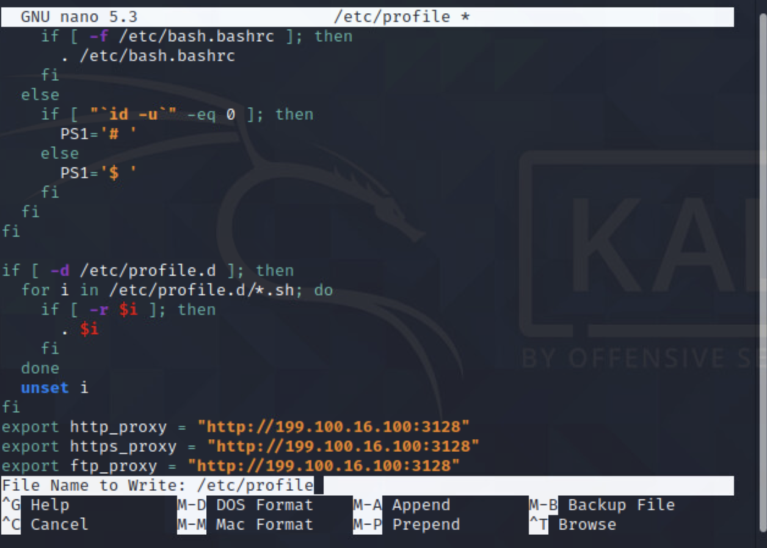
Important Note:
While we have made the proper adjustments to the file, we cannot expect the changes to be applied immediately. It is good practice to get used to restarting your machine every time you make a change with a significance of this magnitude. After restarting the changes should be applied.

E. Adding New Default Setting
- One of the last remaining steps we need to complete is to add a new default setting to our sudoers file. All it does is help us run certain commands with greater ease in the future.
Enter the command “visudo” in the terminal. This is what should come up. You may need to enter the sudo -s command again.

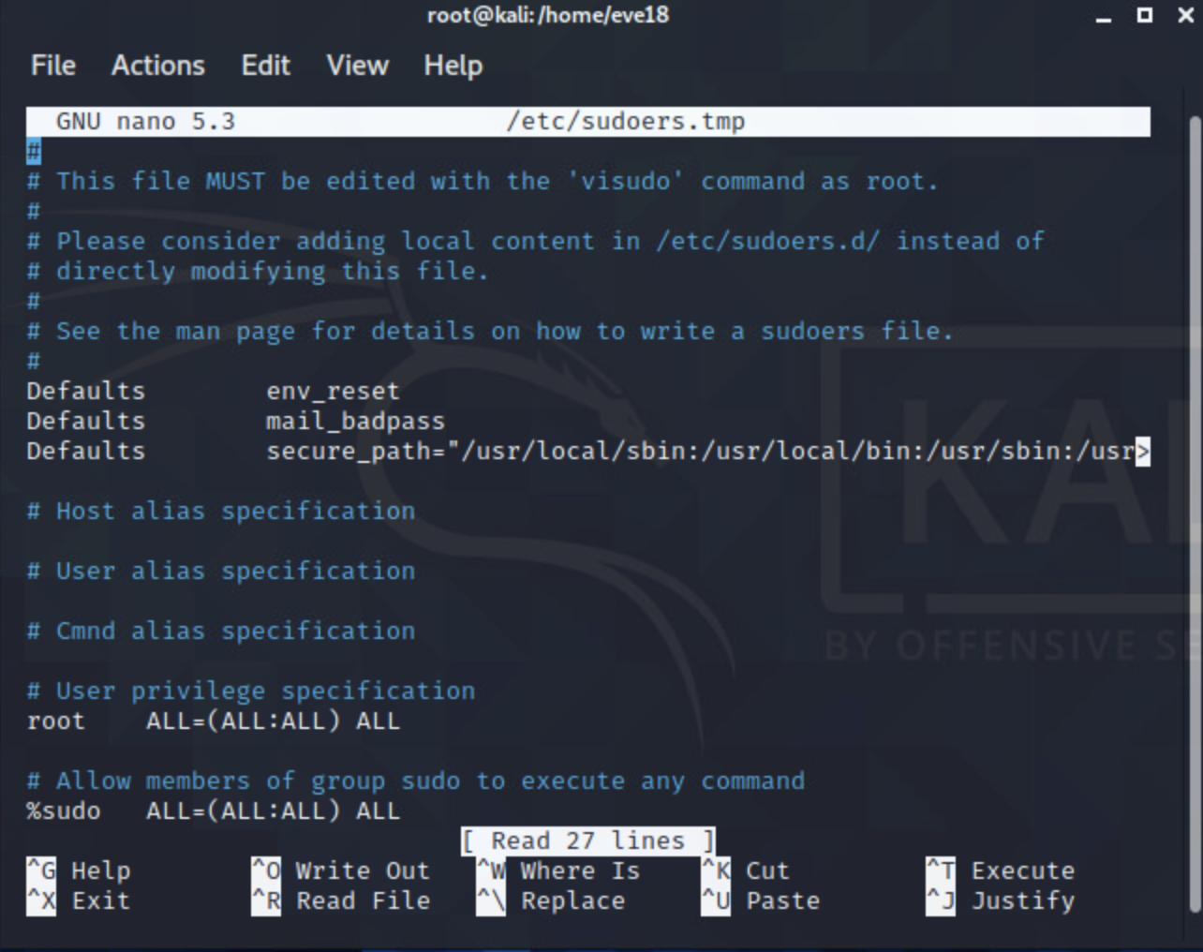
- Add the missing line. Exit and save.
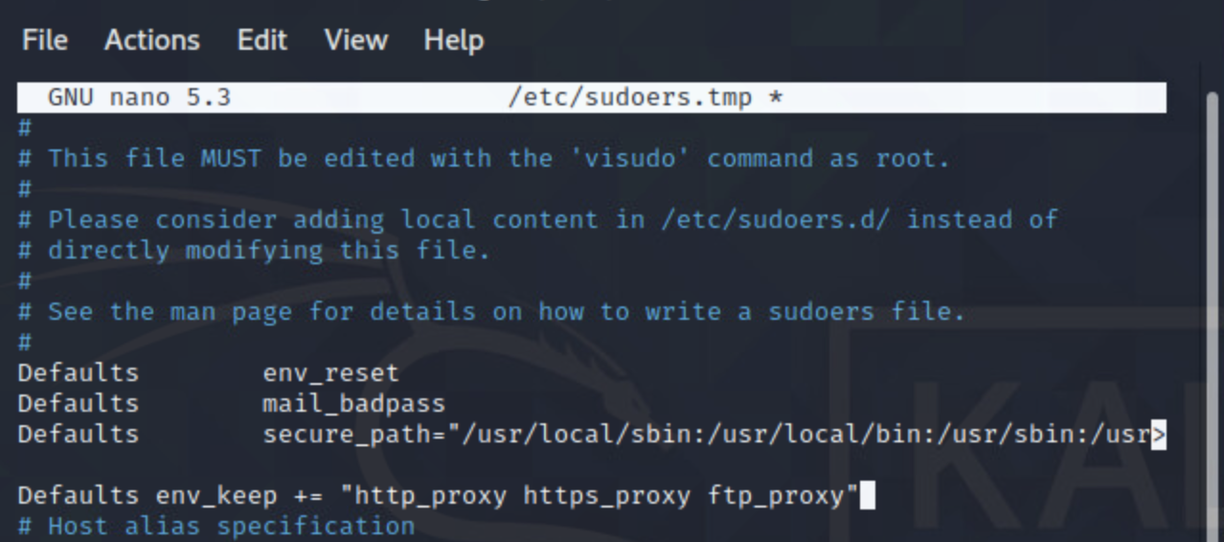
F. Exporting and Updating the Network
- Execute three similar commands in the terminal as you did before in the /etc/profile file. Namely, the three export commands. Note that they won’t return anything. After these three export commands. Enter the apt update command which basically helps us apply all of the big changes we just made. This update may run for about 15 minutes.
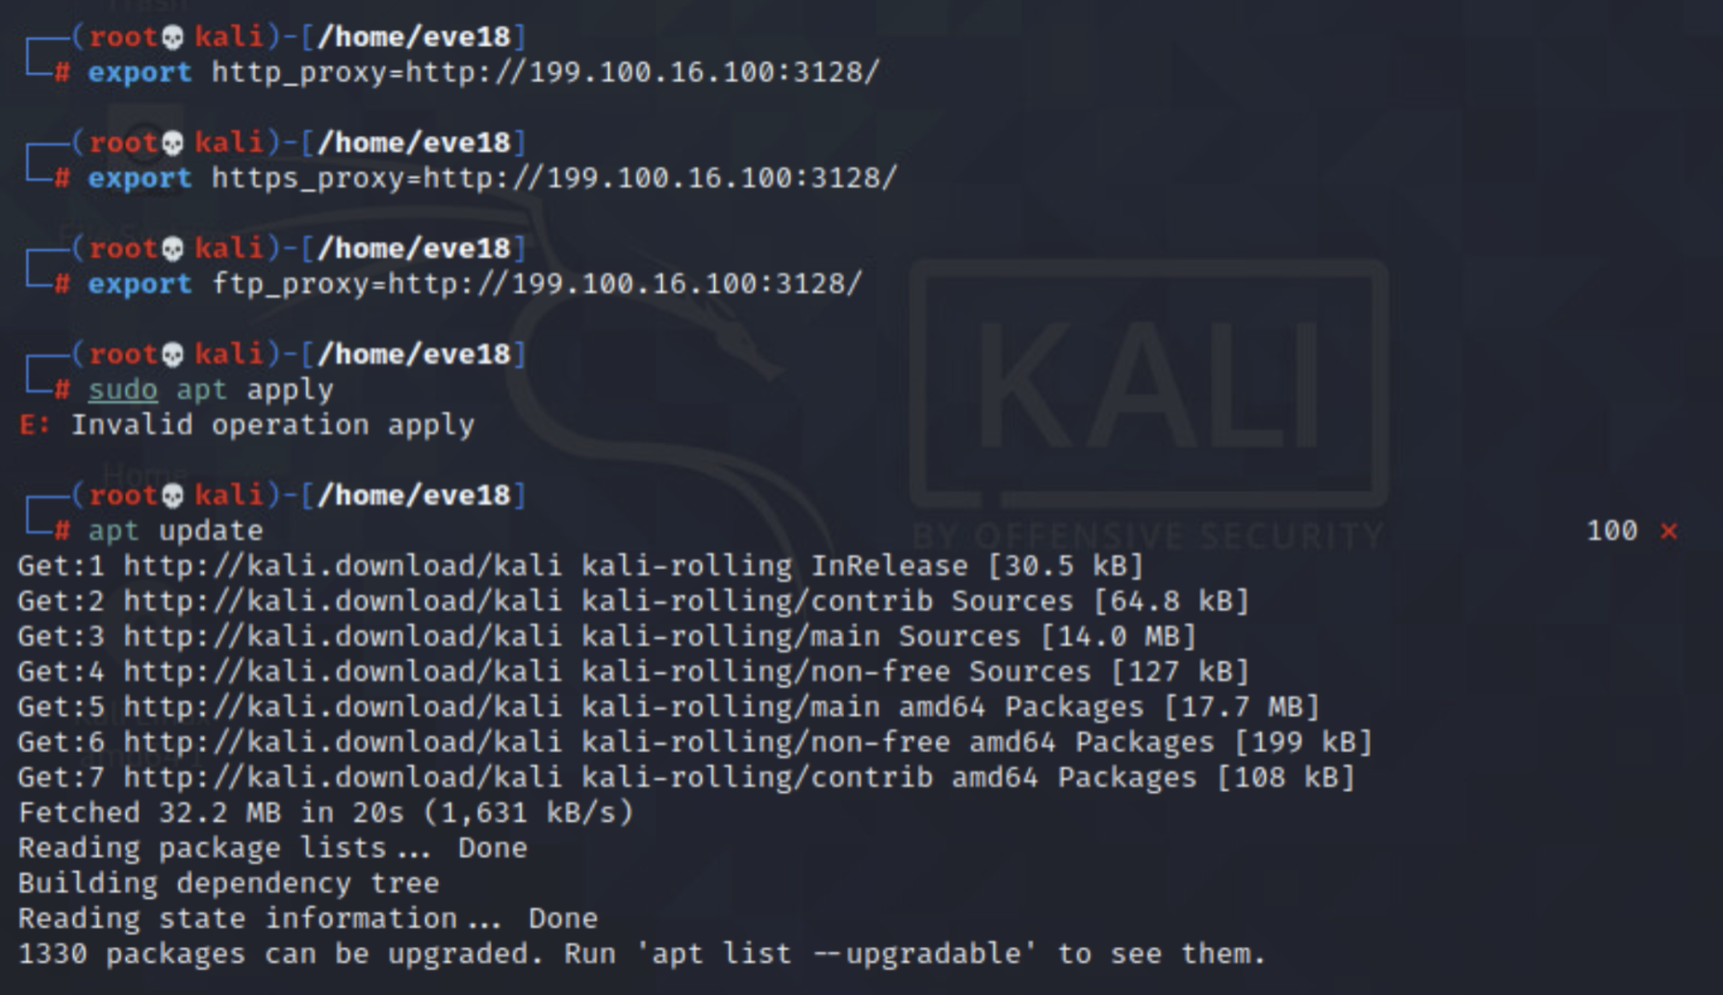
- At some point it is likely that you will run into the following two prompts. Press Enter on <Yes> and type in “YI” before pressing enter on the second prompt.
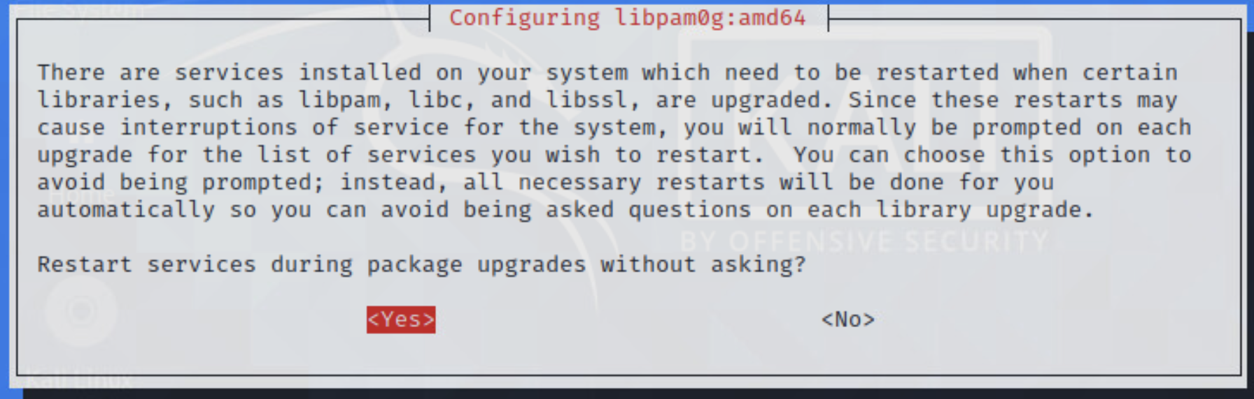

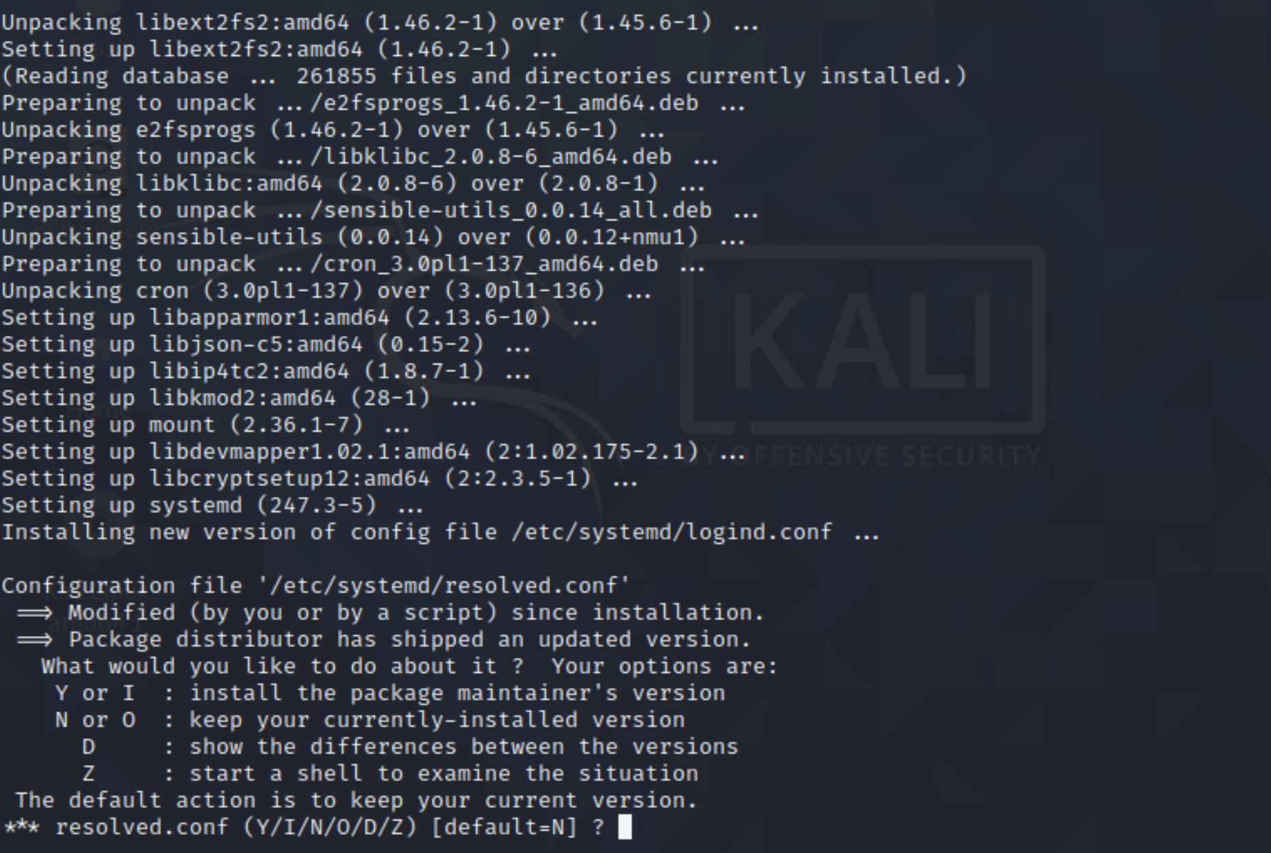

- After this long update, restart your Kali box. Not your physical computer you are viewing this from. Do this with the command sudo reboot.
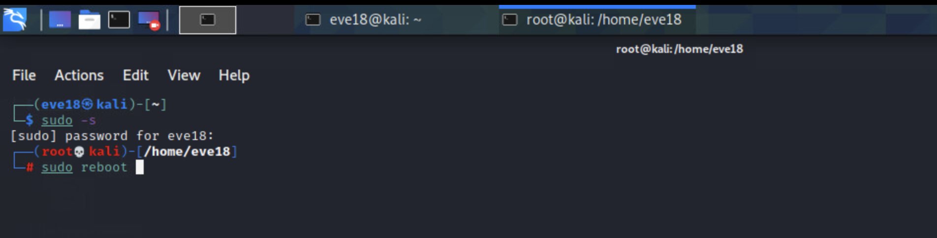

G. Assigning Preferences
- Open up a Firefox tab by clicking on the blue/white Kali dragon icon on the top-left corner of the screen and type in Firefox. It will be called FireFox ESR. Bring down the hamburger menu and click on Preferences. This is a part of configuring DNS. And if your internet connection is non-existent at some point during a future module come back to this section to reconnect.
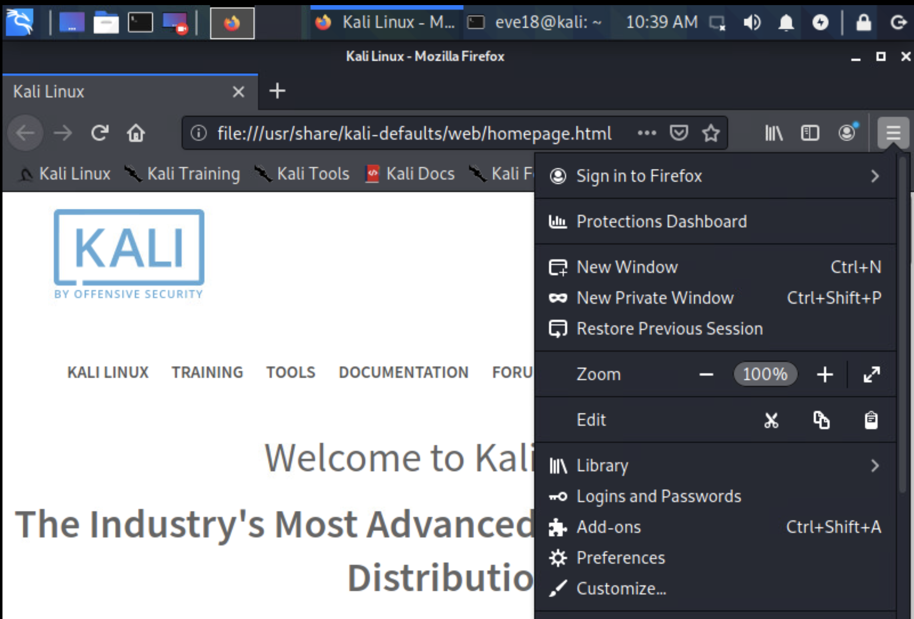
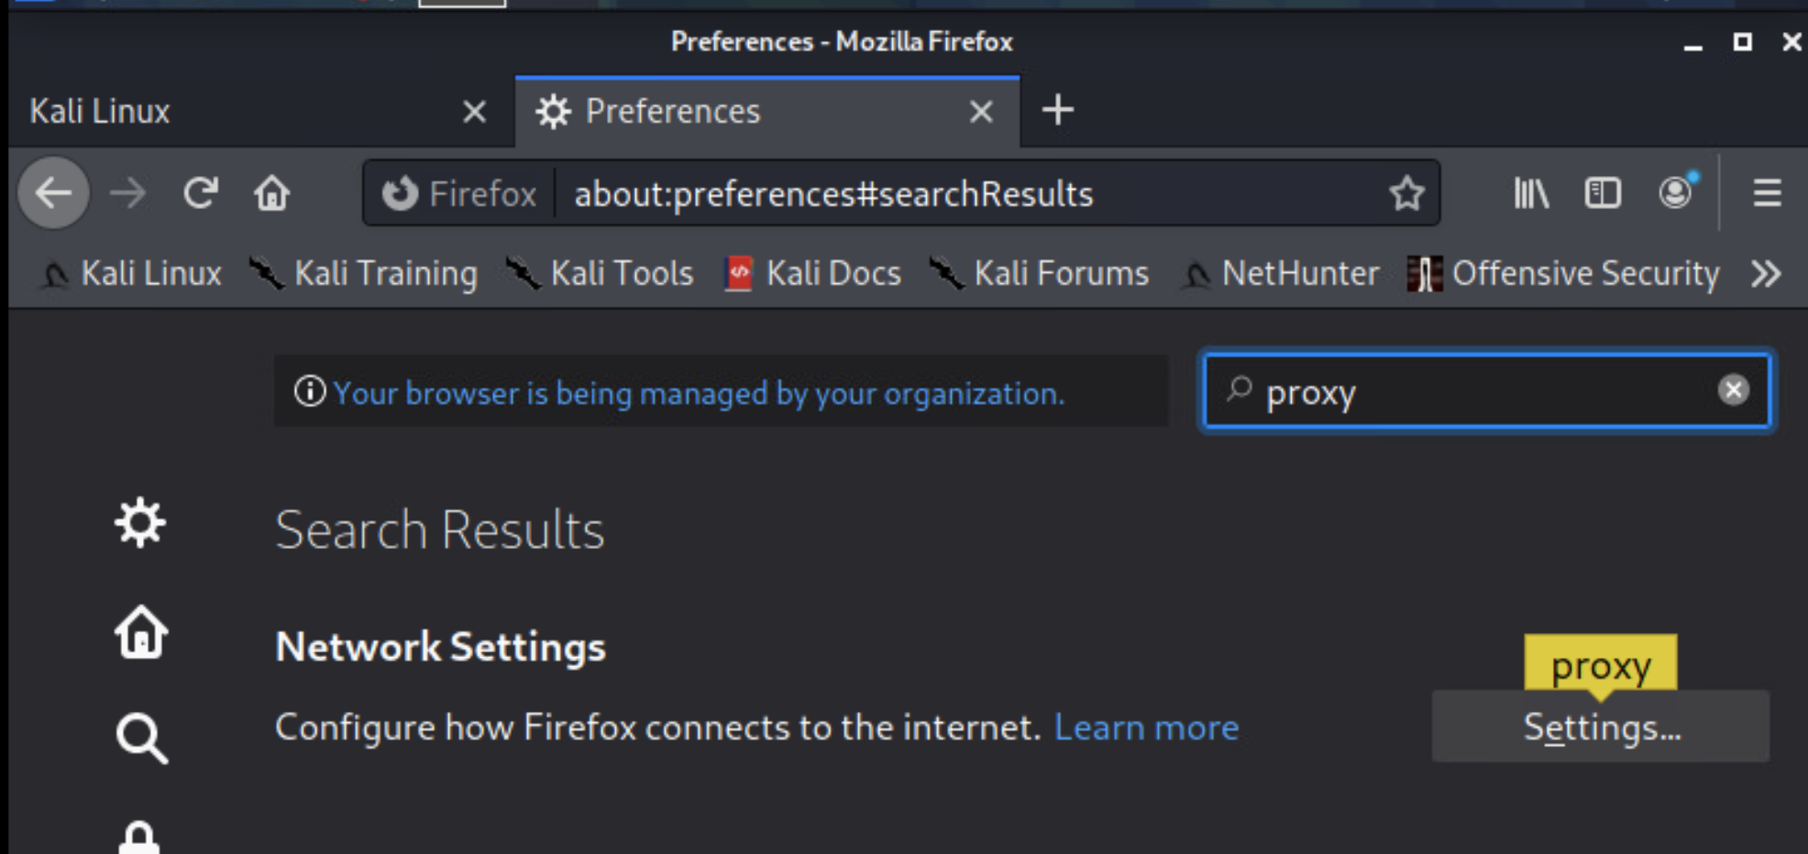

- Click on the settings button and make the corresponding changes before you click OK. This will help ensure that you can access the internet safely through the ISELab proxy.
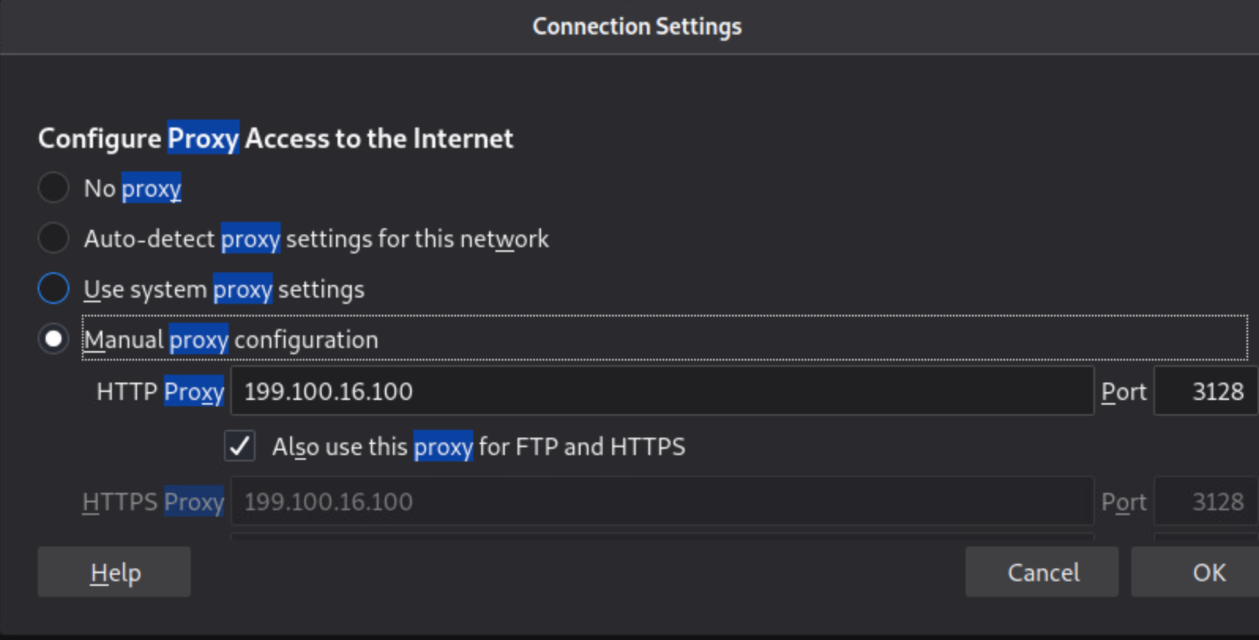
- Finally, close out Firefox and relaunch it. You should now be connected.

DNS stands for Domain Name System. All it does is help translate domain names with alphanumeric characters such as “www.google.com” or “www.twitter.com” into IP-Addresses that computers can understand. Every web address has a corresponding IP address. Google’s is 216.58.192.228. Go ahead and type that in your address bar and see where it redirects you.

