Virtual Machine Snapshots
Module 3 | Activity 2
Introduction
Making mistakes is common in the field of cyber security. Luckily for us working with technology, there are many ways we can simply “press the reset button” to save ourselves a lot of trouble and despair. You simply have to be clever enough to think ahead and foresee a problem before it actually happens.
When working your way through the modules, you will often find yourselves undoing past mistakes. This can be done through the use of snapshots. When you take a snapshot of your machine, you are essentially freezing your machine to the conditions it was in at that point in time.
Similar to when you are playing a video game, you do not lose all your progress and start all over when you lose a life. You simply respawn at the last checkpoint.
If you need help, ask your fellow classmates first then your instructor.

Procedure
- Let’s use Eve’s kali box for this example. Hop on over to the ISEAGE environment and you will see the main VSphere Client page. Which looks something like this:
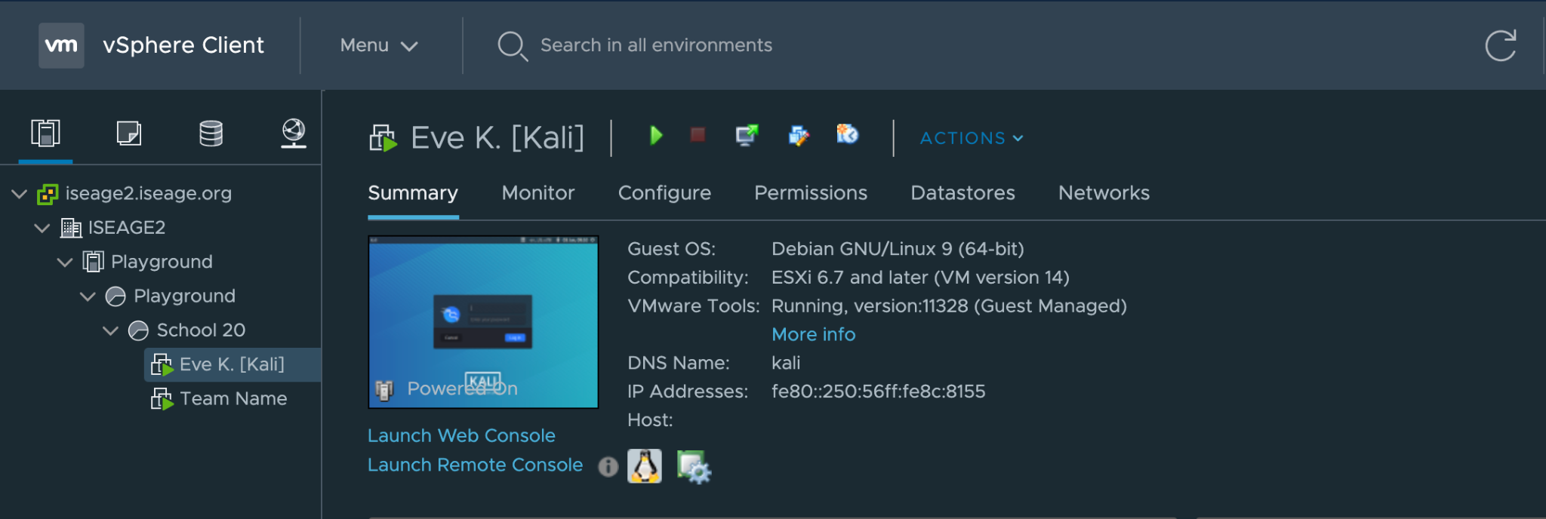
- Your machine does not even have to be on in order to take a snapshot.
- Right click on your machine and a list of options will appear.
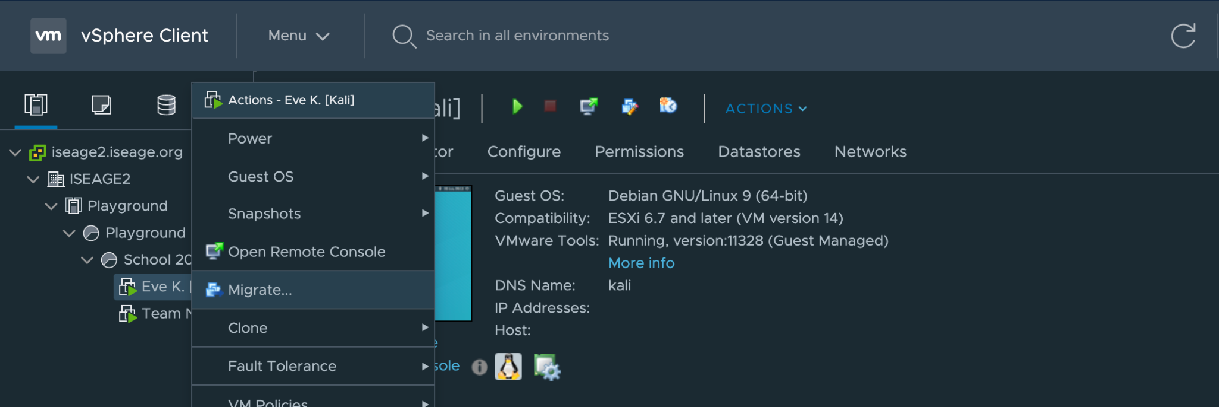

- Hover over the Snapshots option and click on “Take Snapshot…”
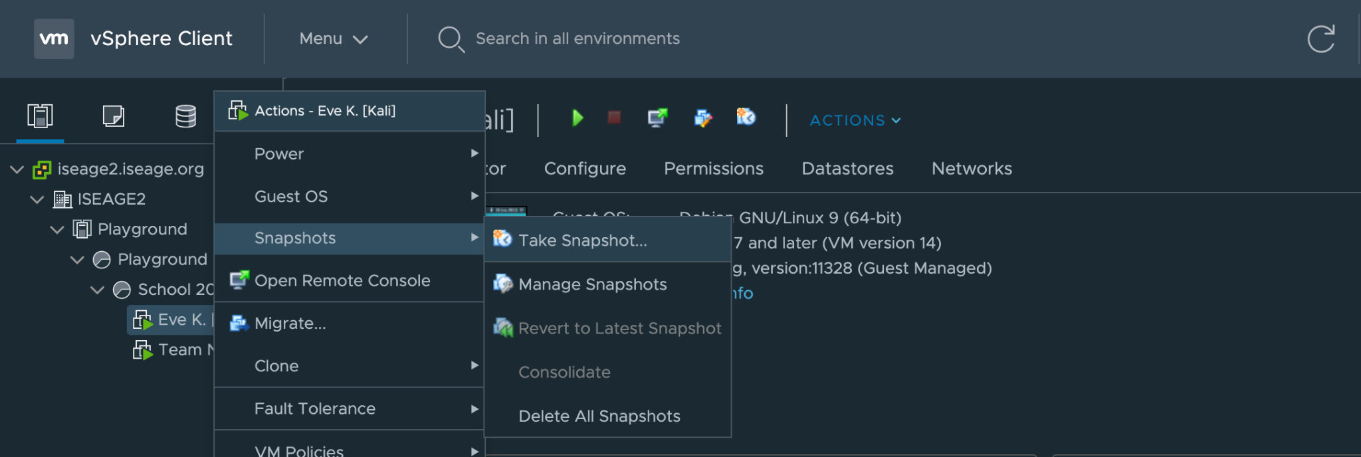
- Another window should pop-up that includes the name of the snapshot and other important identifying information. What I usually do is add a brief description of the snapshot in order to have a better idea of when this was taken. Click OK.
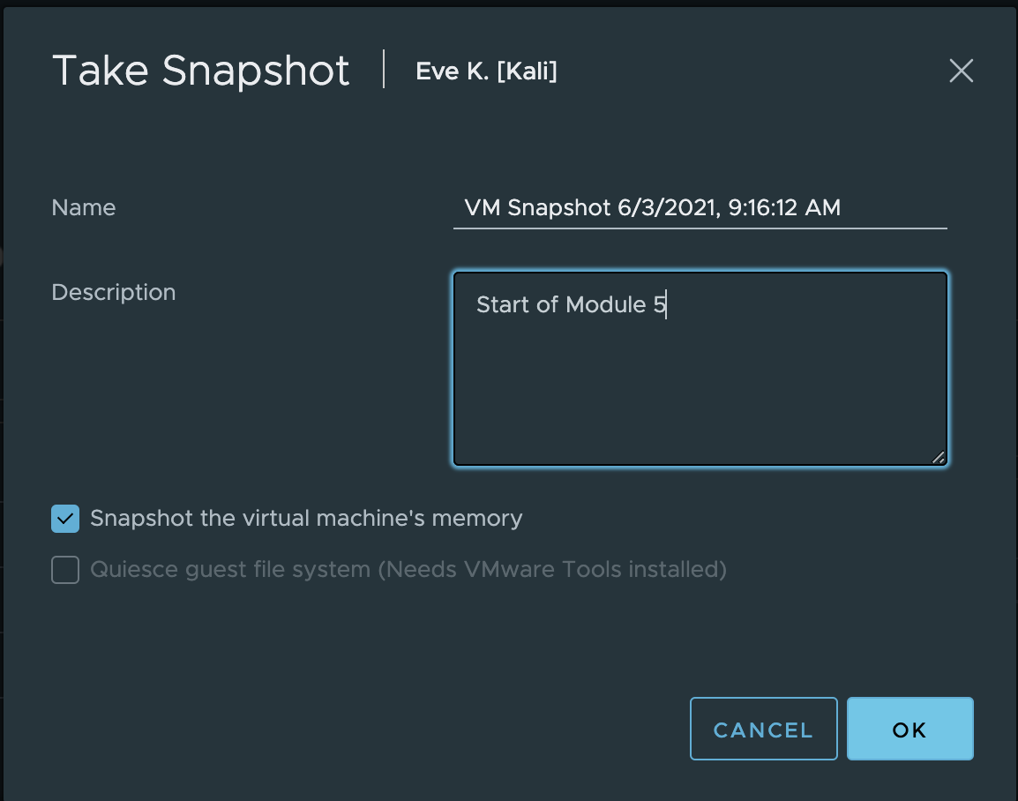

- You will see a progress bar at the bottom of the screen, as shown.
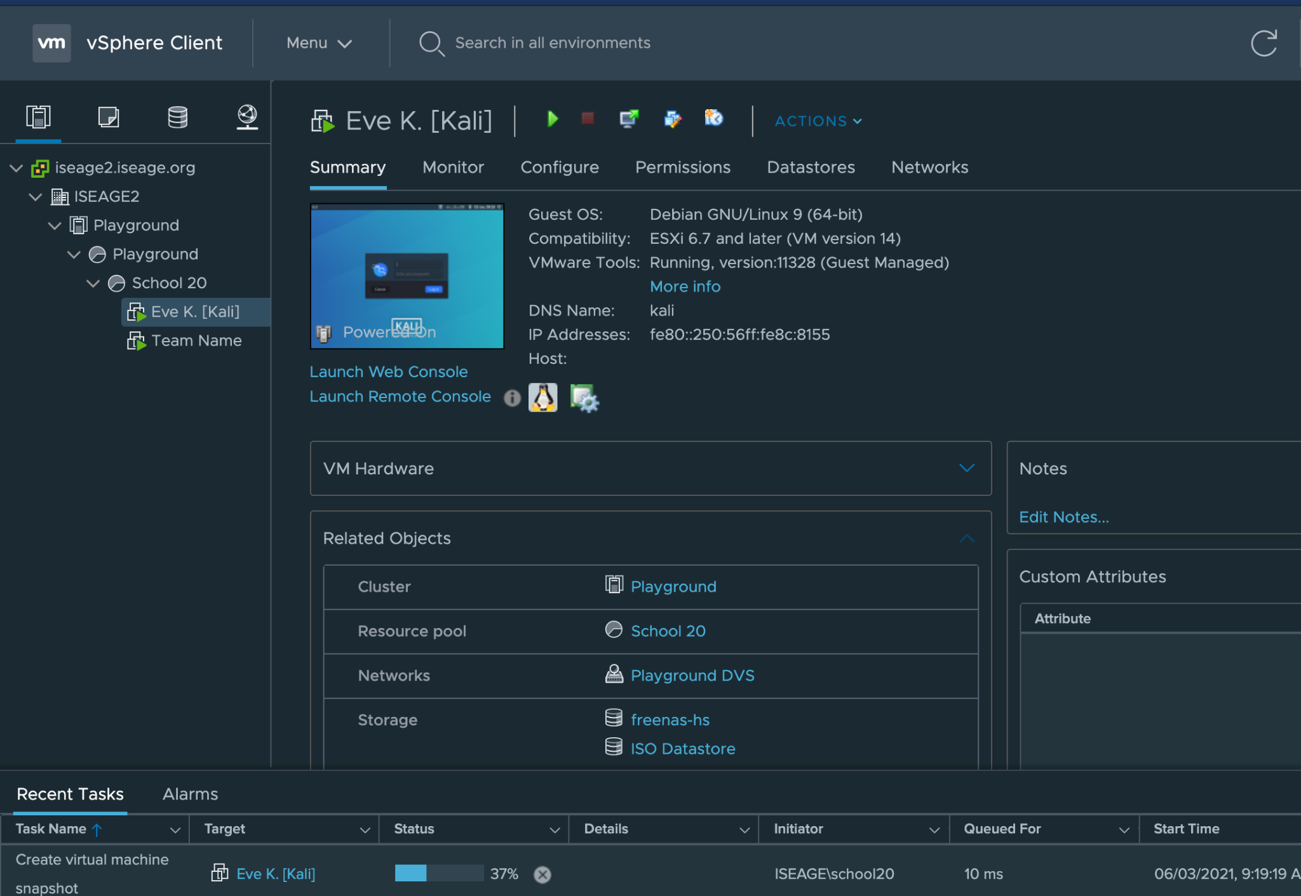
- Now that you have “frozen” a specific instance of the machine, you will be able to revert back to this snapshot if anything ever goes wrong with your machine.
- There have been numerous times when reverting back to a previous snapshot really saved the day for me as a student. What I recommend is to take a snapshot at the end of every module. This way if anything goes wrong during the module, you can simply hit the reset button and be well on your way.

- Here is how to revert back to a previous snapshot. Go to the main VSphere Client page and right click on your machine again. Follow the Snapshots → Revert to Latest Snapshot, thread and click on that option.
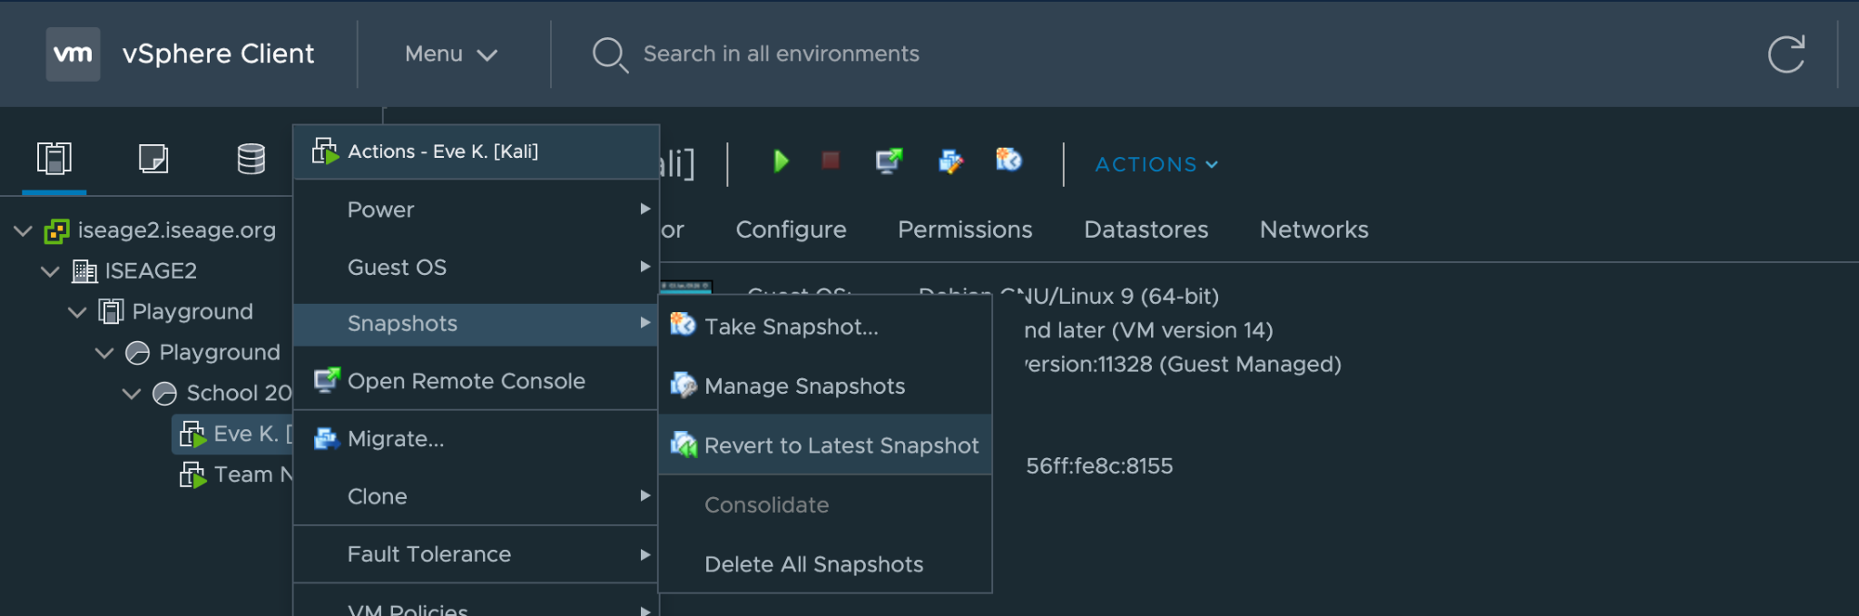
- Doing so will pop-up another window that wants you to confirm this move. Verify the date and time of this snapshot and select yes if you want to continue. And there you go! That is our way of going “back in time”.
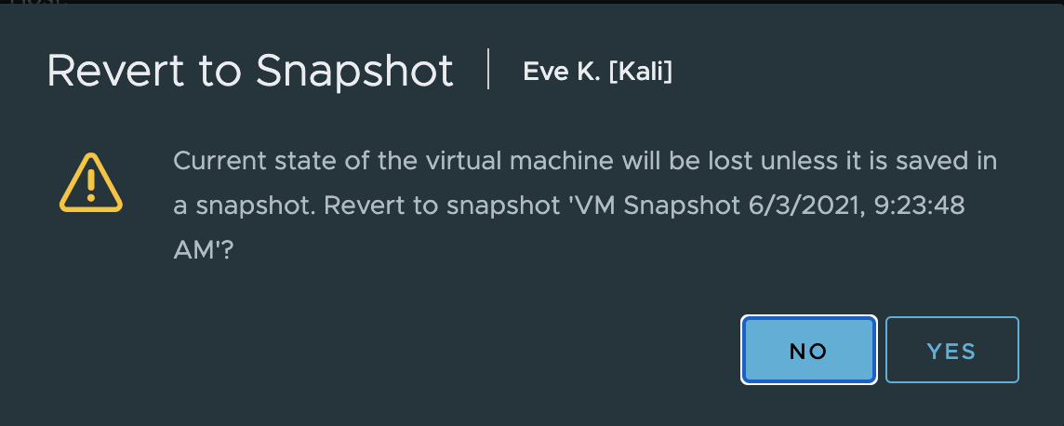
- That being said, please don’t go wild and take snapshots for every step within the modules. They do take up space, and even though it may not be much it can add up.

