Creating Virtual Machines
Module 3 | Activity 1
Introduction

In this activity, your team will be configuring a virtual machine that will run Kali Linux, which is a Linux distribution designed for security professionals. Within your club or class, break up into teams. Each team will work together to configure a virtual machine that will be used throughout the semester for other modules and activities.

Getting Started

Logging In
Navigate to the ISELab environment, available here.
Click on the blue Launch vSphere Client button.
Enter your school’s login information to continue.
Once you’ve been authenticated, find your school’s resource pool
Refer to the image below to see what this looks like.

As a heads up, the following examples will use the School 20 account, but your school will have their own number. You might be School 19 or School 51.

Resource Pool
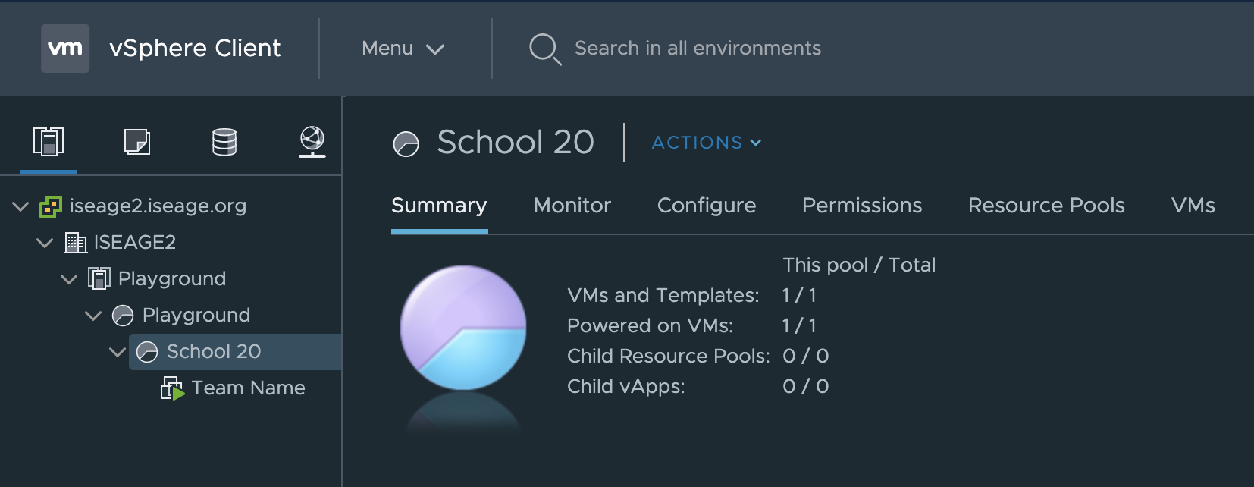

Creating a New Machine
Under the Actions menu click on New Virtual Machine.

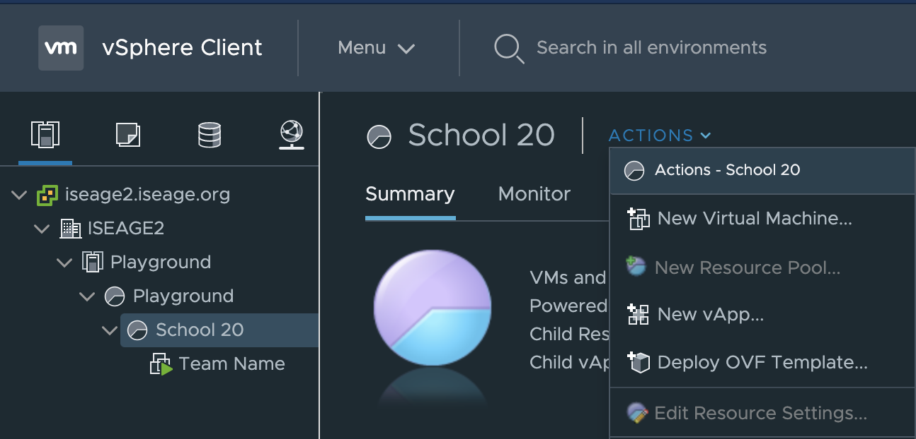

On this screen, simply click Next, while keeping the
Create a New Virtual Machine option highlighted.

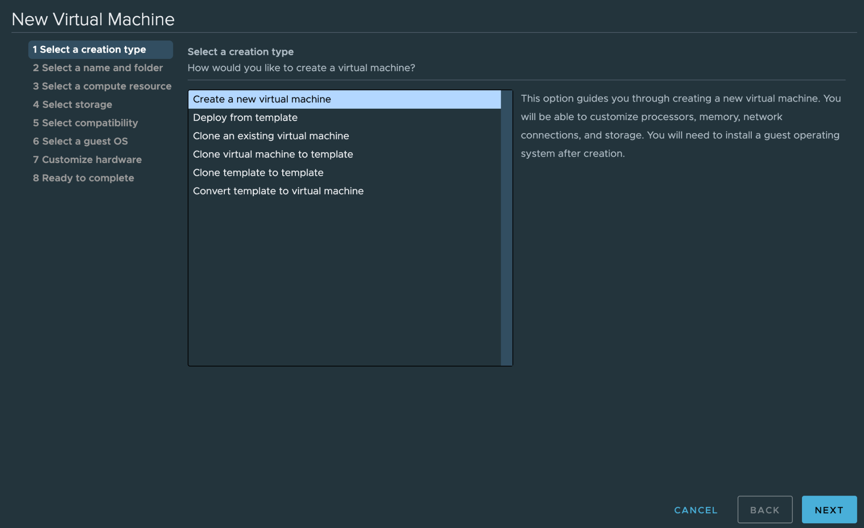

Step two requires you to name your machine and select the folder where it will be placed.
Please ensure that the name is unique and school appropriate.
Attach the word Kali in brackets at the end to make it easily distinguishable from other machines you will be using in the future.
Select your school’s folder and click Next.
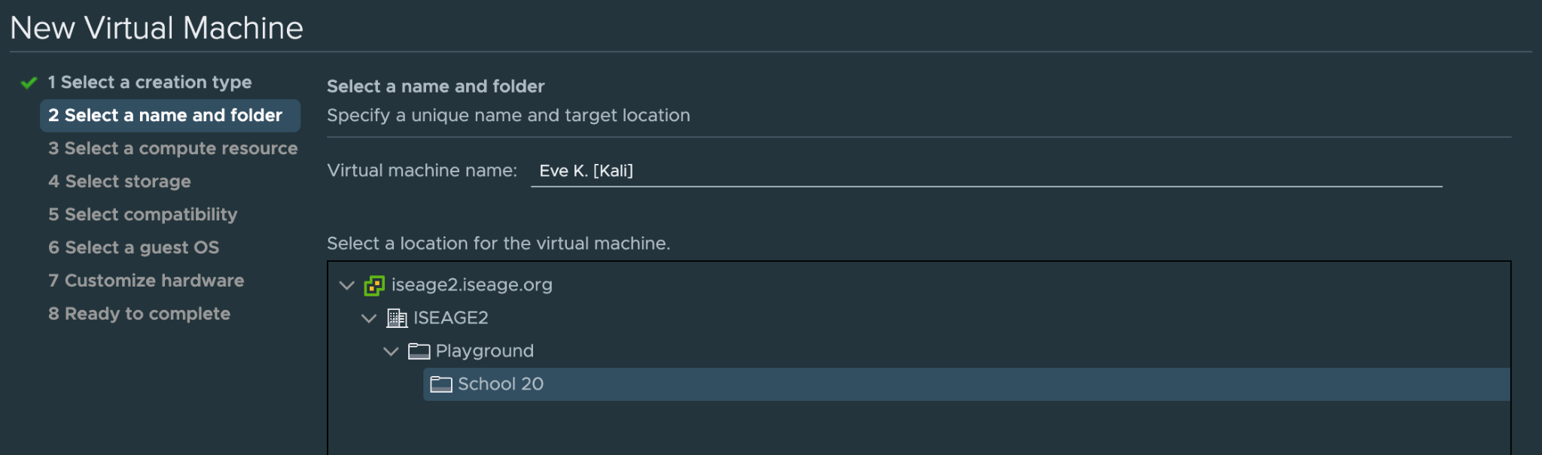

Step three will ask you to select a compute resource or resource pool. Which is School 20, once selected click Next.

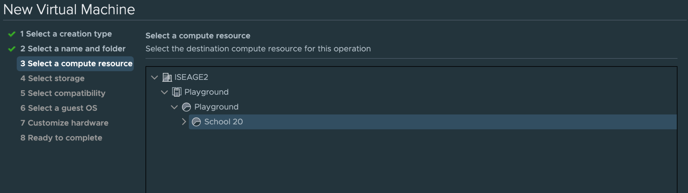

Please select the freenas-hs storage option in step four.
Click Next.
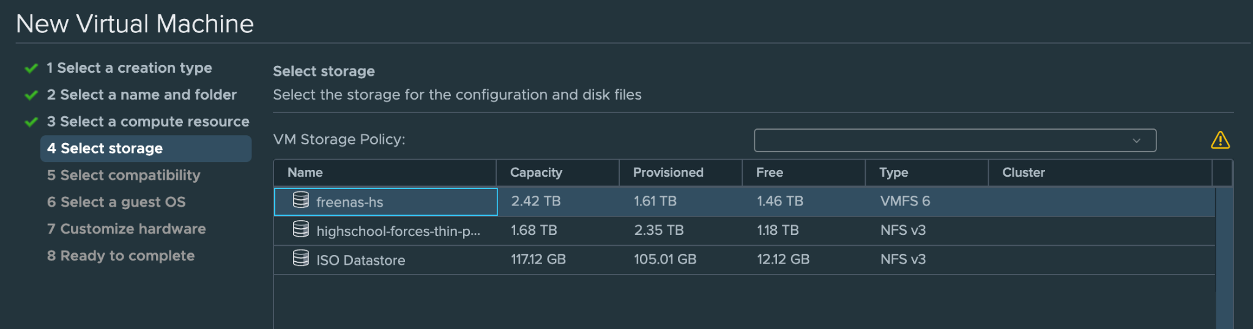

Select the latest VMware Hypervisor version ESXi 6.7 and later.
Click Next.
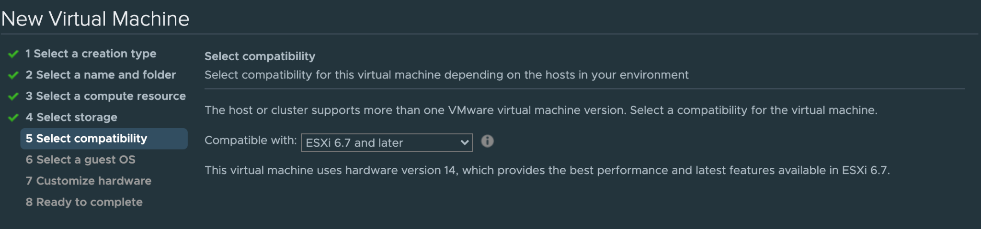

You will now select the guest OS. We are going to be running Linux, and since Kali Linux is Debian based, make the corresponding selections from the dropdown menu. Click Next.

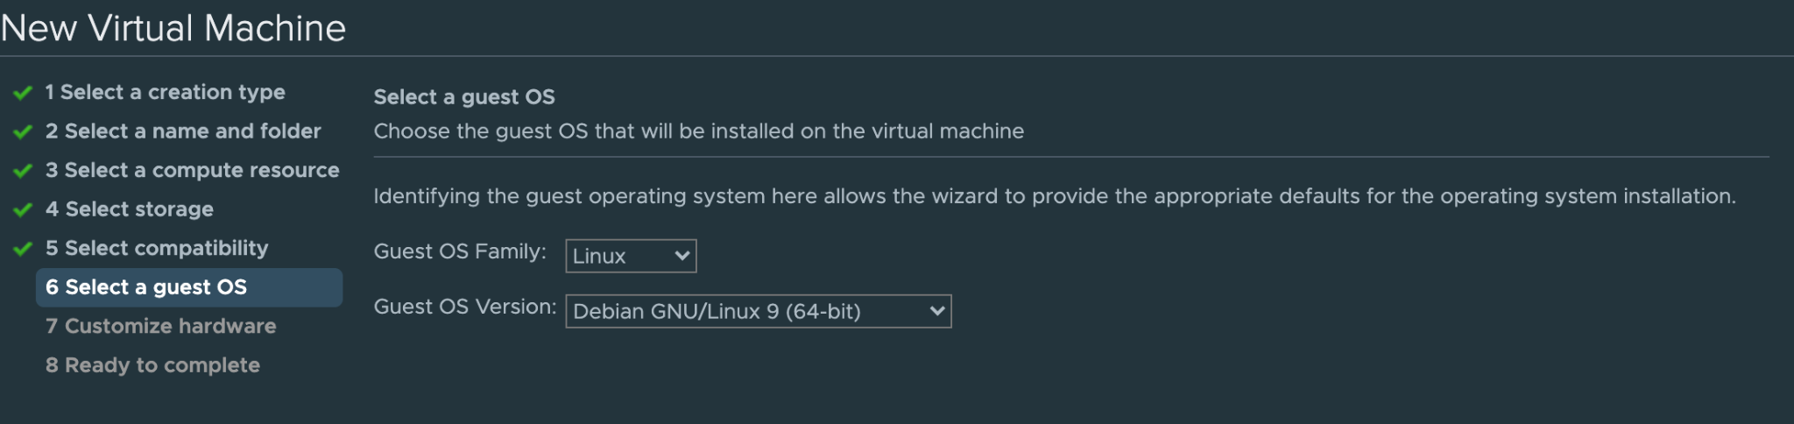
In step seven, click on the New Hard disk tab and select Thin Provision. Which is a memory-conserving configuration.

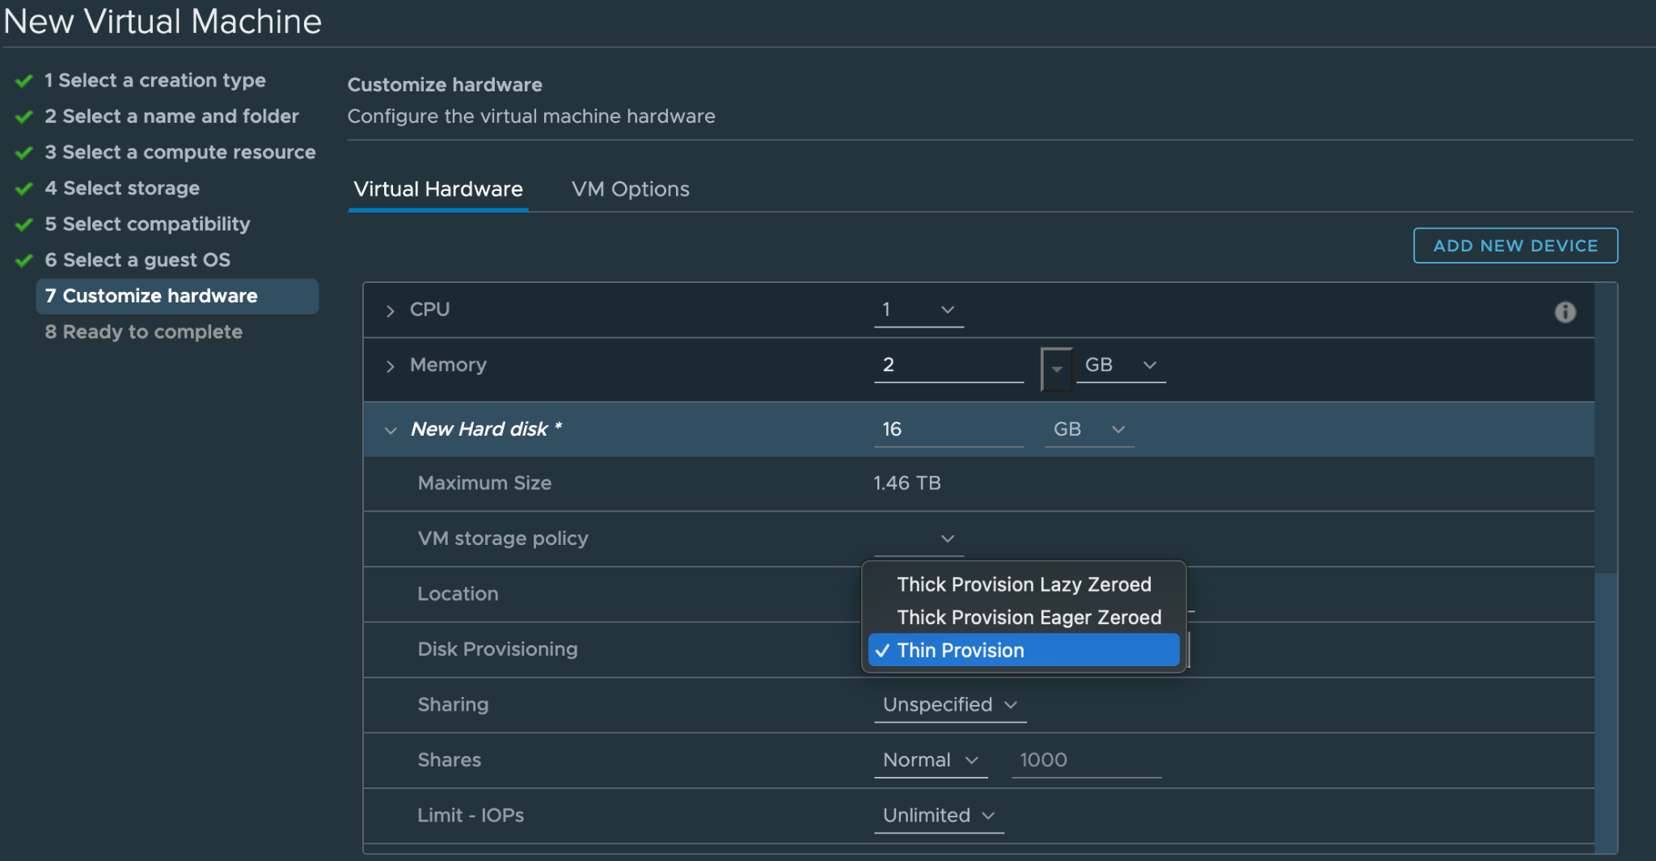

Don't click the big blue Next button just yet!!!

We are still on step seven, but to change the network your machine is connected to, scroll down slightly and you will see a New Network sub-menu. Connect to the Playground network. If you
don’t see it, you might have to click the dropdown menu and click Browse before it becomes visible.
Also ensure that the Status Connect At Power On is enabled.

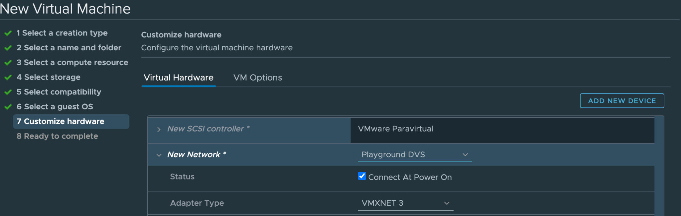

Since we’re not quite done we now need to select a download source for our operating system. Click on the dropdown menu for New CD/DVD Drive where it says Client Device and you will want to change that to Datastore ISO File.

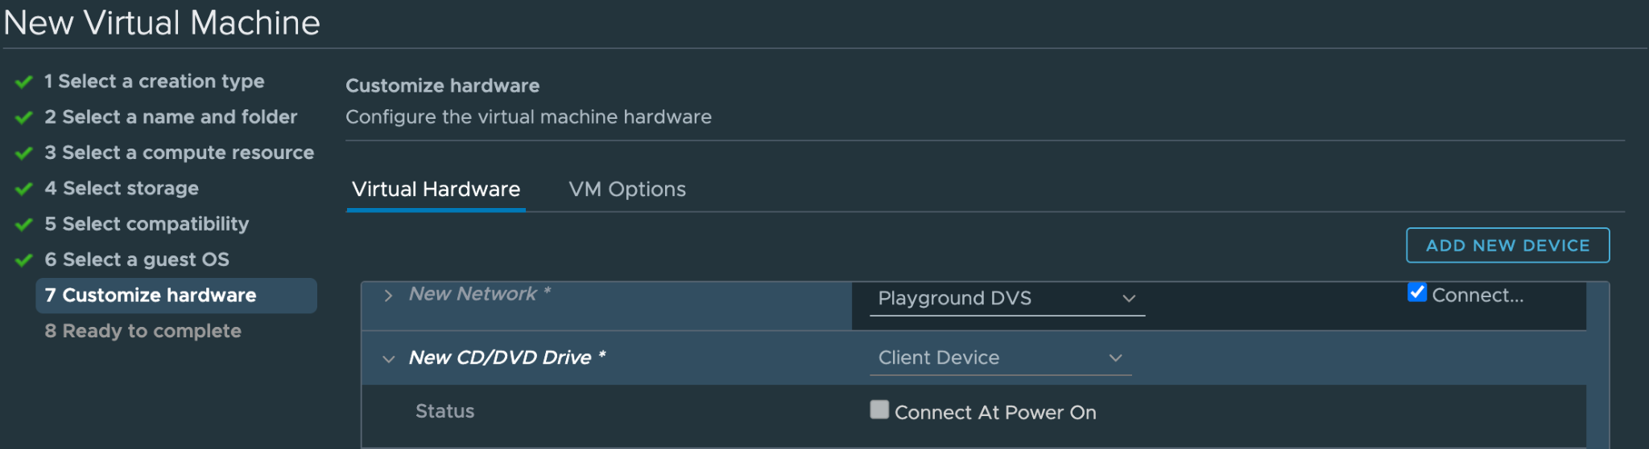

Clicking on the Datastore ISO File option will take you to another menu that looks like the following. Under ISO Datastore, be sure to select the kali linux amd 64 option.
Yes, Hannah Montana Linux is a real thing.
Kinda cool, kinda weird.
Click OK.

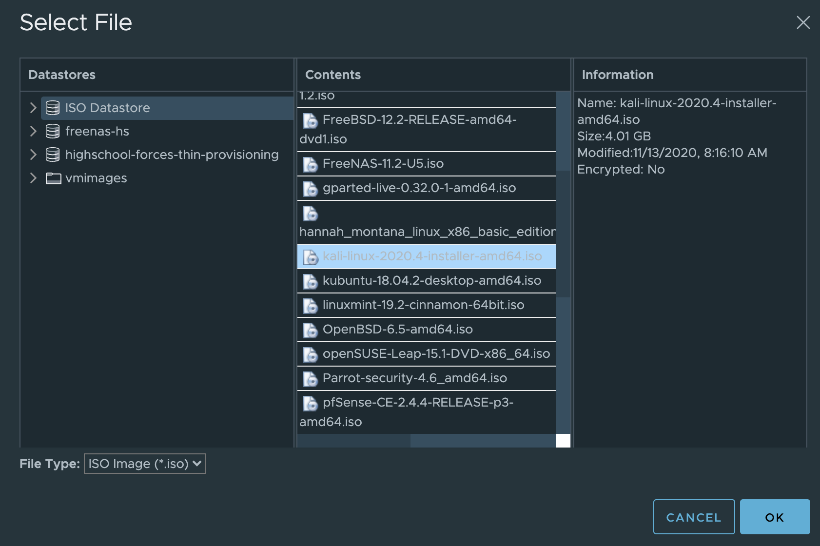

Make sure you also check/enable Connect at Power On, for this change. As shown below.

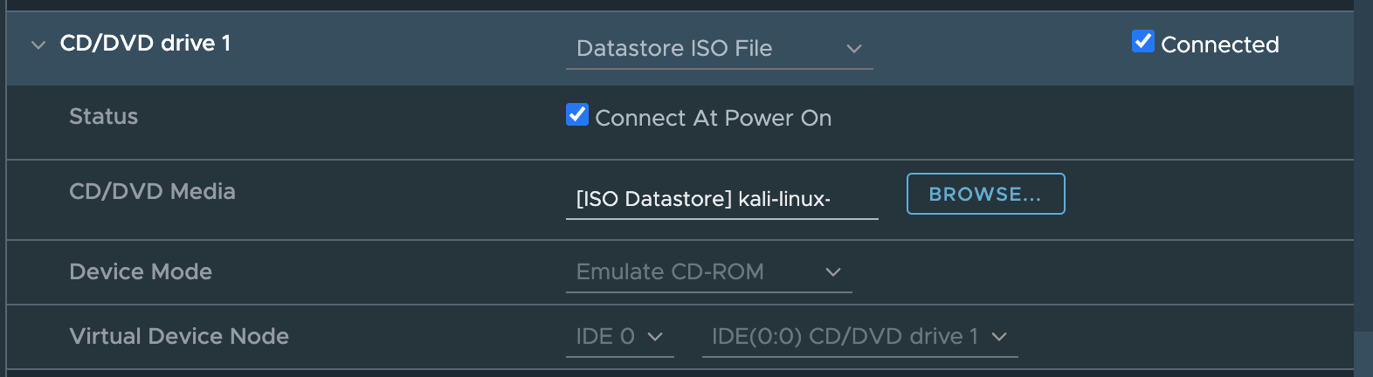

In step eight, all you have to do is look through the summary page and click Finish.

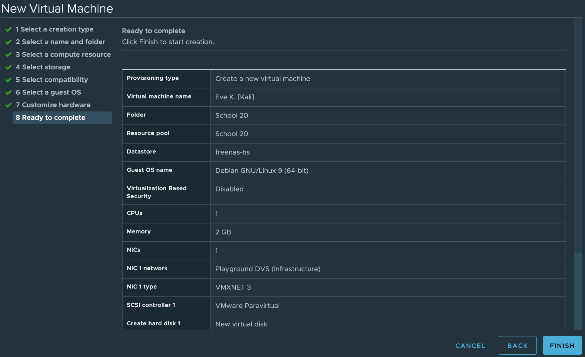

Starting Your VM

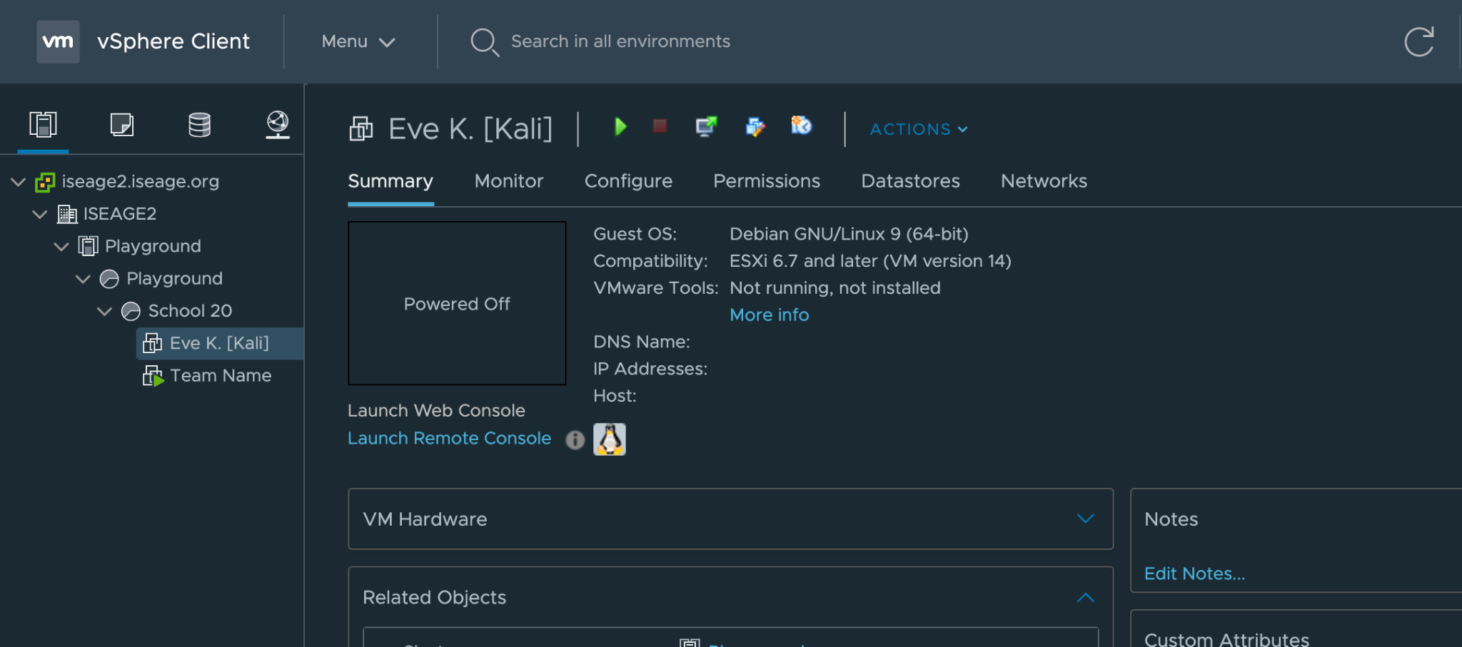

Your Kali VM should now be visible on the main page of the playground. Now click on the green play button on your own machine and then click Launch Remote Console. This will open up a new window in your browser, and we will begin the installation process.

A blue menu is the first thing you should see, it is the Kali Linux installer menu. Use the arrow keys to move down to the Install option and press Enter.

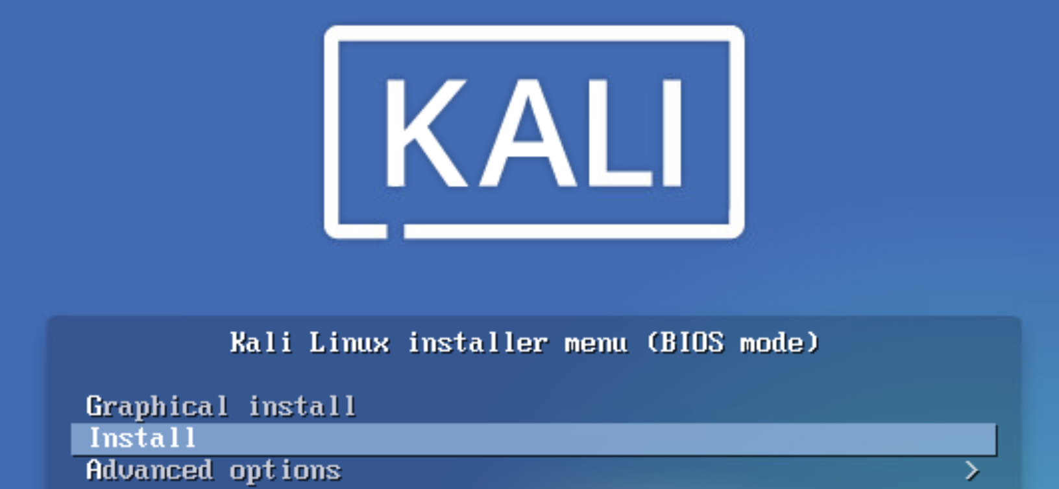

In the language select screen, select English and press Enter.
Select the United States as your geographic location.
Select the American English Keyboard layout and press Enter.

After those last three steps, you will see a loading screen similar to the following...

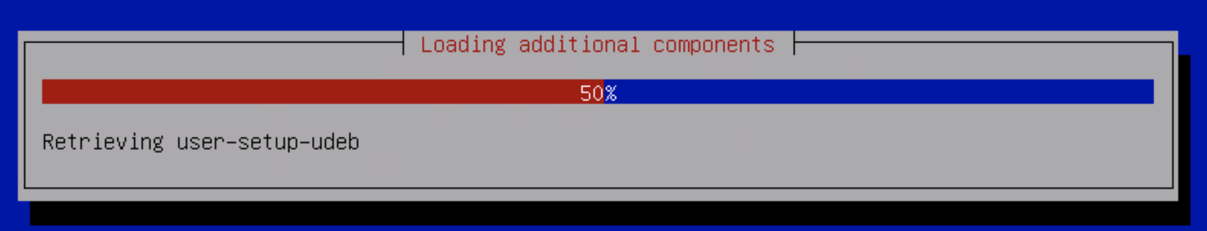

You will get an error stating that the network autoconfiguration failed. Which is OK. We will take care of this later. For now, simply press Enter. And then select the Do not configure... option in the following screen immediately after the error.

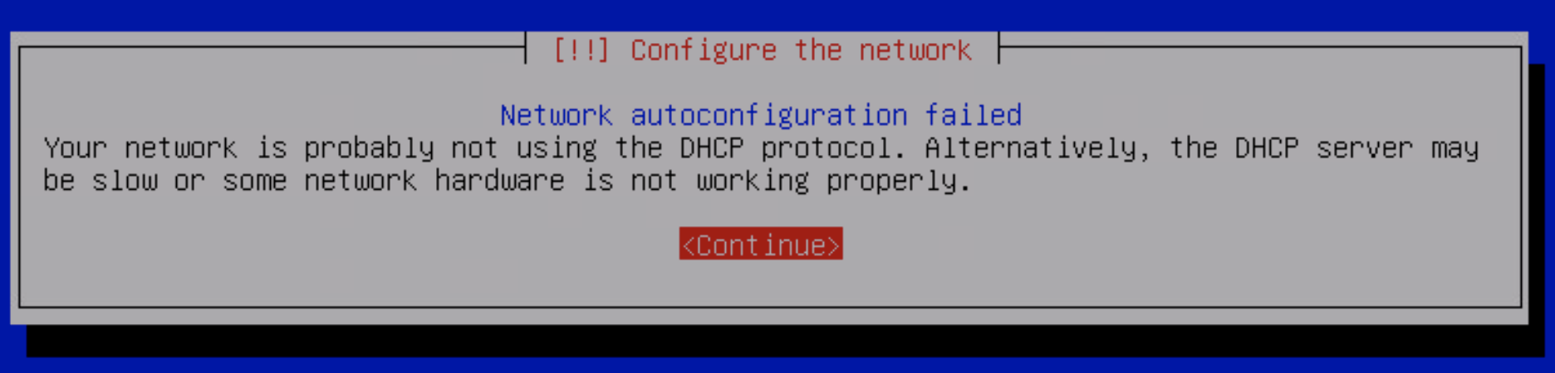

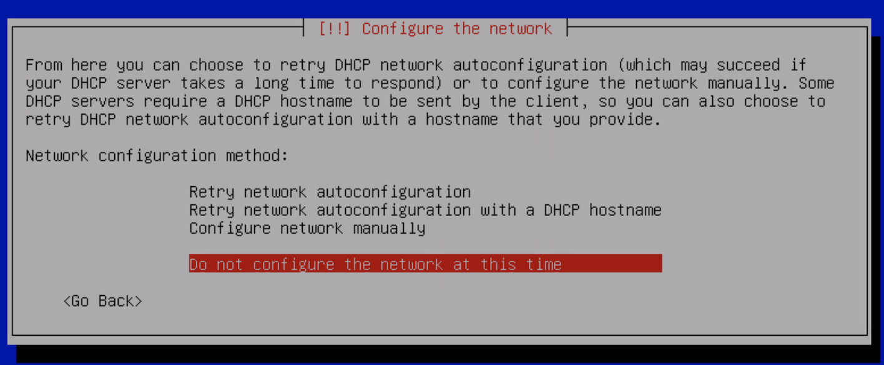

Choose a hostname for your Kali machine. Continue to the next step.

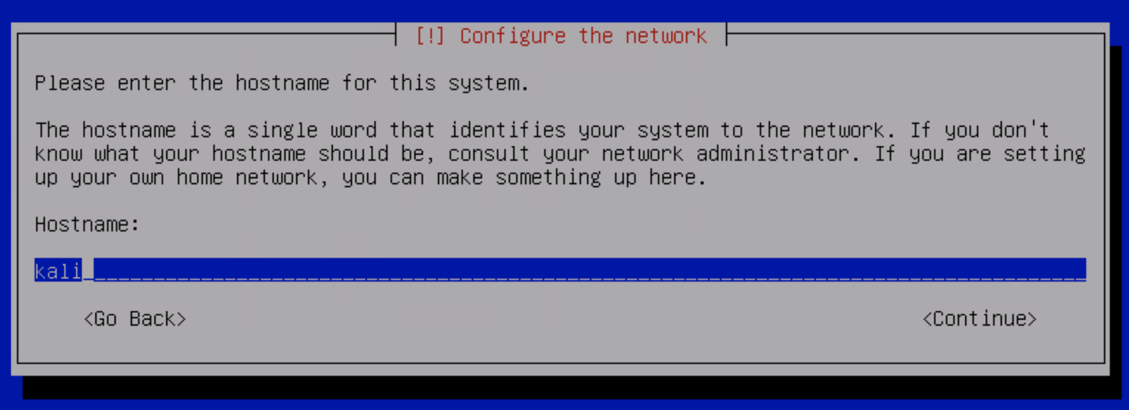

In this step, enter a name for the new user. It’s not important that you enter your full name.

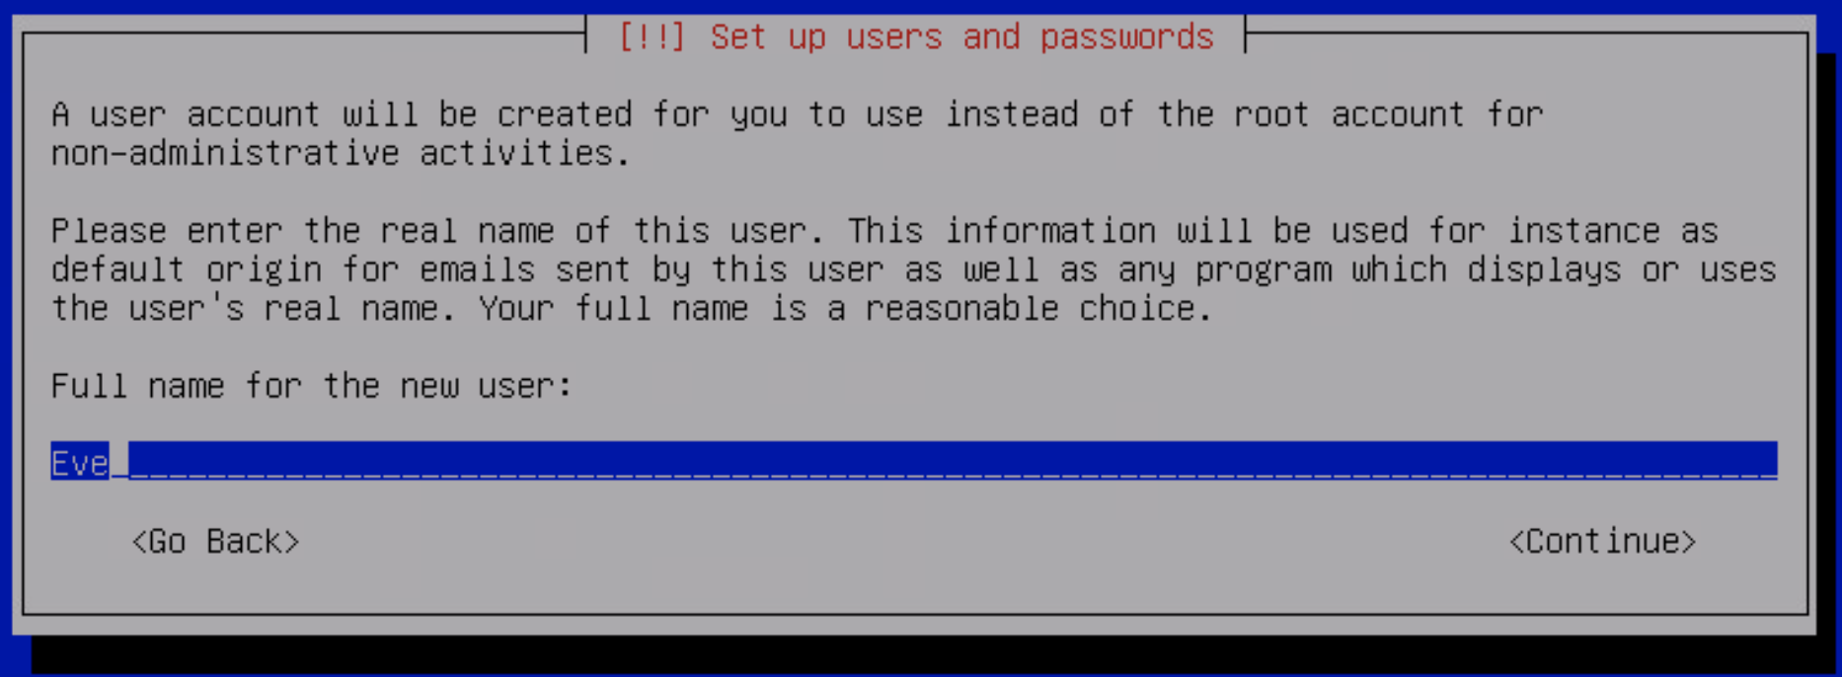

Select a username and proceed to the next step.
Please write it down!
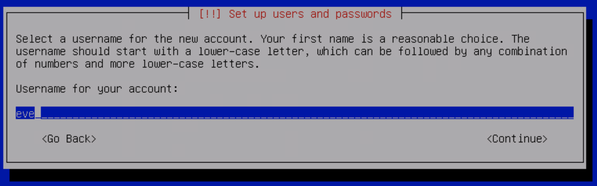

Enter a password you can remember.
You will need it soon. So make sure you scribble it down somewhere!

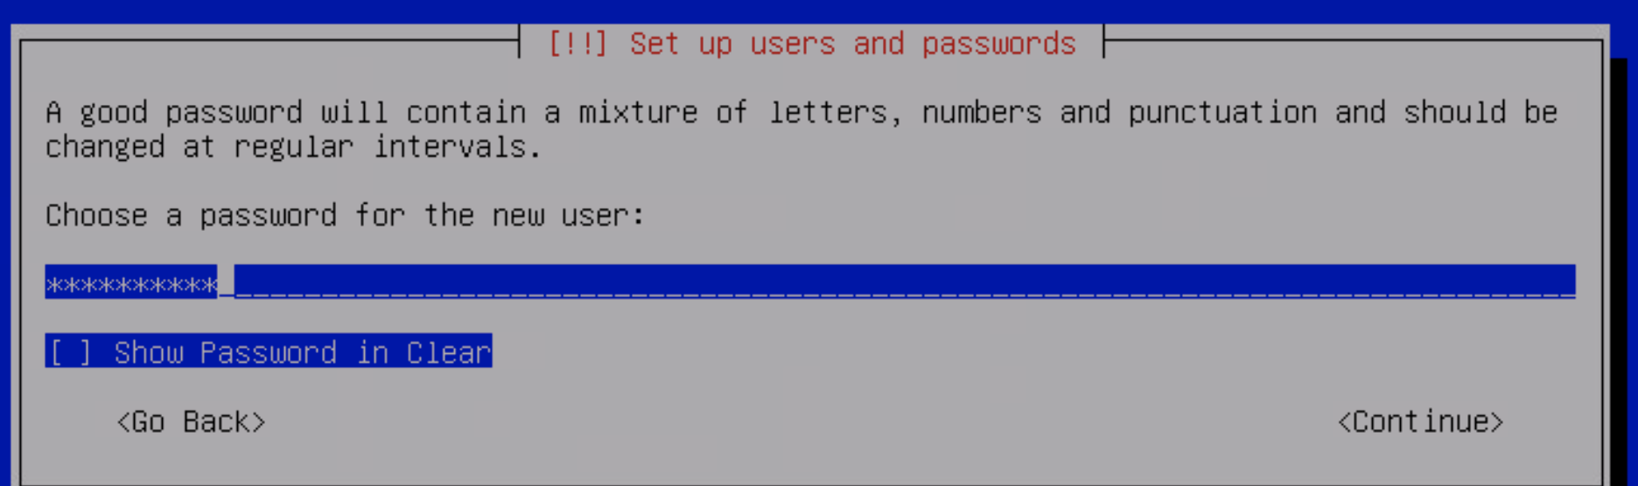

The next step will ask you for your time zone.
After selecting central time, you will be asked about Partition Disks. Select the option where you use the entire disk.

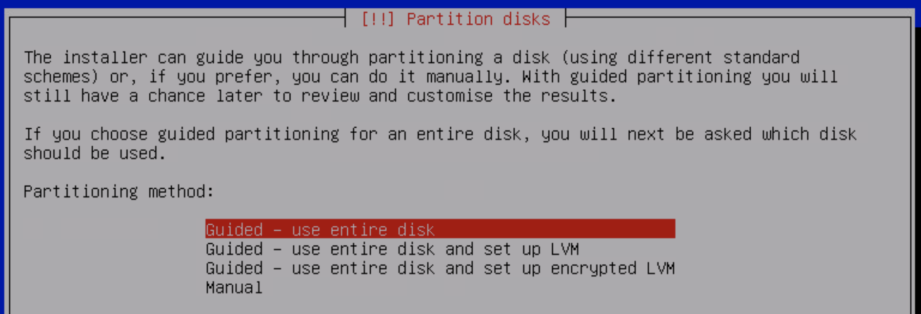

<Continue>, it's the only option available.

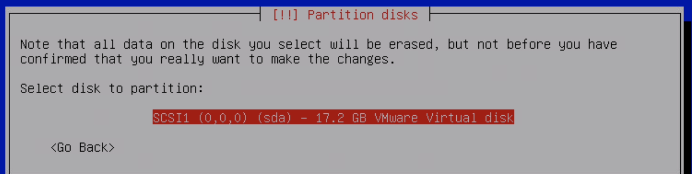

Select the best option for new users.

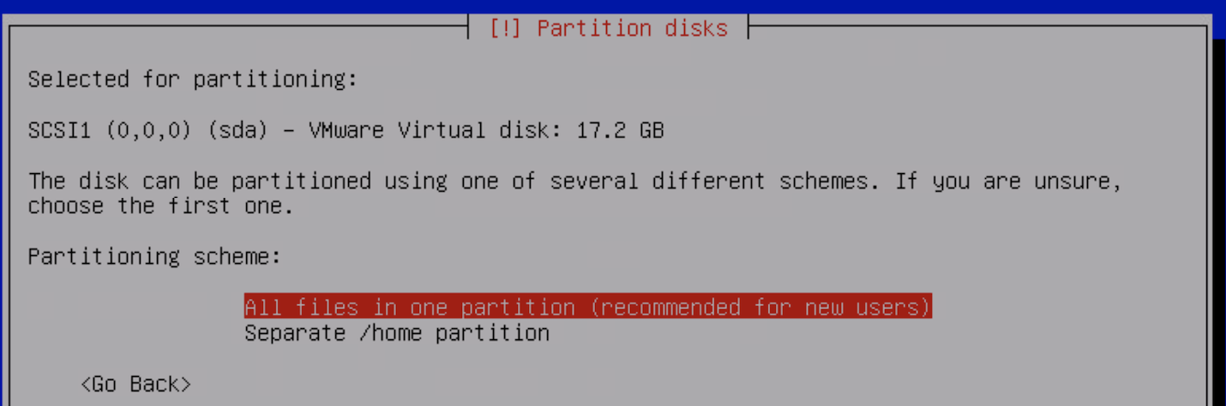

Hold on a little bit longer, we’re almost done! On this screen, write the new changes to the disk and press continue.
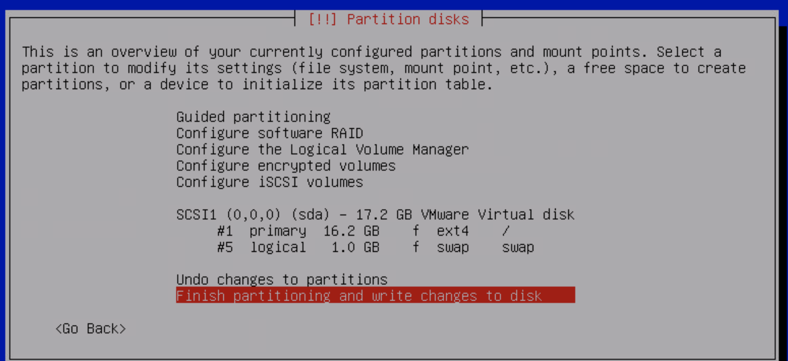
Write the changes to disks? Yes.

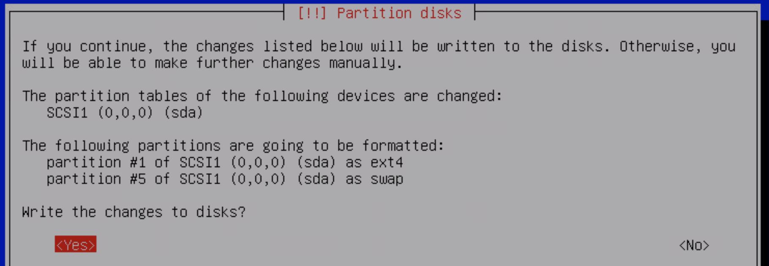

Configure the package manager to continue without a network mirror.

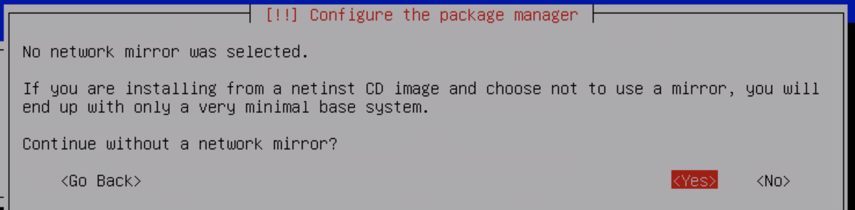

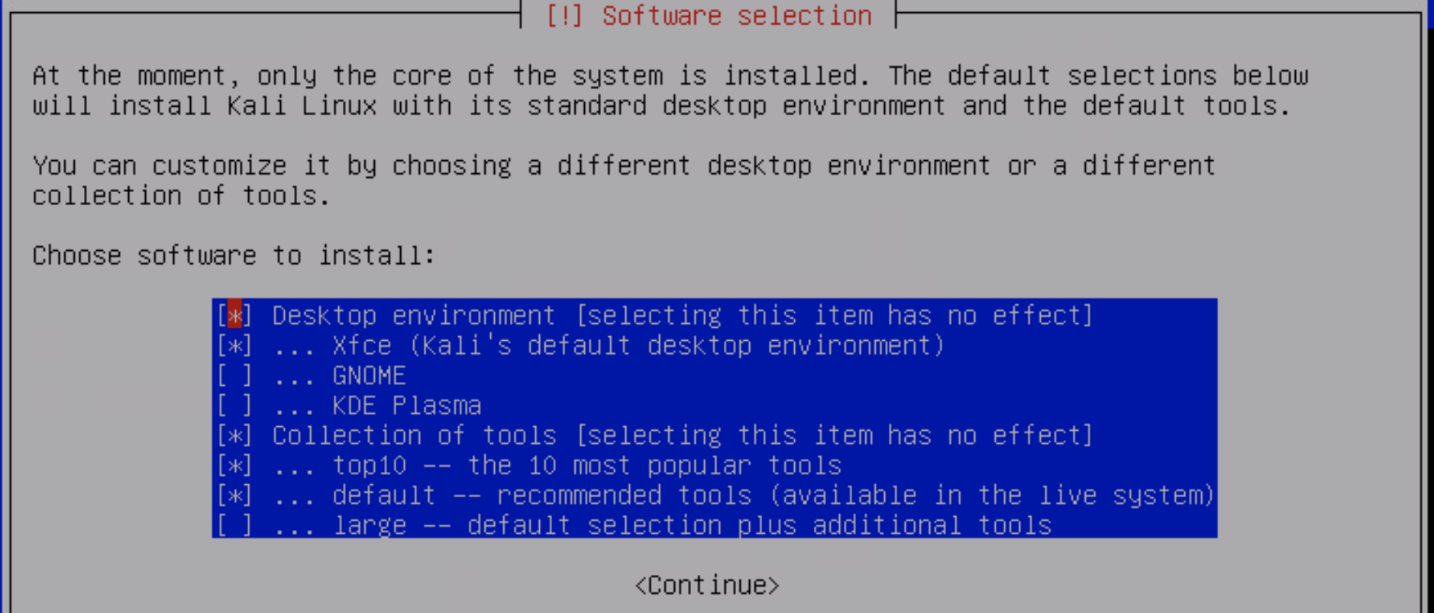
Keep the red bubble on the first option and continue.

The following screen will then show up and the installation process will take about 15-minutes to complete. Sowwy :(

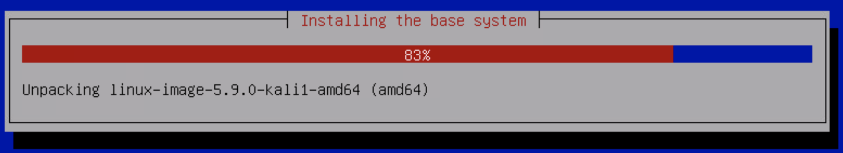

Select Yes when asked if you want to install the GRUB boot loader to your primary device.

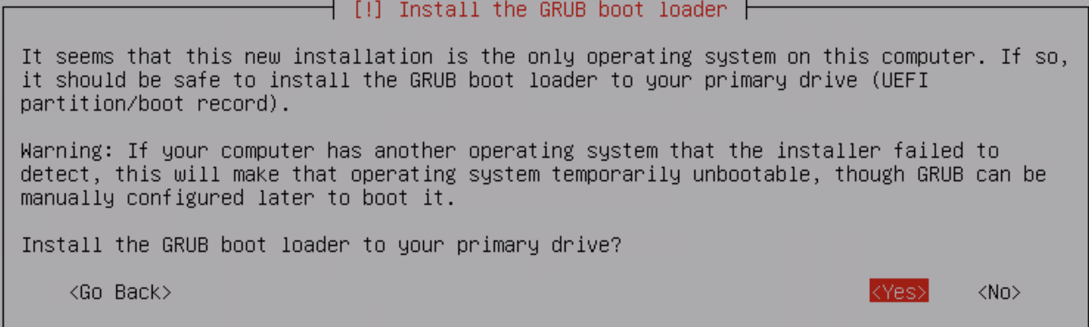

Select the /dev/sda option.
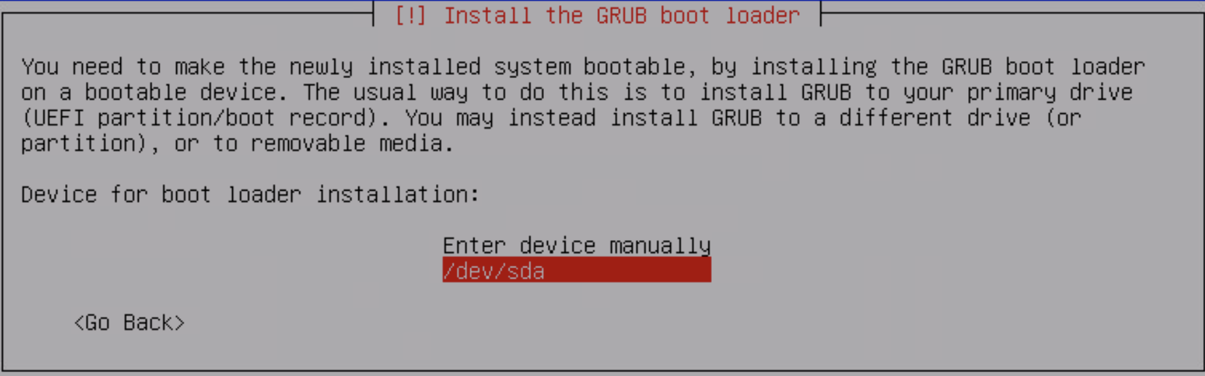

Installation complete. Press Enter to continue. You will then be redirected to your machine’s boot-screen prompts.

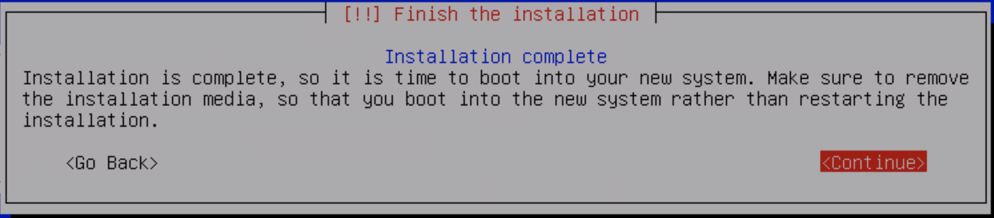

Enter your credentials from before to log in.

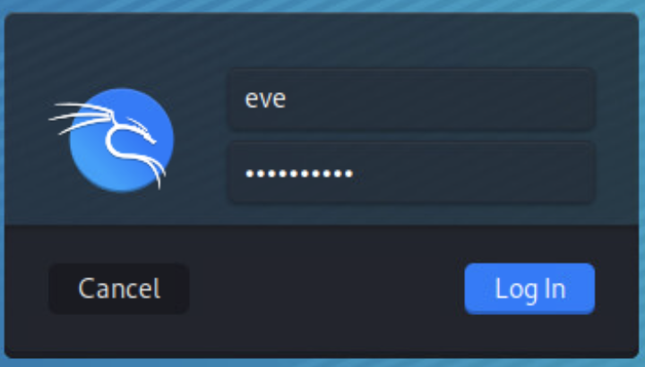

Congratulations! Your team has successfully installed your very own Virtual Machine running Kali Linux, one of the world's leading security platforms. Feel free to look around and explore this Linux distribution.

Note: To search for a program that is not immediately on your screen, click on the blue dragon icon on the upper left corner to view a menu.

