ISELab Scavenger Hunt
Module 2 | Activity 1 Key

Task #2: Capture your school username and password from your teacher/sponsor.

Username: varies Password: varies

Task #4: WooHoo! You have cracked into ISERink! Now it is time to search high and low for the Playground.

Answer the following questions by searching through the tabs. . .

How much memory is free in the playground? 186 GB

What is the number of Total Processors?
Two Dual Quad Core Processors

How many Tasks are there? Varies

How many Virtual Machines are there? Varies, but they would be located on the left hand side of the screen under your school name.

Task #5: Continue on the same path to find your School.

List at least two Alarm Definitions under the
Configure tab.
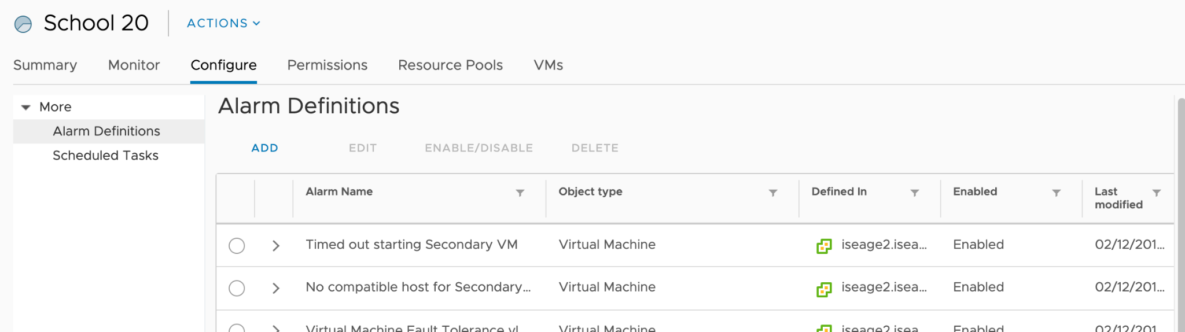

Task #6: Hey you! Here is something new! Find the Menu!

What are all the shortcuts provided to you?
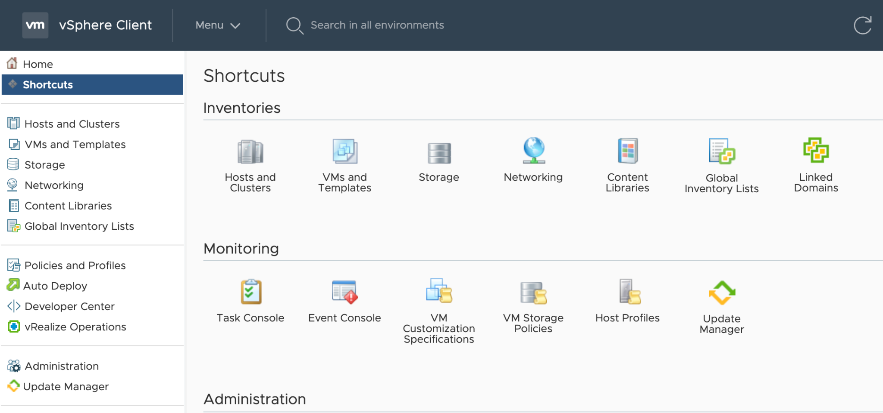

Task #7: Do not stop here! You are almost there!

In the menu dropdown,list all the shortcut commands here.
(i.e) Home : ctrl + alt + home
