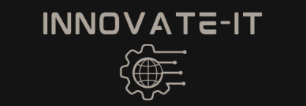

Practice CDC
Module 16 | Stage 1

Introduction
For the Practice CDC, your club will be split into two teams. This can be done by your advisor or by choice. The Practice CDC will take 2 weeks minimum to complete. The first 2 weeks will be Stage 1, and the second week will be Stage 2.

For this activity we will be explaining the steps of Stage 1. Stage 1 is a mock Setup Phase of the CDC. During the Practice CDC, each team will be using one person's virtual machine they have been working with all year. This machine should already be equipped with the softwares installed throughout the course of this venue. After choosing whose machine you will be utilizing for the Practice CDC, complete the following.

Getting Started:
This activity will guide Team 1 and Team 2 in setting up for the Practice CDC. Make sure NOT to share any of your machine's information with Team 2 as you will be competing with them.

Copyright © 2021 Iowa State University

- First things first, decide on whose machine to use.

- As routine, we are going to scan the machine for any gaps to patch up. This is a crucial step as we do not want the other team to find vulnerable points of entry to your machine. *You may want to change passwords if your group members are on other teams.

- Now it is time for the fun part! It is time to start placing some flags. The goal of these flags is to hide and protect them for the other team. The other team's job, in stage 2, is to try and capture the flags. These flags should be text files named as “Flag Number #”. You will be hiding 5 flags total. Each flag will have points of either 2, 2, 3, 4, or 5. You will give points to each of your flags by typing the point total in the text file. The hardest flag should be scored at 5 points and the easiest flags at 2. You can keep track of your flag below. *Make sure the other team does not find this information.

Flag Number # | Flag Location | Points

Copyright © 2021 Iowa State University

Copyright © 2021 Iowa State University

