Physical Security: Live Images
Module 13 | Activity 2
Introduction
Keep the slideshow in mind while completing this activity. Think of all the different ways you learned in going about trying to access a secure building. Everything ranging from exploiting weak electronic systems to simply trailing behind a person as they hold the door open for you. There are hundreds of other ways to go about this.
As an intruder, what is there to do once you have successfully trespassed? You wouldn’t just walk around aimlessly until you get caught. Your first move would involve locating a certain target, that being a certain person, object or in this case a computer and obtaining any necessary information before getting out of there as soon as possible.
In this activity you will do exactly that. You will play the role of a red team hacker by breaking into a computer with the use of a live image, and you will then assume the role of a blue team hacker that will be patching up your system to protect them from these types of physical attack vectors.
What exactly is a live image? A live image is basically an operating system contained within a USB flash drive or any other removable media. This live image, when physically connected to a computer, will run on top of the underlying operating system. It is then reduced to a mere collection of files, and can set new rules or permissions. The power behind a portable live image comes from the fact that it is able to re-write the rules of what can be viewed, edited or executed.
The operating system enforces the read, write, execute permissions that you learned about a few modules back. A live image is therefore your very own “government” that can enforce new rules upon the underlying system.
What you are doing in this lab is the real world equivalent of inserting a cd into your Windows computer and running Kali Linux on top of it.

Getting Started - Attack Phase
Go to ISELAB and open your Windows machine that you used during module ten. You will need to ensure that this machine has a password. At the end of this activity you would have cleared the machine of its password as a way to prove that your attack was successful. In my example I will be using my own Windows 7 machine named (W), and I will be clearing the password of user Johnny, (fire123).
Go to your Windows VM settings. You do this by right clicking on your virtual machine and selecting, Edit Settings.
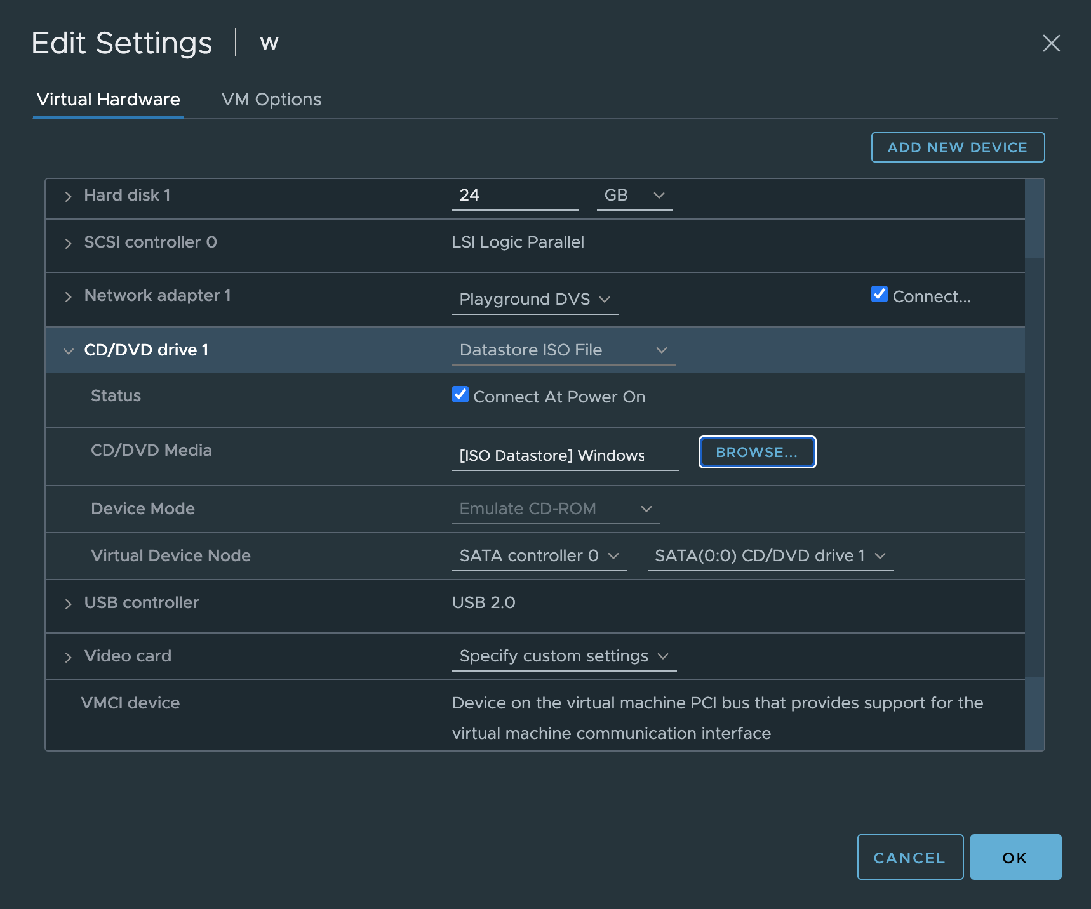

Under the CD/DVD Drive settings, (Datastore ISO File) should already be the default, if not, change it accordingly.
Now click on the BROWSE… button under the same tab. This is where we will be selecting the operating system that is going to run on top of Windows. A Select File prompt will appear, under ISO Datastore you will need to select the Kali Linux ISO shown below.
Kali-linux-2021.2-live-amd64.iso
If this exact version is not available. Feel free to select another kali linux amd64 version from another year. It will still work.
Click OK.
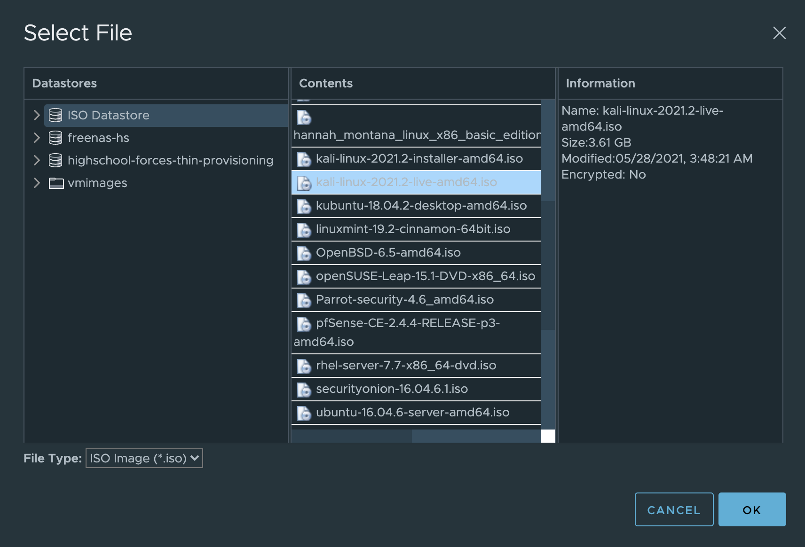

You should return to the main settings page where you will have to enable Connect at Power On. This ensures that the changes we made will be applied when we power on the virtual machine.
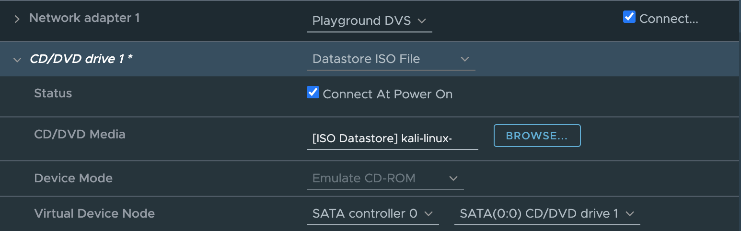
While still under the Edit Settings menu, navigate to the VM Options tab which is where you will find another tab for VM Boot options. Boot options are essentially settings you might want to configure concerning the start up process of your virtual machine.
What we want to do is to delay the boot process by five thousand milliseconds which is equivalent to five seconds. You will find out why we want to do this, shortly. Now press OK to exit.
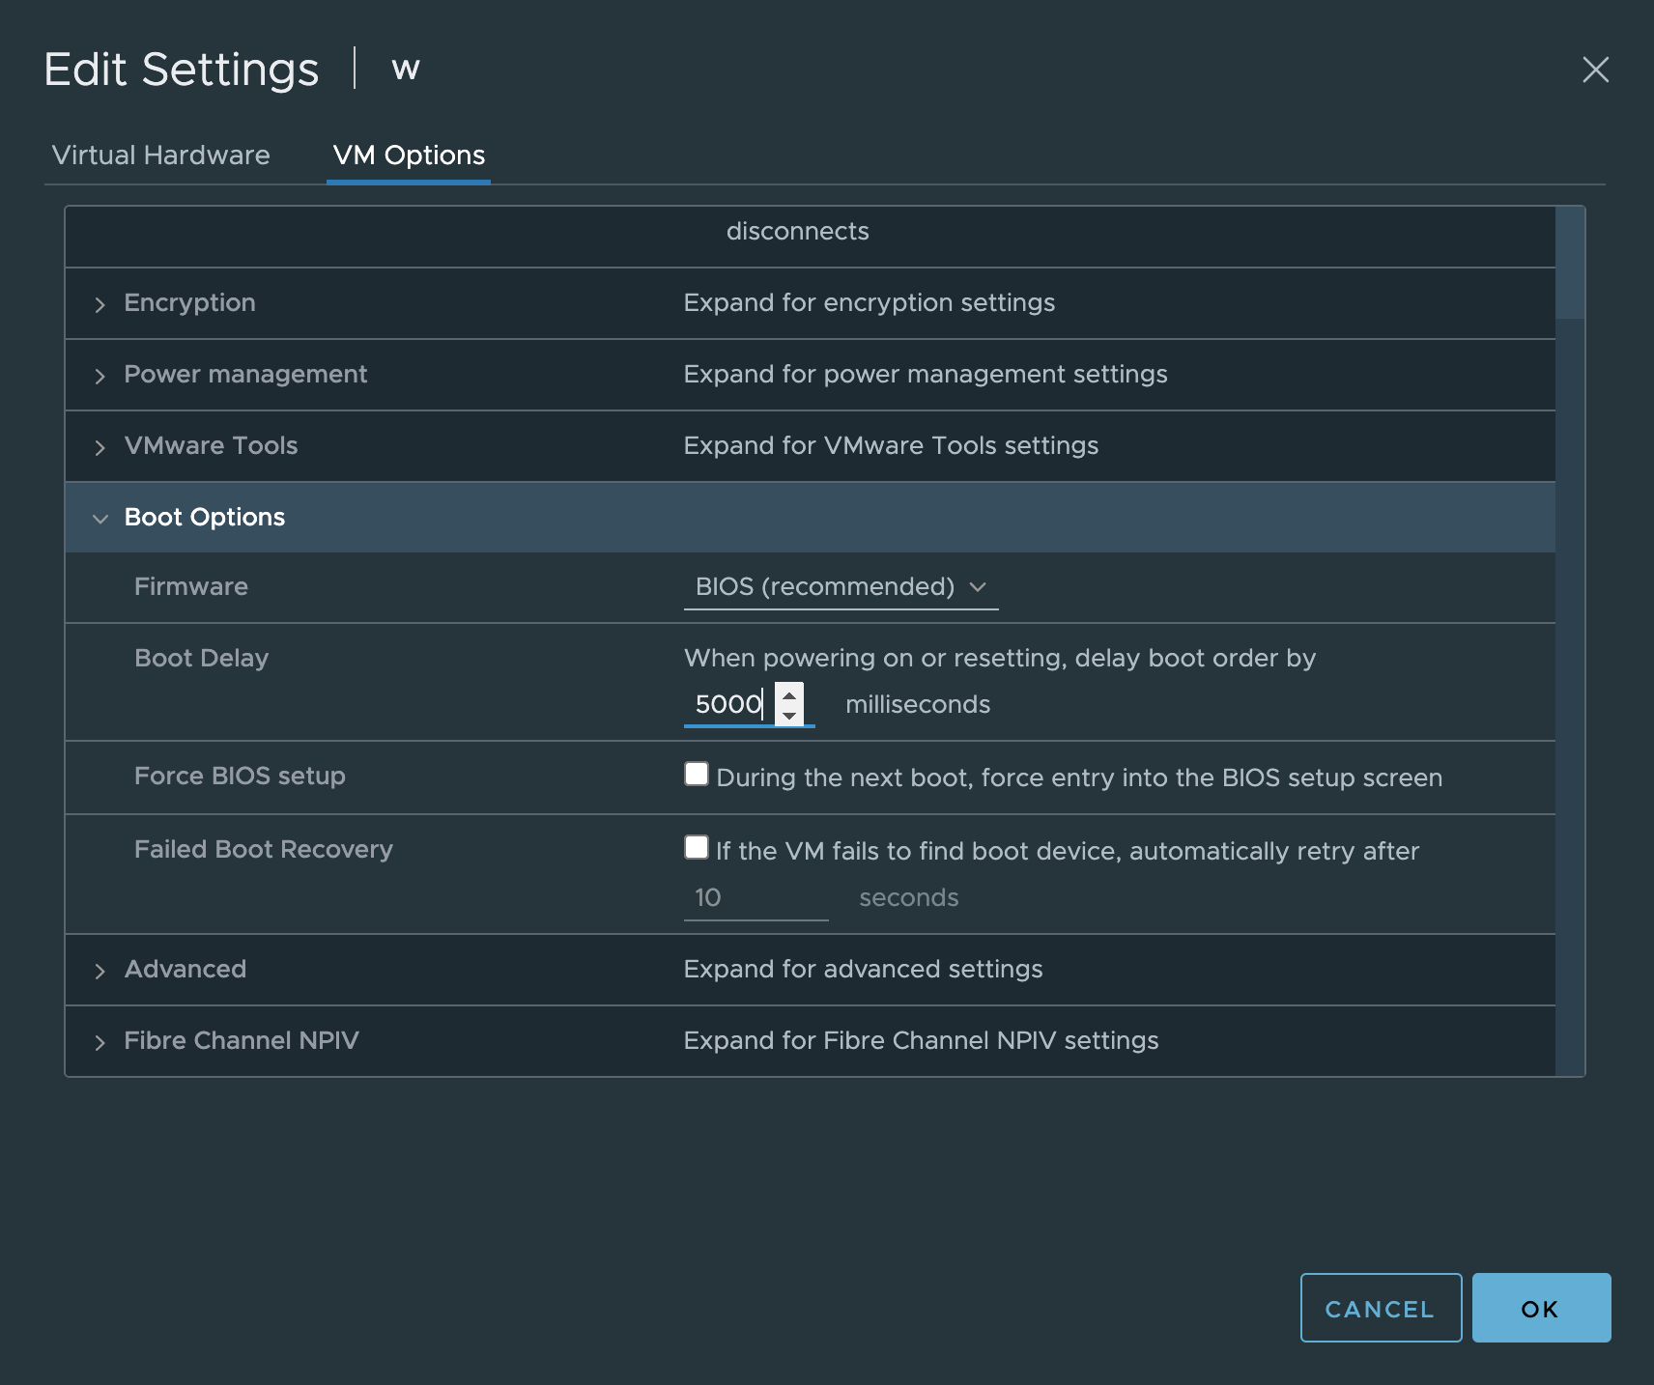

We are now ready to initiate the attack. You will want to do the following steps quickly, because you will only have five seconds.
Return to ISELAB and power on your Windows virtual machine and launch a Web Console as fast as you can. You will be sent over to the new tab where you need to press the ESC key.
You might have to click somewhere on the screen of your VM for it to start detecting the ESC key.
If you miss it, you will have to simply restart your computer and try again.
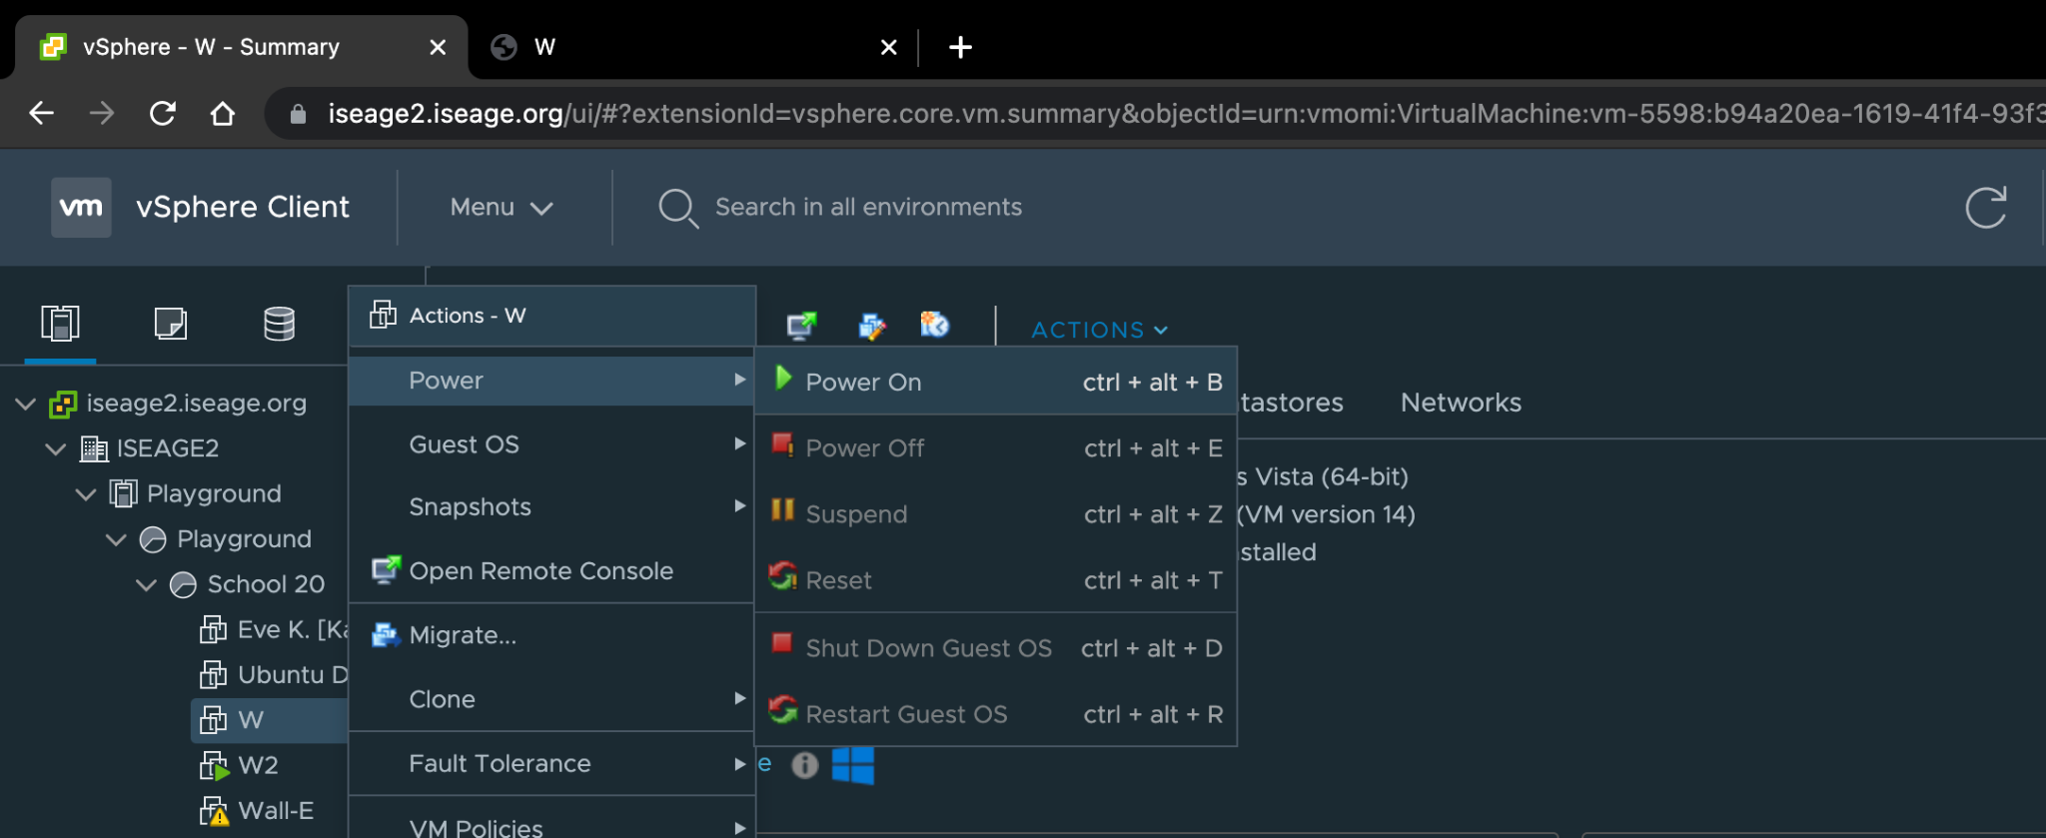
Hit ESC when you see this screen:
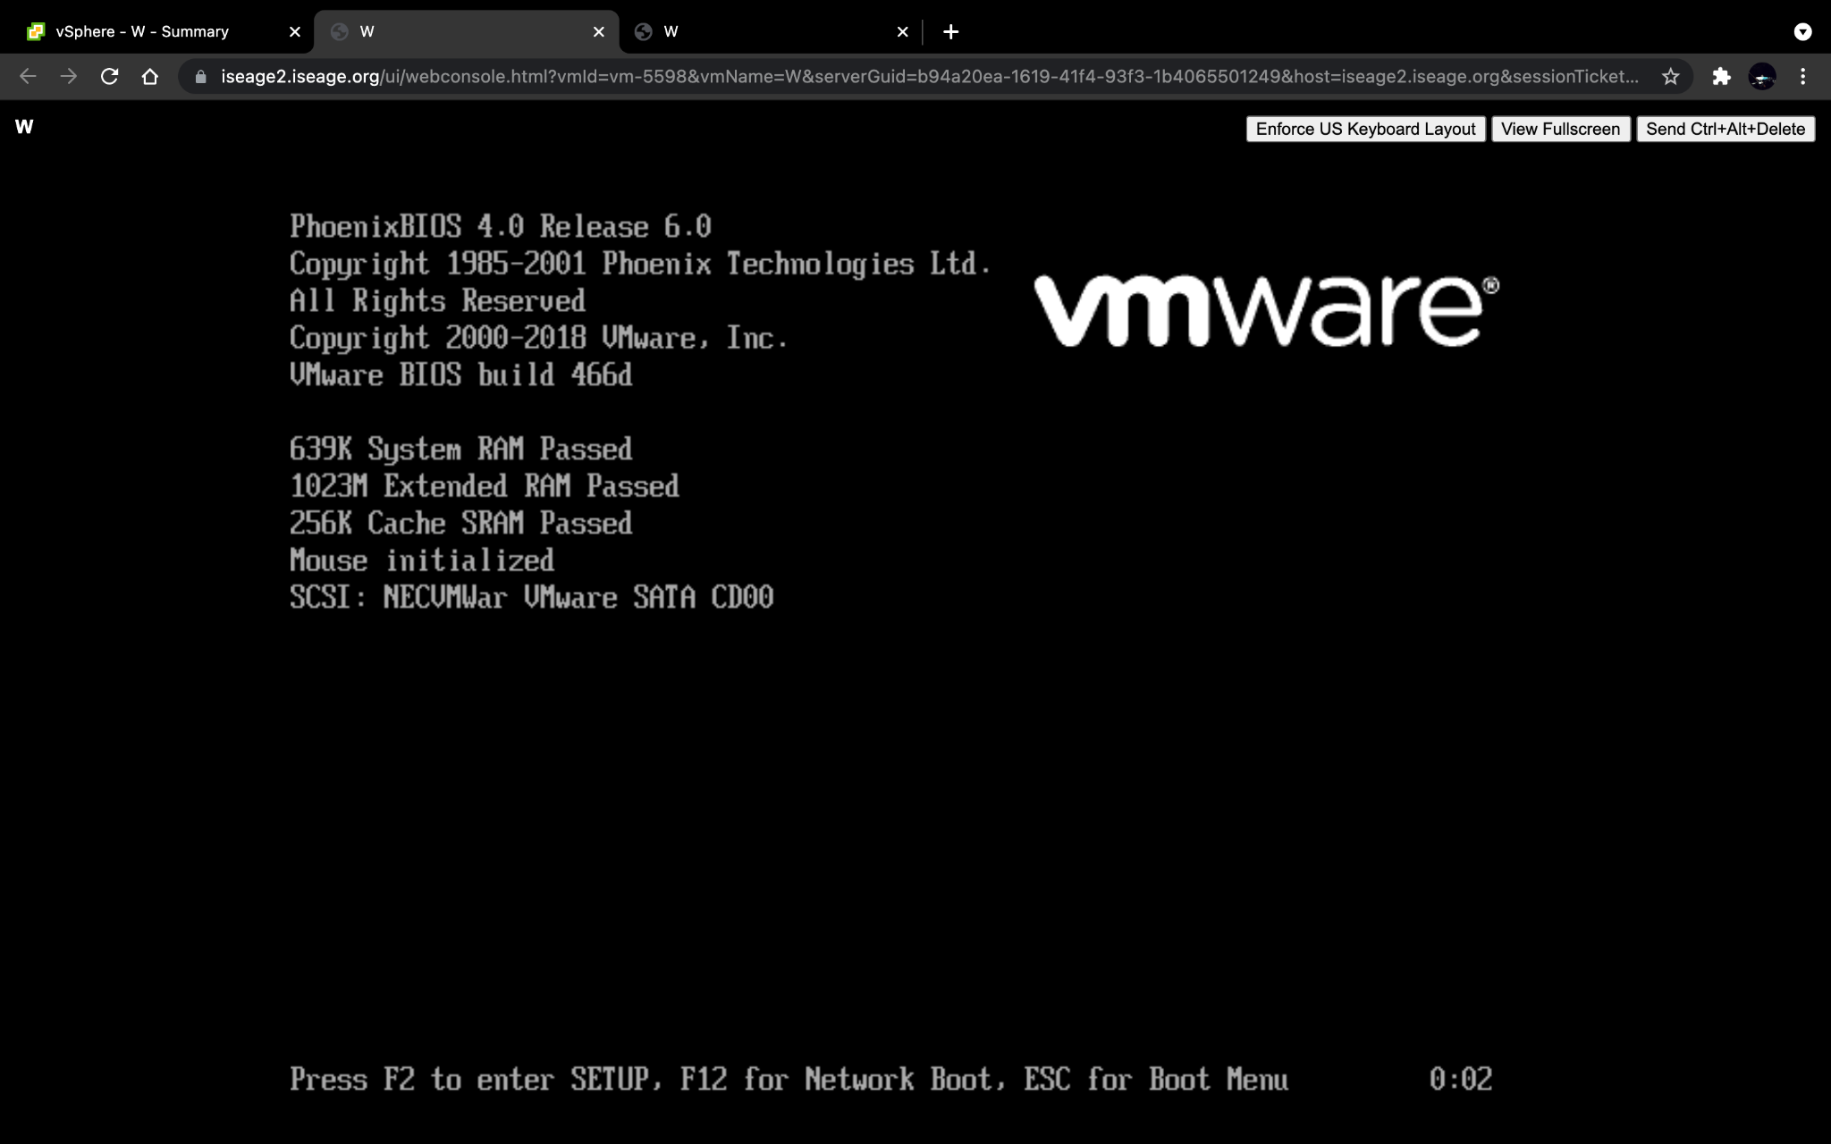

If you are successful.You should find yourself looking at the Boot Menu. This menu displays a list of options you can boot from. We will select CD-ROM Drive. Use the arrow keys to move down and press enter.
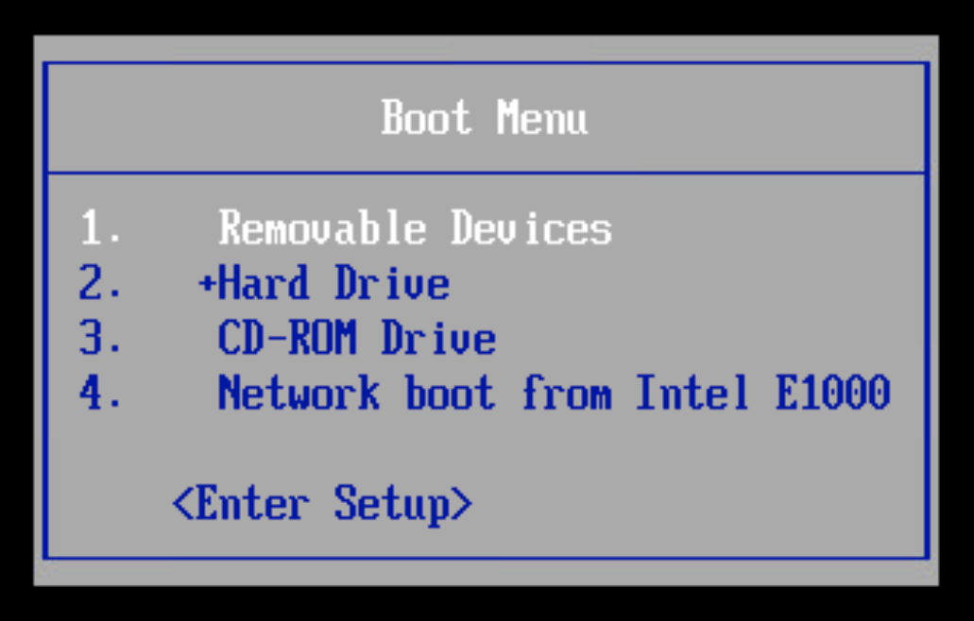
You will then find a familiar Kali boot menu. We only really care about the first option, which is regular Kali.
Press Enter on the Live (amd64) version.
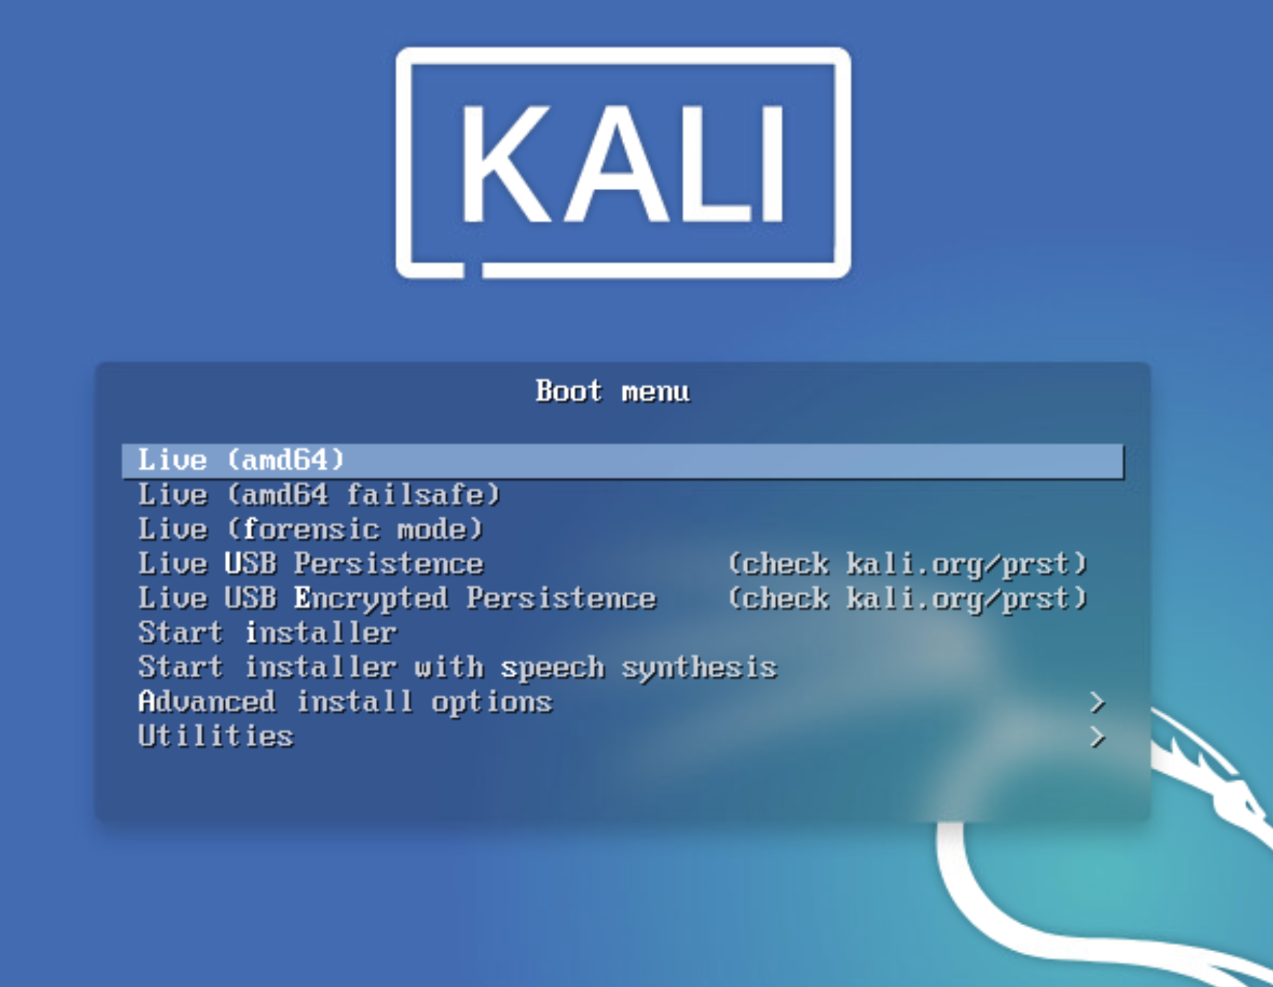

You will now be looking at a Kali desktop. Similar to those you interacted with in the past. Nevermind the little warning in the corner.
Open up a terminal.
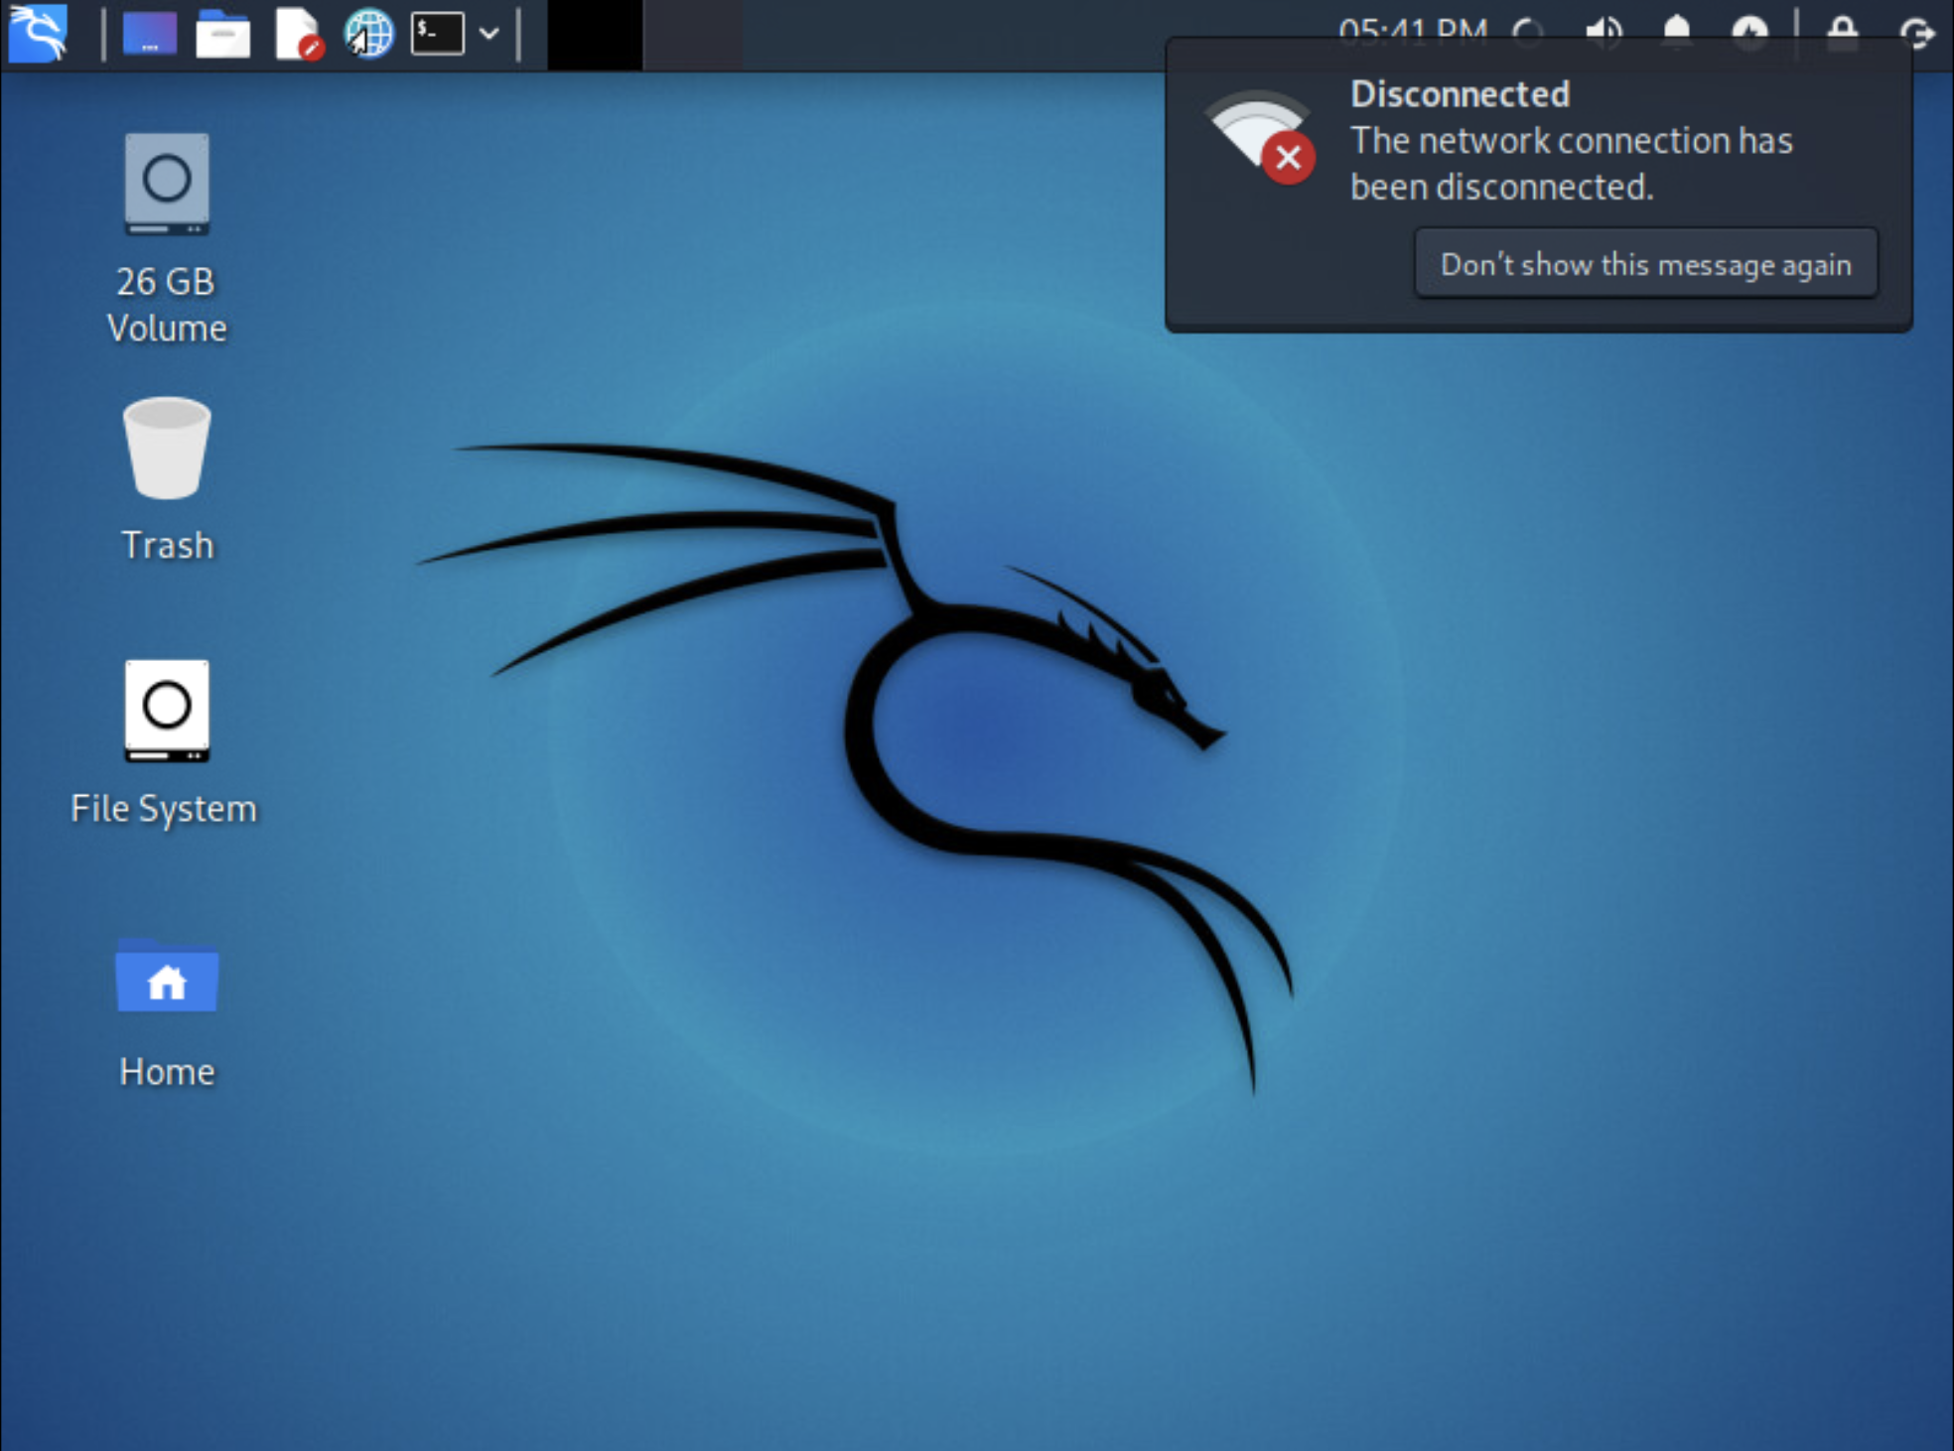
Within the terminal we want to know what “block devices” are available on the linux system. We find this by using the lsblk command. Block device examples include RAM-disks or CD-ROM drives. The sda block would be the underlying Windows machine.
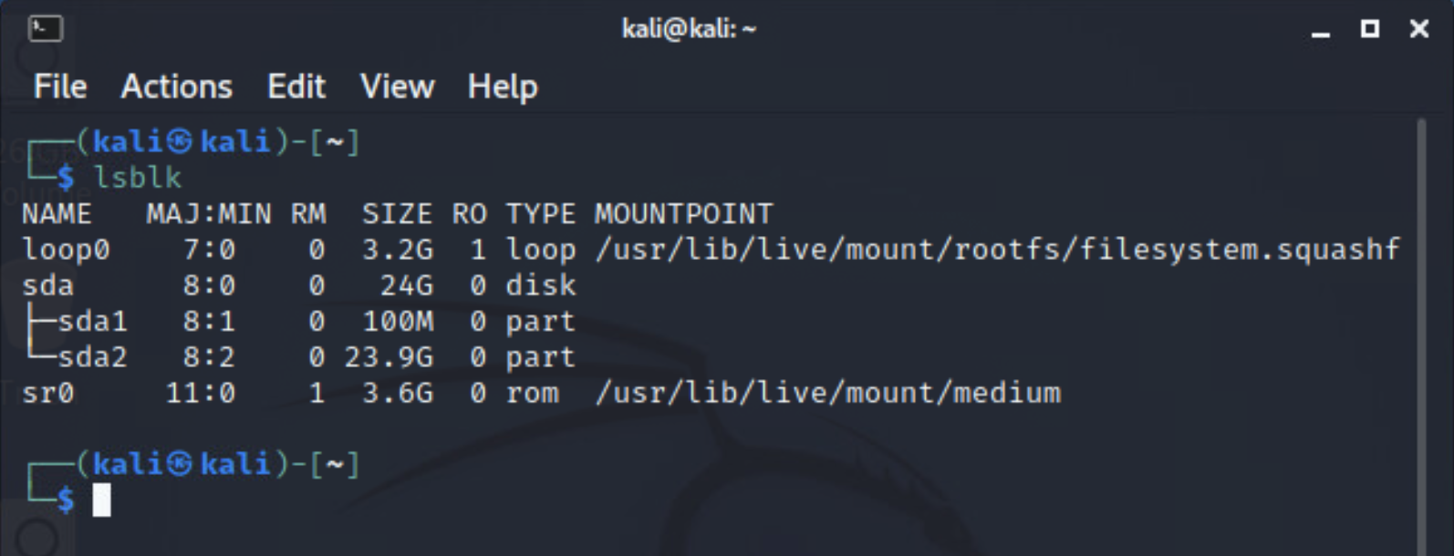

To be more specific, we want to access the sda2 partition. In order to interact with it, we have to mount the sda2 partition.
With the command: mount /dev/sda2 /mnt
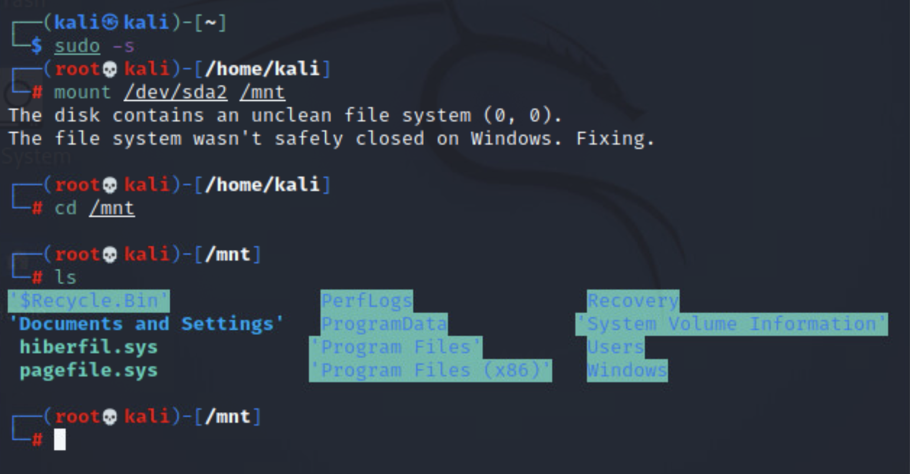
After the previous step we are essentially able to roam around the Windows environment. What we will be searching for is the Windows SAM file. The Windows Security Account Manager is a file in many versions of the Windows OS that stores user passwords.
Let’s navigate to the location of this file.
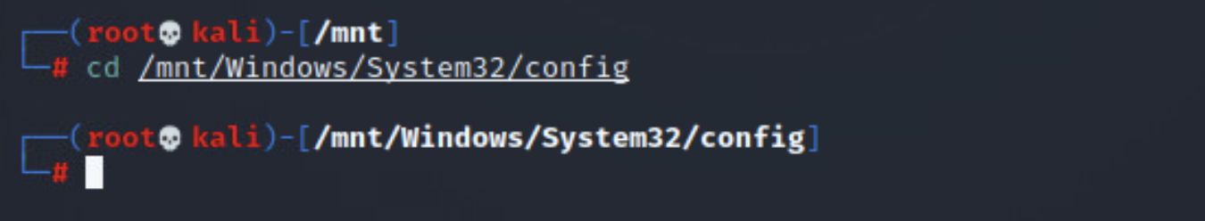

Once we are there, we are able to start deleting or changing passwords. In order to see what accounts exist we use the command:
chntpw -l SAM
There are only three accounts associated with my Windows VM, yours will look different.
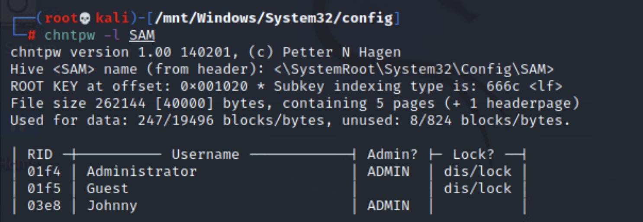
Now that you know what accounts exist you can add accounts, modify privileges, delete passwords etc. but for our activity lets remove Johnny’s password.
In your case this account will have a different name. But it's the same idea. Initiate the process with the following:
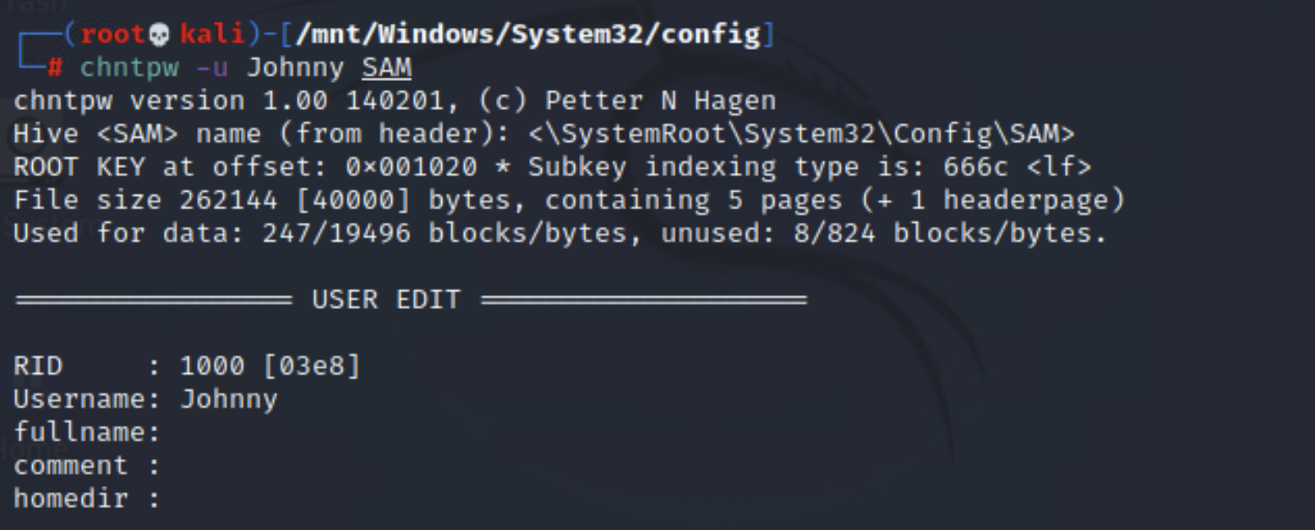

A list of options will pop-up, you will select the first one by typing the number “1” and pressing Enter. You should notice a Password Cleared message.
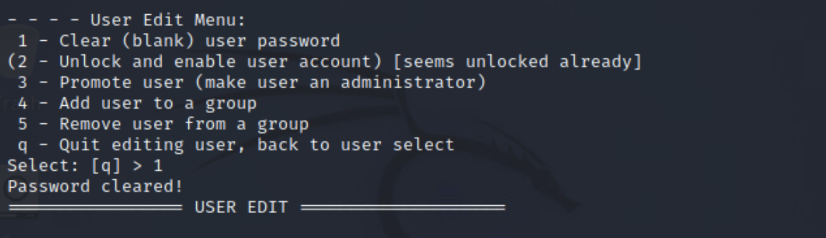
You will then type the letter “q” to quit and press Enter. As shown below...
If asked about writing hive files simply type in “y” for yes and press Enter.
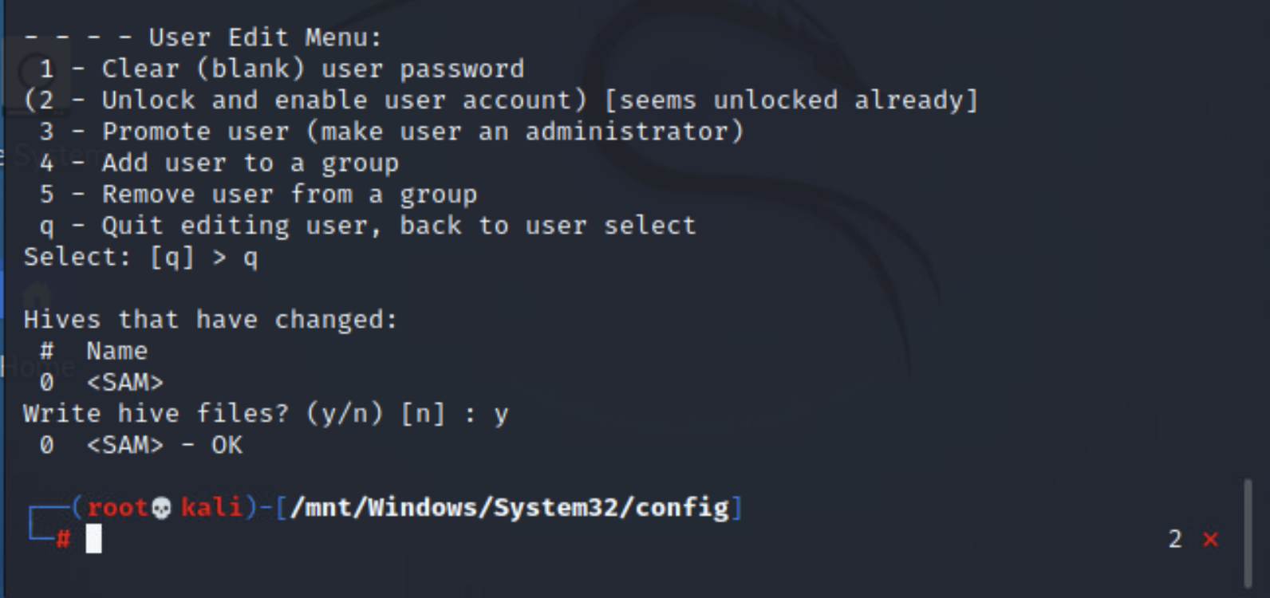
What we just did was remove the password for Johnny’s account without logging in as an Administrator or any other user on that computer. Which is dangerous in the real world.
You should now be able to power on this virtual machine and be automatically logged on as Johnny because his account is now password-less.

We can also prove this by running a previous command and taking note of the change. Notice anything different?
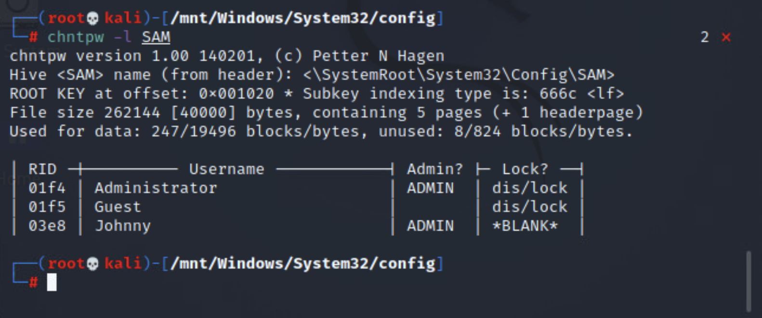
Dismount from the Windows system
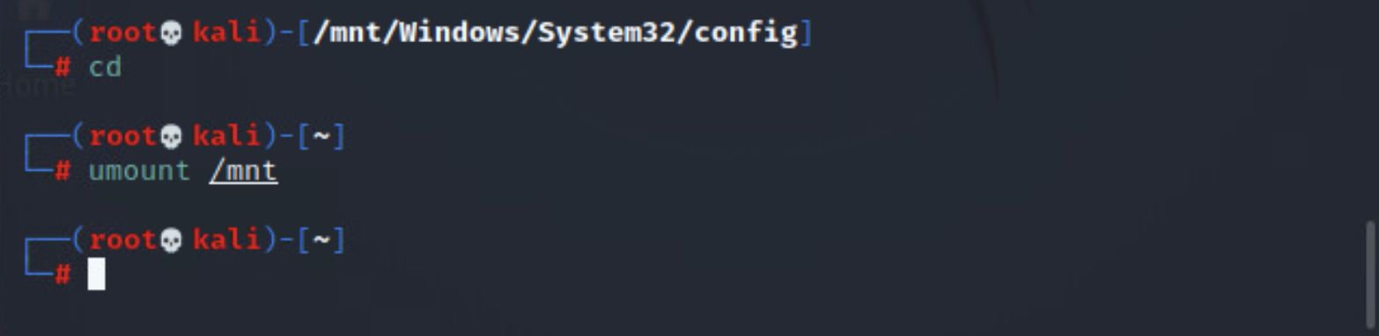
Now restart your virtual machine and see the change in action!
Don’t worry about pressing ESC this time. Just wait five seconds without pressing any key for it to boot normally.
DONE.

Defense Phase
In order to protect your computer from this type of attack, we need to lock down the BIOS/boot menu with an administrative password.
Computer manufacturers have their own reasons for not making this a default setting, which is why this has to be changed manually on your machine.
To protect your computer from a live image attack follow these instructions.
Return to this screen in your Windows virtual machine, which can be done by restarting your VM. The five second boot delay should still be in place. Press the F2 key to enter setup.
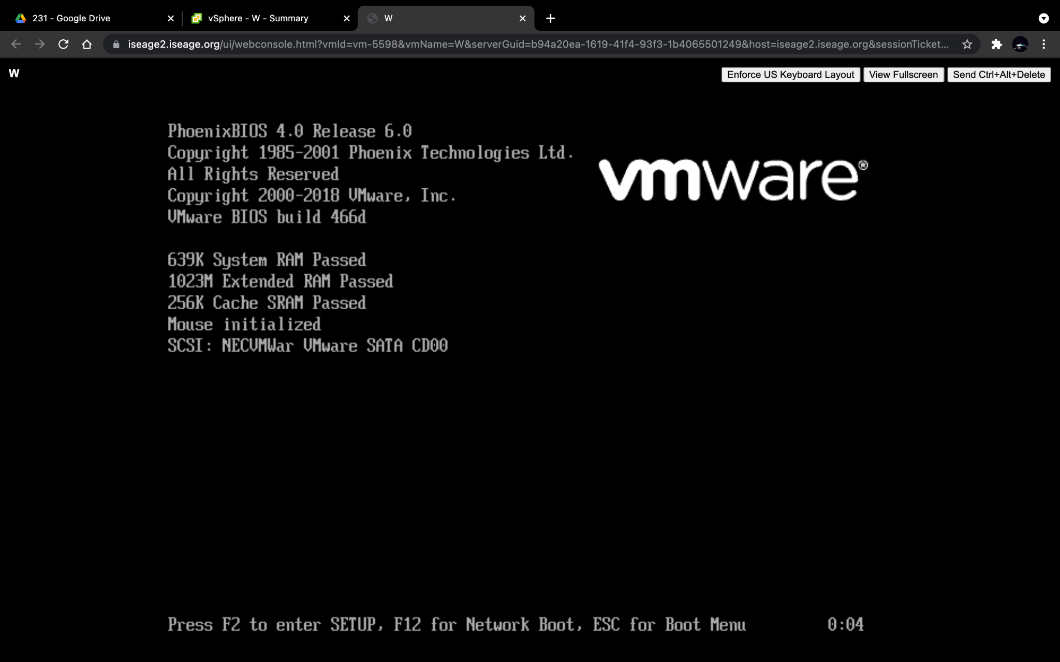

Once you press the F2 key you should find yourself looking at a menu that looks like this.
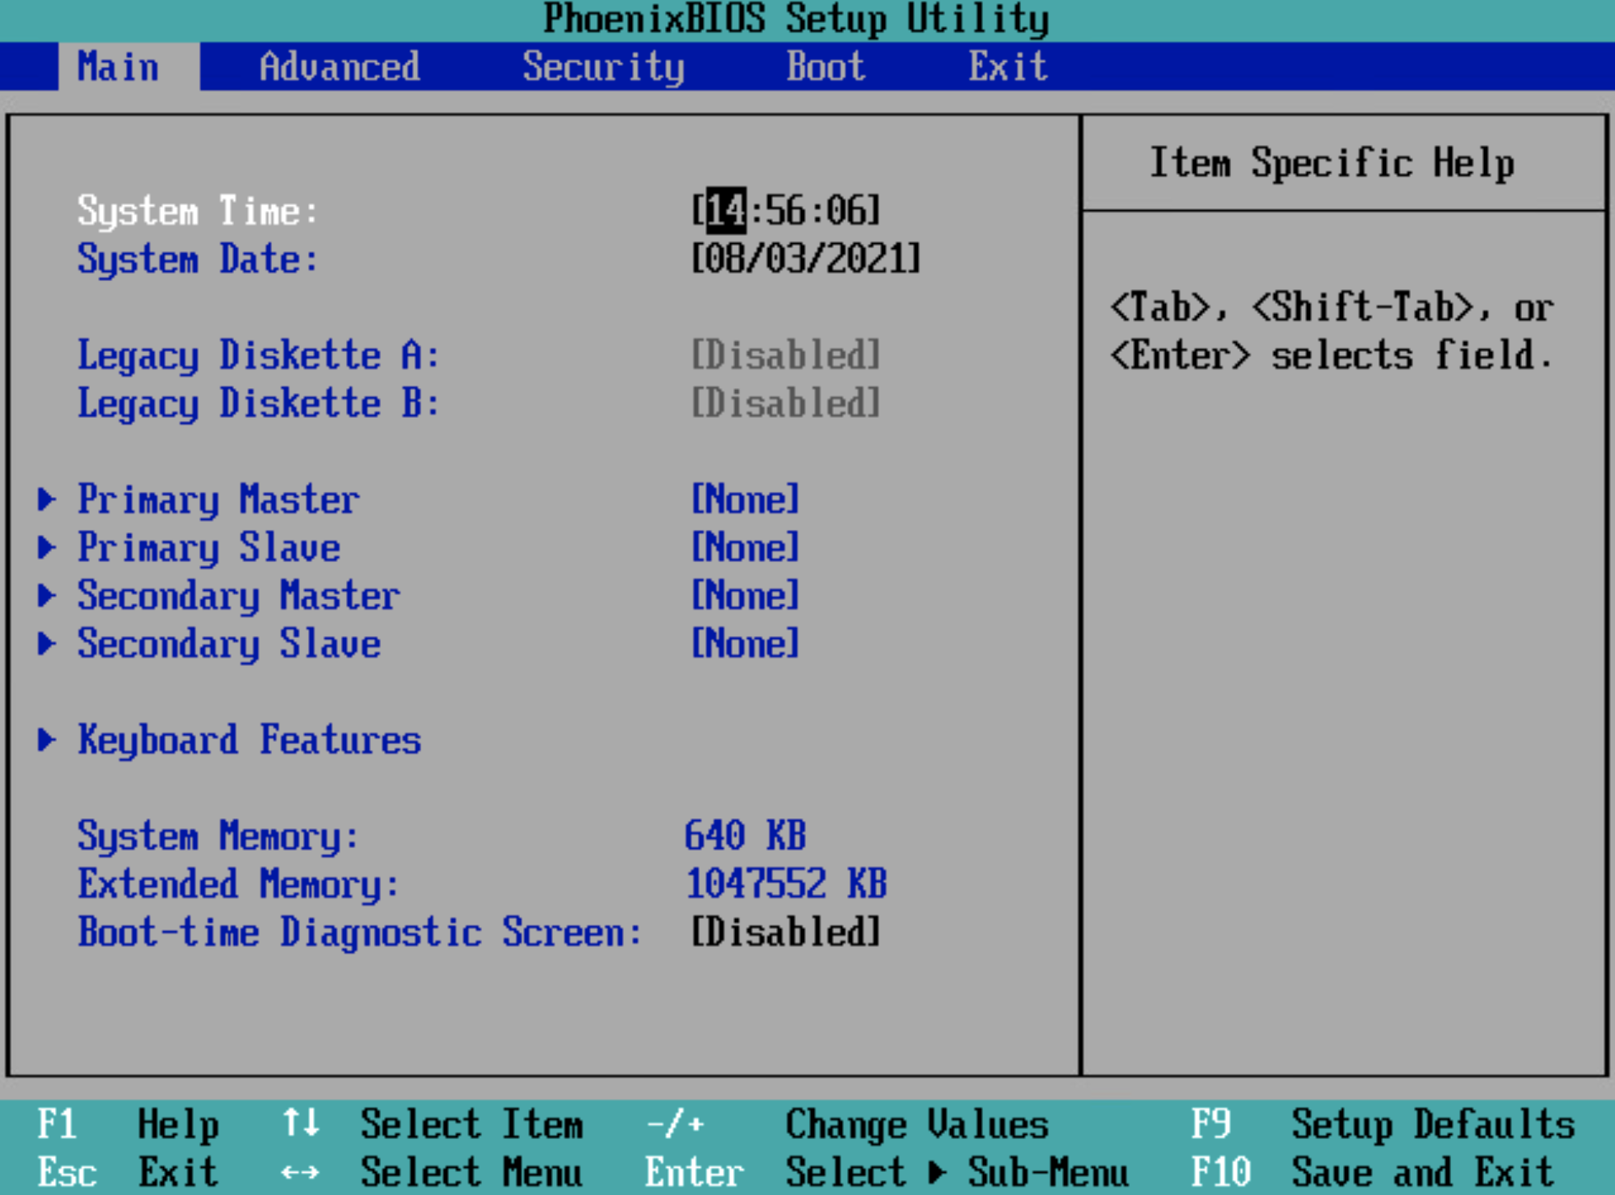
Use the left and right arrow keys to find the Security tab. Under security we need to set a supervisor password.
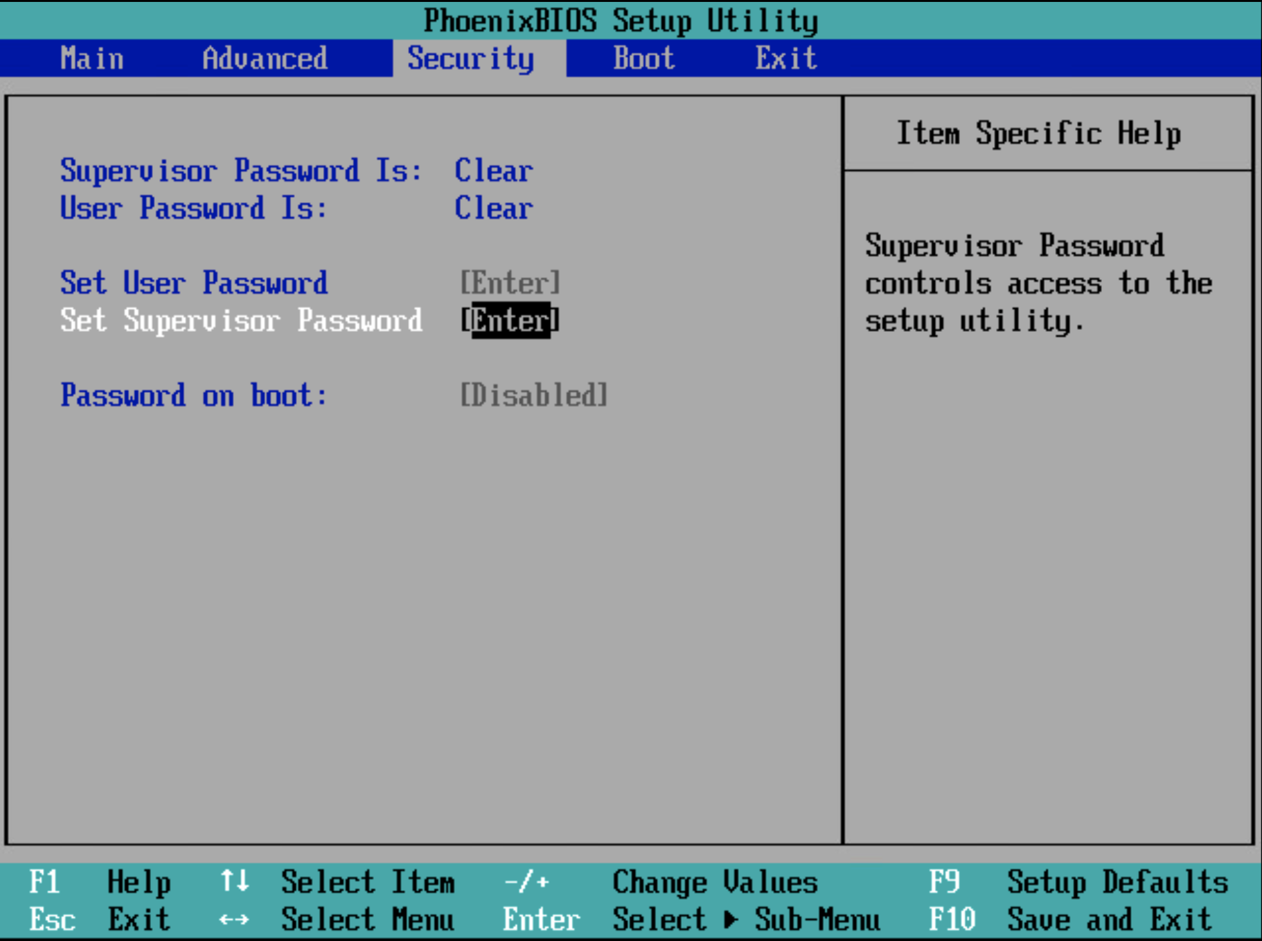

It is necessary to set both a user password and a supervisor password. The supervisor password controls access to the setup utility but the user password will control access to the system at boot. These should be different passwords.
Finally, enable the require a password on boot field. As shown.
Press F10 to save changes and exit.
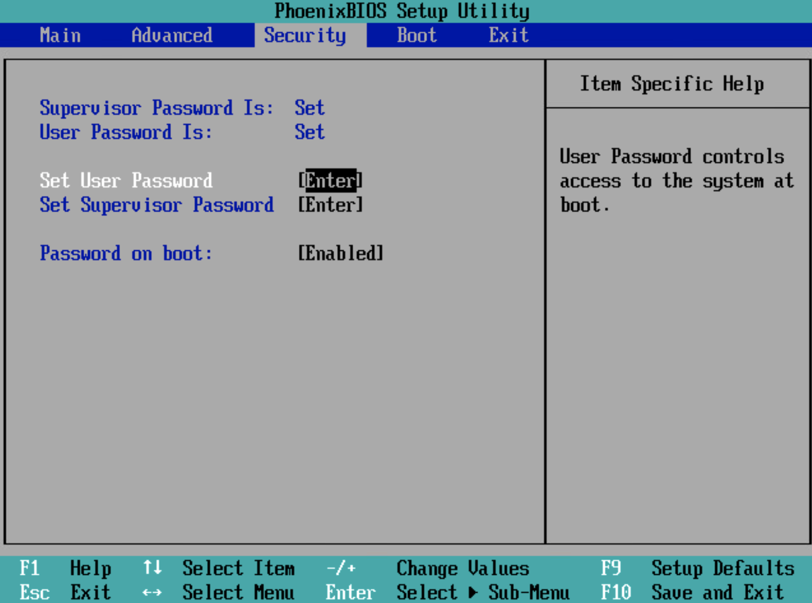
After this you are all set. Once you save your changes the system will reboot and you have a chance to test whether the new security features are in place. On the black VMWare screen press ESC and what you will find is an Enter Password field. This is the user password you set in the last step.
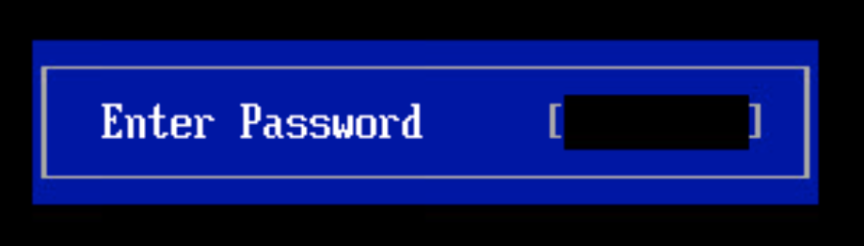
DONE.

