Career Fair
Module 12 | Activity 2
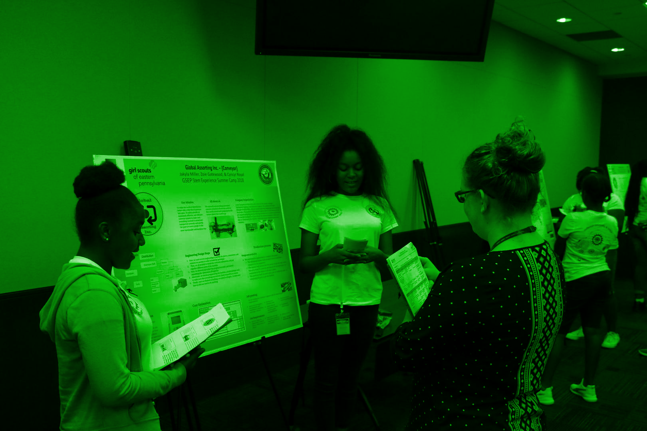
Introduction
You learned in the Module 12 Slideshow that cyber security is a rapidly growing field. There are many job opportunities in the world of cyber security that can intrigue a variety of students. Module 12 Activity 2 will help you as a class/club discover a cyber career that interests you the most.

Getting Started
This activity will have each team research a variety of different cyber security careers. We will start off individually by taking a quiz to determine if cyber security is a good fit for you. Then we will have each team select a career to research. Each team will present their findings to the class/club, so everyone can grasp an understanding of many different careers. This activity is meant to be a fun and simple way to explore jobs in cyber security, and get you thinking about your own path.

- First, let's take a few minutes individually to find out if cyber security is the path for you!
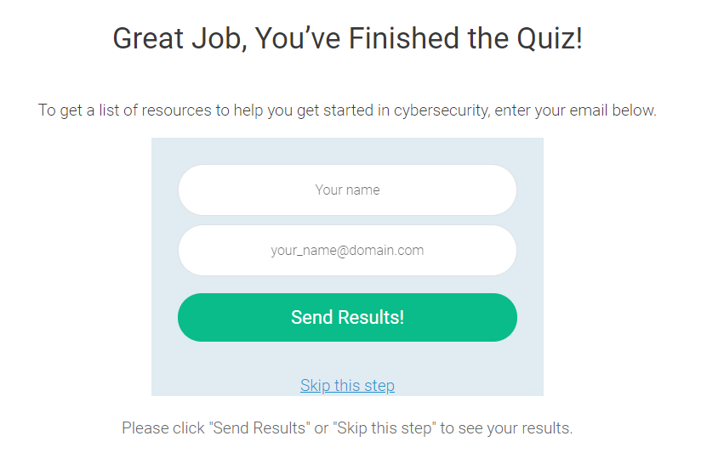
Head on over to the [Link] to take the Cybersecurity Quiz. This quiz will ask you a few questions to determine if cyber security might be an interest to you. The results are not the end all be all, so it is encouraged to follow your passions! After you have finished the list of questions and reach this page, click “Skip this step” to see your results.

- Once you have completed the quiz, hop on over to Ten Entry-Level Jobs in Cybersecurity as a team. Scroll on down to the section titled “Ten Entry-Level Jobs”. You will see a list of 10 cyber security careers.
  - As a team, skim through the careers and pick which one interests you the most. Tell your teacher/sponsor what career you would like to research. This is a first come first serve situation.

C. After your team has selected/been assigned your career of choice, it is time to do some research. You will be given ten minutes to do some brief research on what the job entails. After about ten minutes, your team will verbally present the information you found to the class. It is your responsibility to divide up what each team member will be researching and presenting. Make sure to document your findings.
Your presentation must include…
- Job Description
- Average salary
- Required skills
- Schools and/or experience needed
- Job Responsibilities/Requirements

