EternalBlue
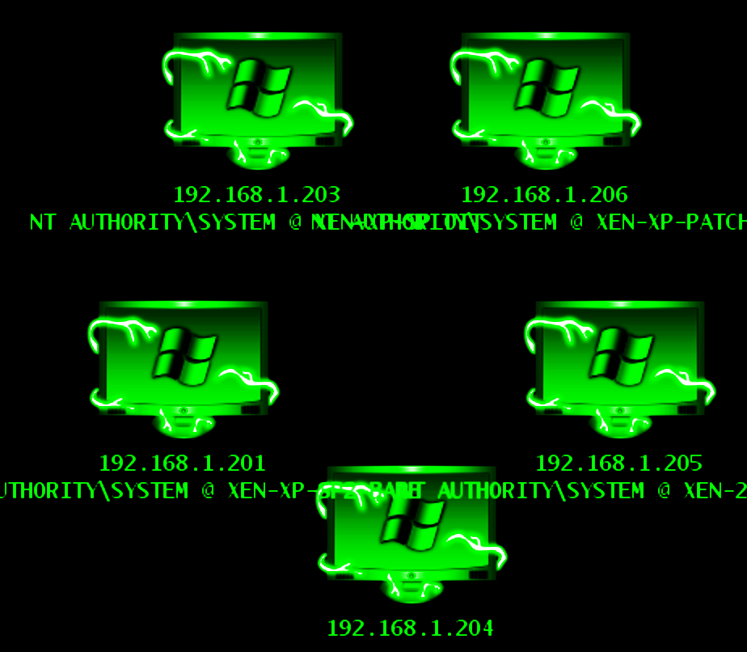
Module 10 | Activity 2

Introduction
In this activity, you will learn how to break into a Windows computer from your Kali machine. You will be using a program called Metasploit that is basically an exploit-assistant. Metasploit automates a lot of the steps that would otherwise have to be manually configured when attempting to gain access to another machine. Luckily for us, Metasploit already comes installed on computers running Kali Linux.
Not every exploit is available on Metasploit. Sometimes you need to regularly update it to retrieve the latest ones. We will be using some older exploits to gain access to a Windows 7 machine.
We will be using the EternalBlue exploit. There is a lot of history that you can look up about this, the U.S government even got involved. I encourage you to Google EternalBlue.

Getting Started - VM Setup
The first thing we need to do is to create a new Virtual Machine that will run Windows 7. Go to ISELAB. This is the computer we will be breaking into.
Under your school’s environment right click and select “Create a new Virtual Machine”. Please note that my screenshots will look a bit different than yours. As long as you follow along, not everything needs to be identical to work.
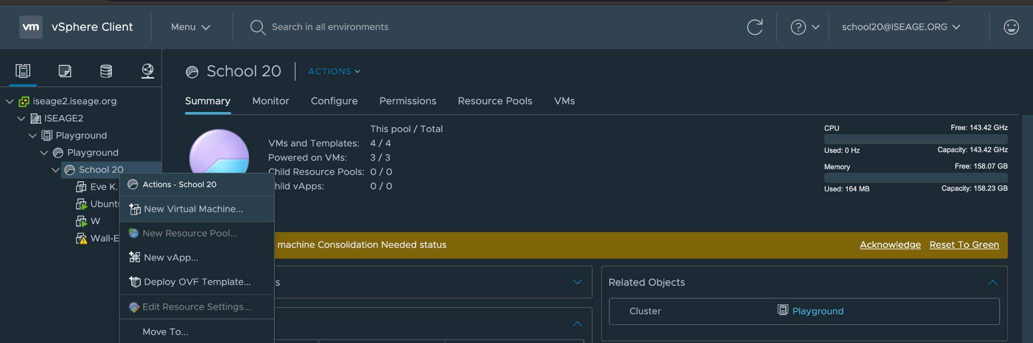
Click Next on step one.
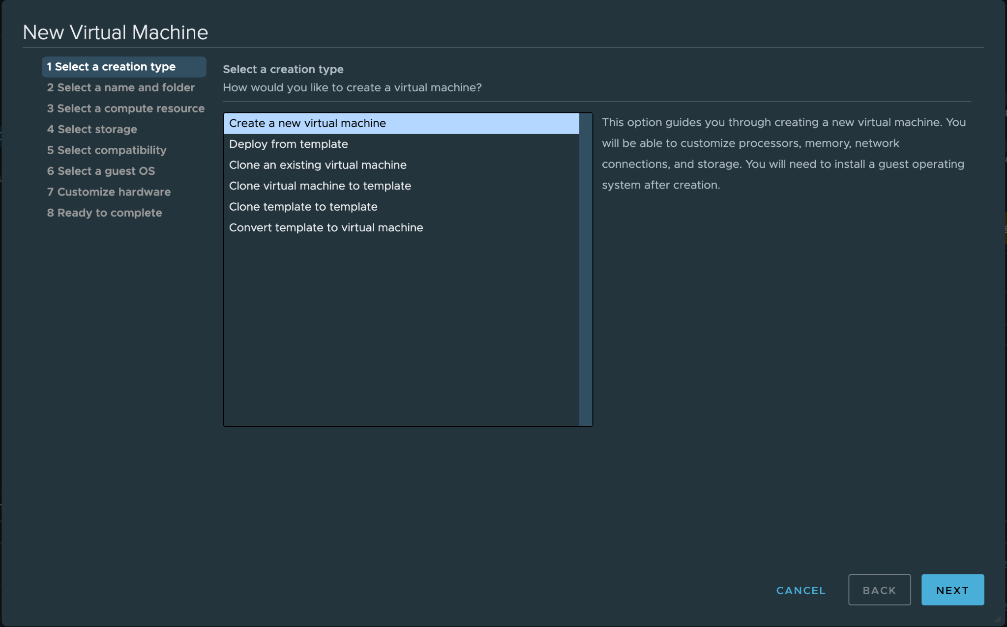

Name your machine something unique. It cannot be the same as other groups in your club. Use the dropdown tab to find your school’s folder, select the folder and click Next.
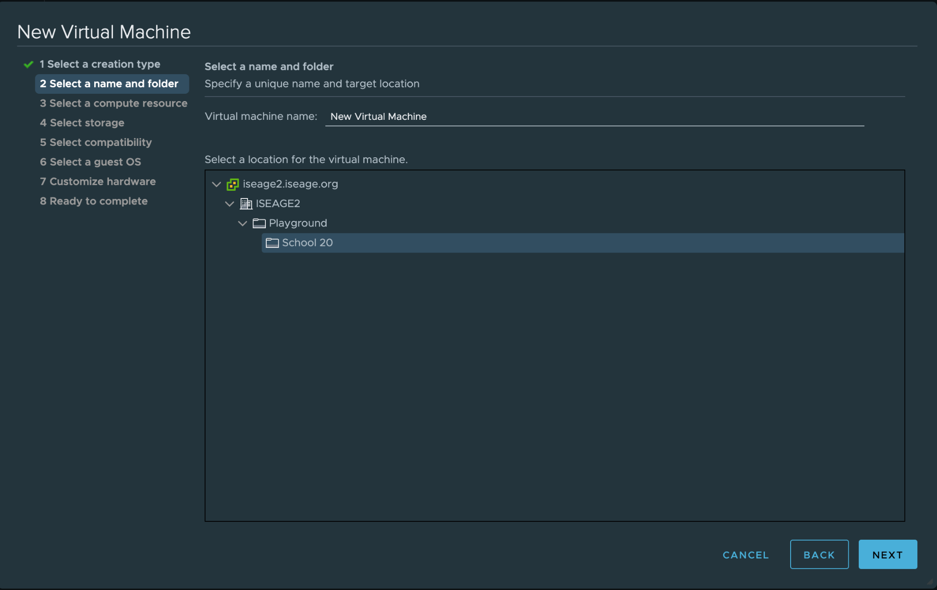
For step three, leave the default settings and click Next
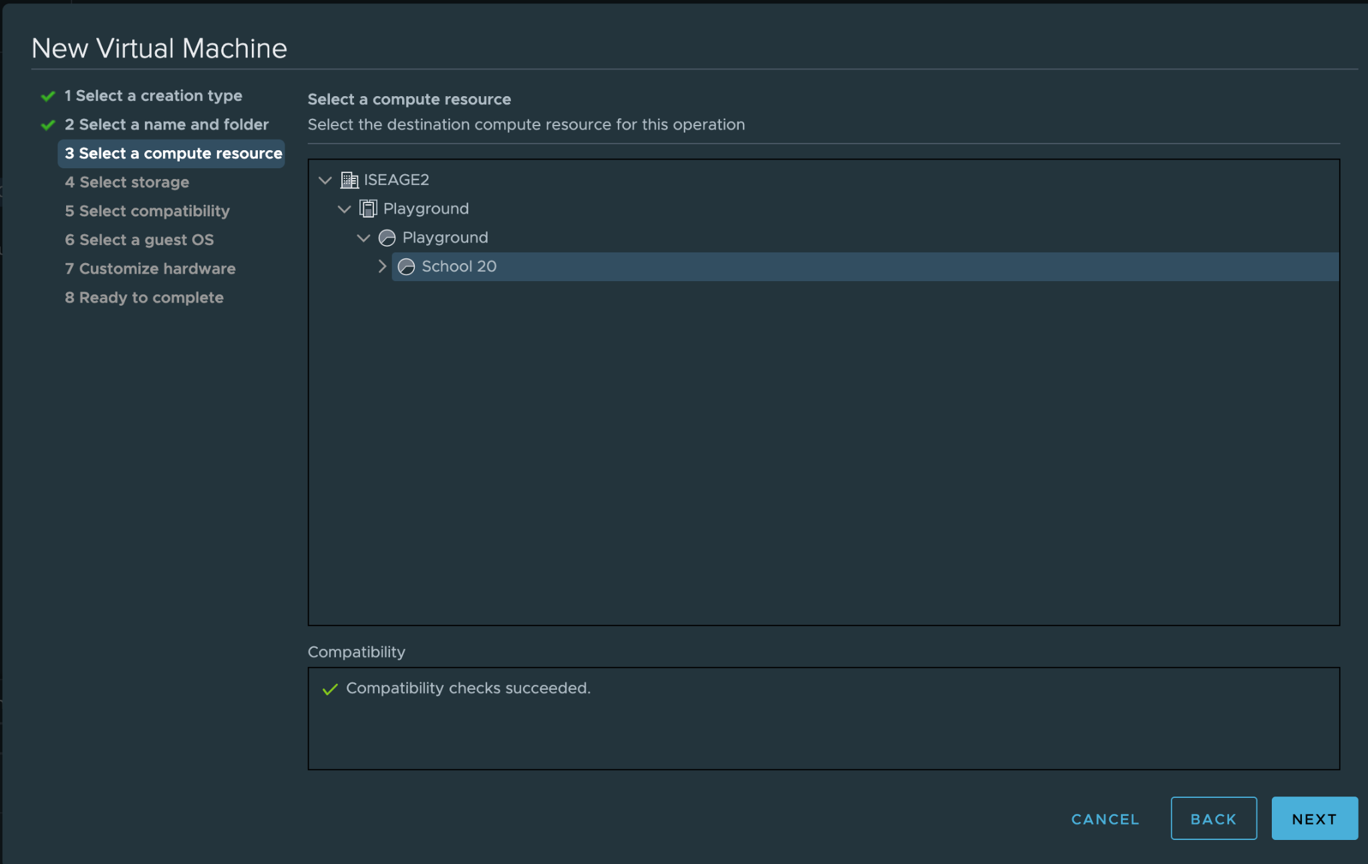

Leave the default settings alone or select freenas-hs if not already selected and click Next.
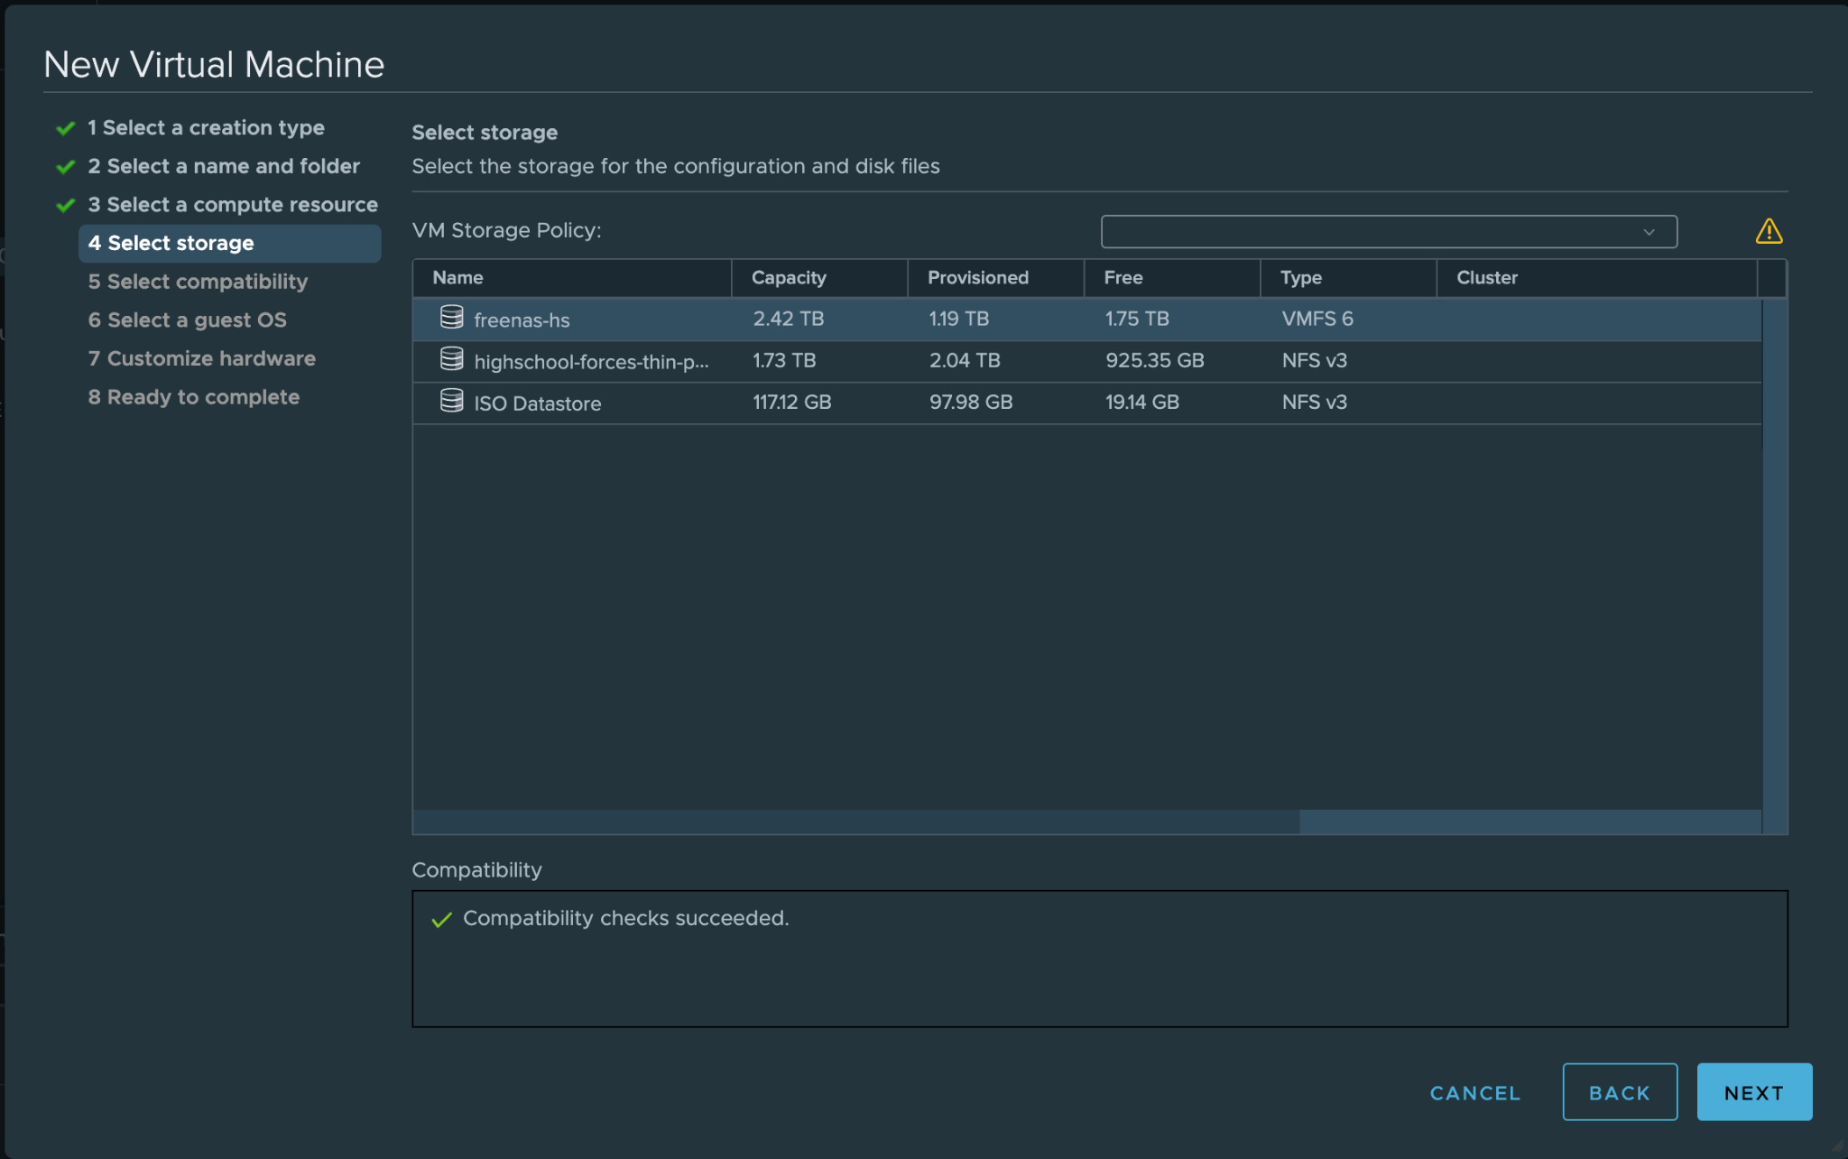
Leave the default settings and click Next on step five.
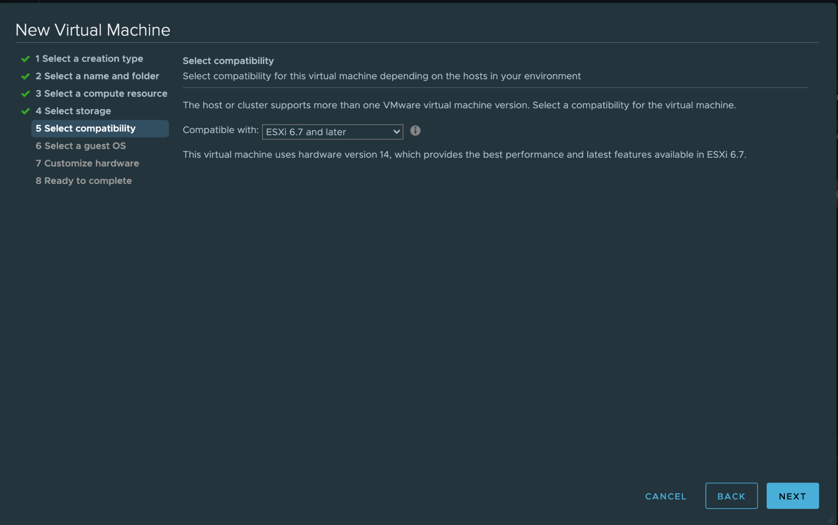

For step six you need to select the Windows OS family and the Guest OS Microsoft Windows Vista version, click Next.
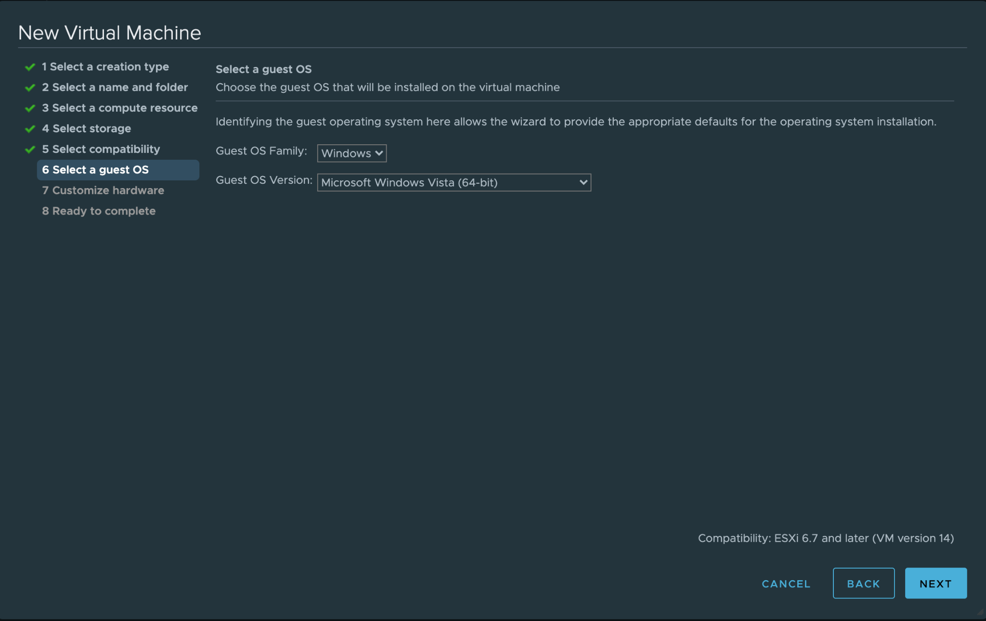
Step seven requires you to select an iso which is essentially the old school equivalent of inserting a CD into your PC to install your computer’s operating system and you also need to connect a mouse. Otherwise your cursor will remain frozen.
Connect a virtual mouse by clicking on the Add New Device Button and selecting USB Controller. That’s all to add the mouse.
Now, you need to click on the tab where it says “Client Device” under CD/DVD and select Datastore ISO File out of all the options.
The next few screenshots will go over the steps described in the paragraph above. Since I can’t put them on the same page. They will be posted and captioned below.

Adding a mouse screenshot.
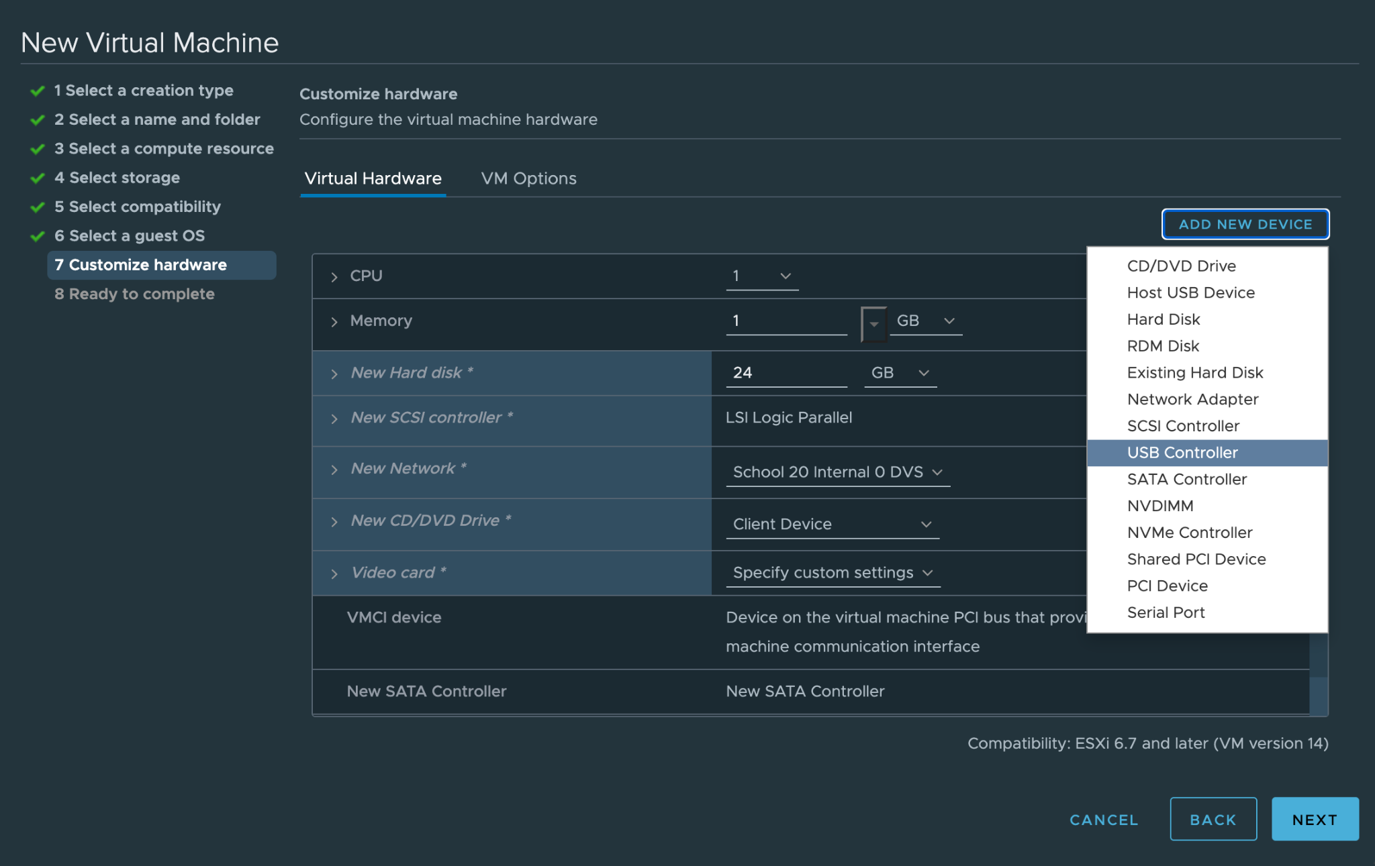
ISO Screenshots...There are a few of them for this step.
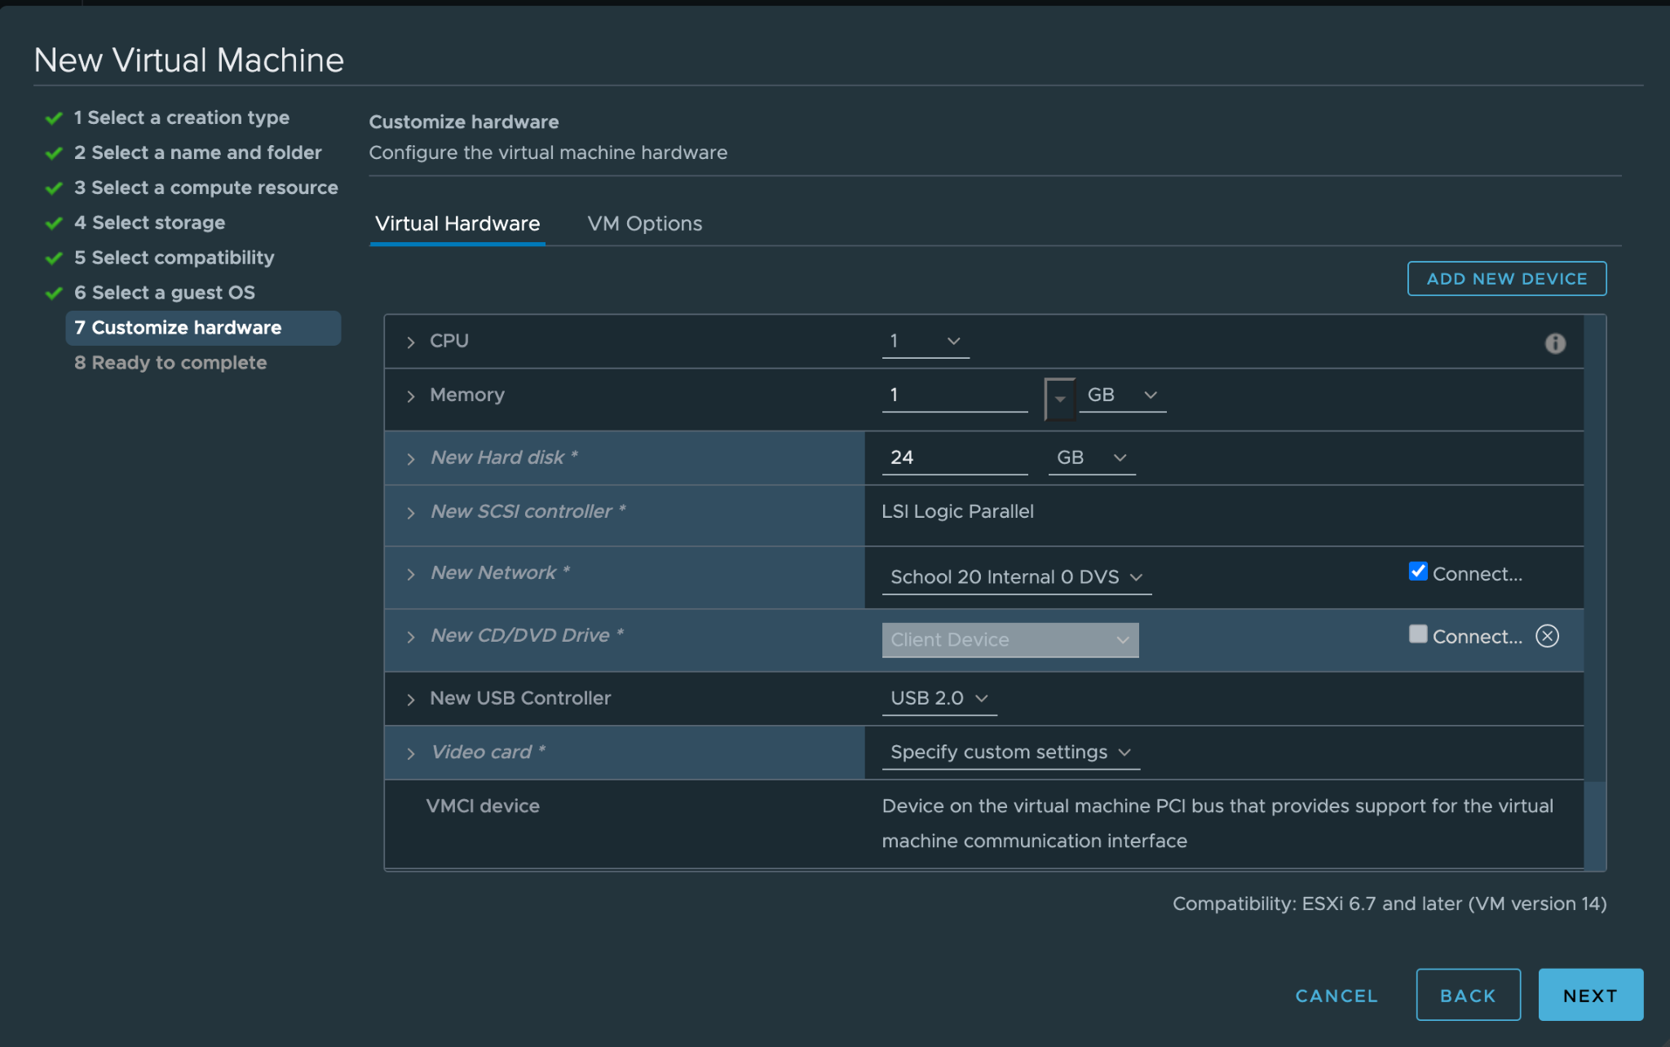

Before clicking Next you need to select the Windows 7 option. From the ISO Datastore options. There is only one of them so you can’t miss it. Once selected, click OK.
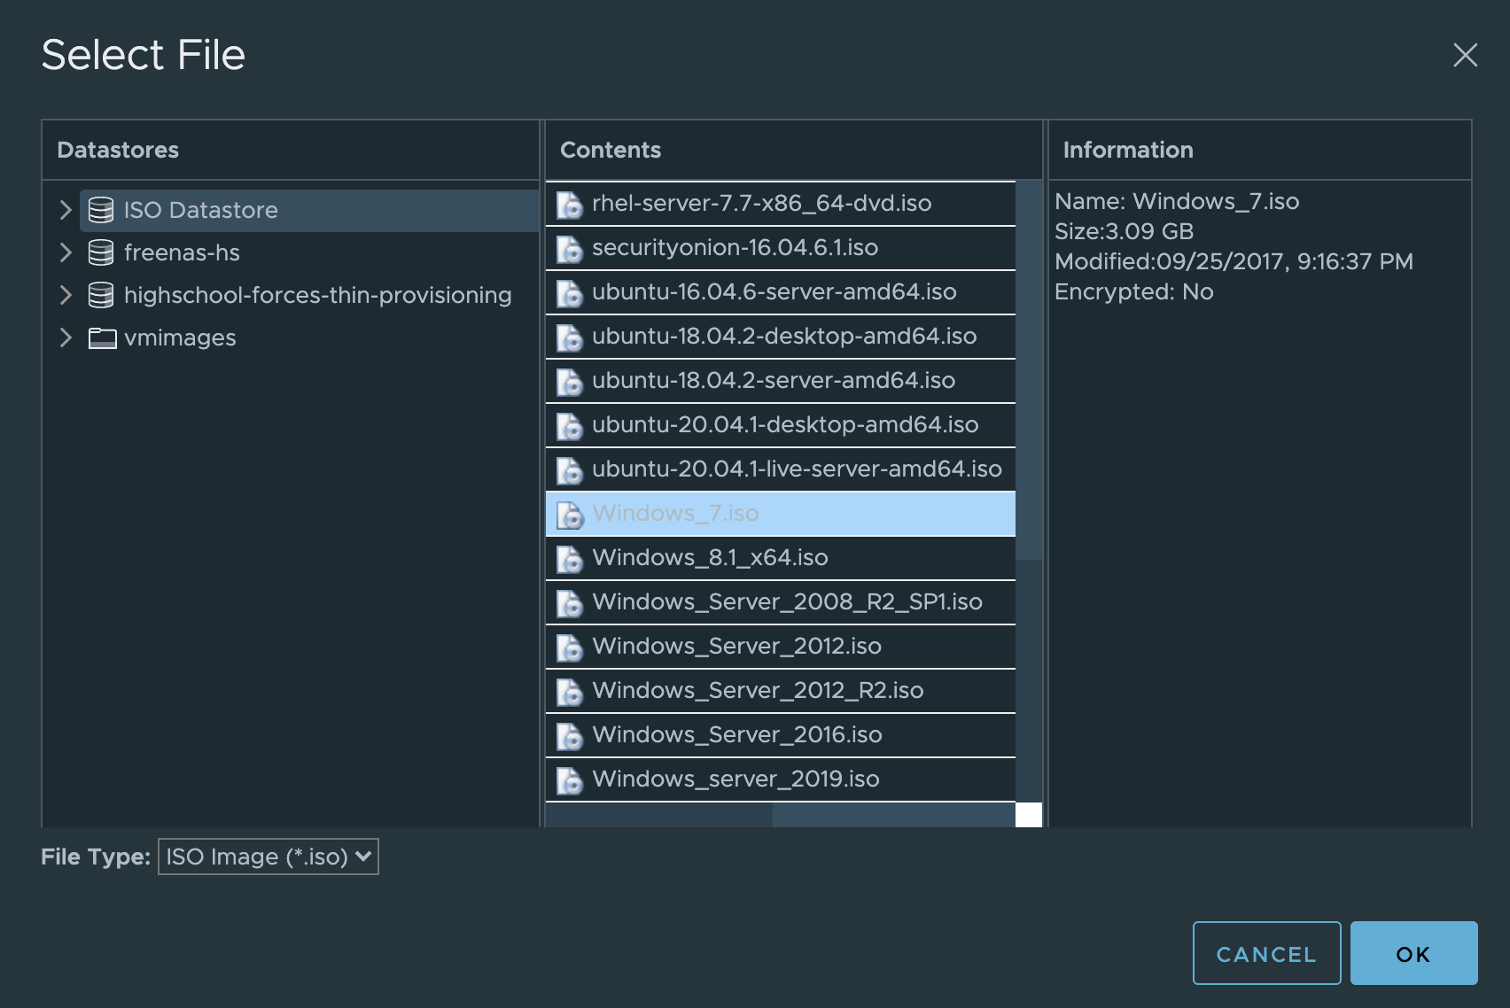
Make sure that both of those blue boxes are checked as shown below. Under the New CD/DVD Drive tab. You will need these to be checked, otherwise the OS will not run. Now click Next. And finally click FINISH.
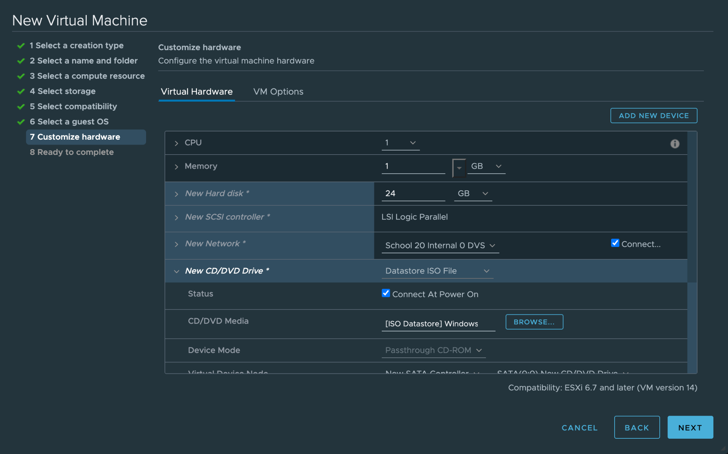

***END of Step Seven***
Your new Windows Virtual machine should now be in your ISELAB main menu.
One final step before you turn your machine on by pressing the green play button. You need to change the network to playground DVS. Right click on your machine and select Edit Settings. Bring down the network adapter tab and select browse since your new connection might not show up automatically. Once you click Browse another menu should appear and you need to select Playground DVS before you click OK. Click OK again to exit all menus.
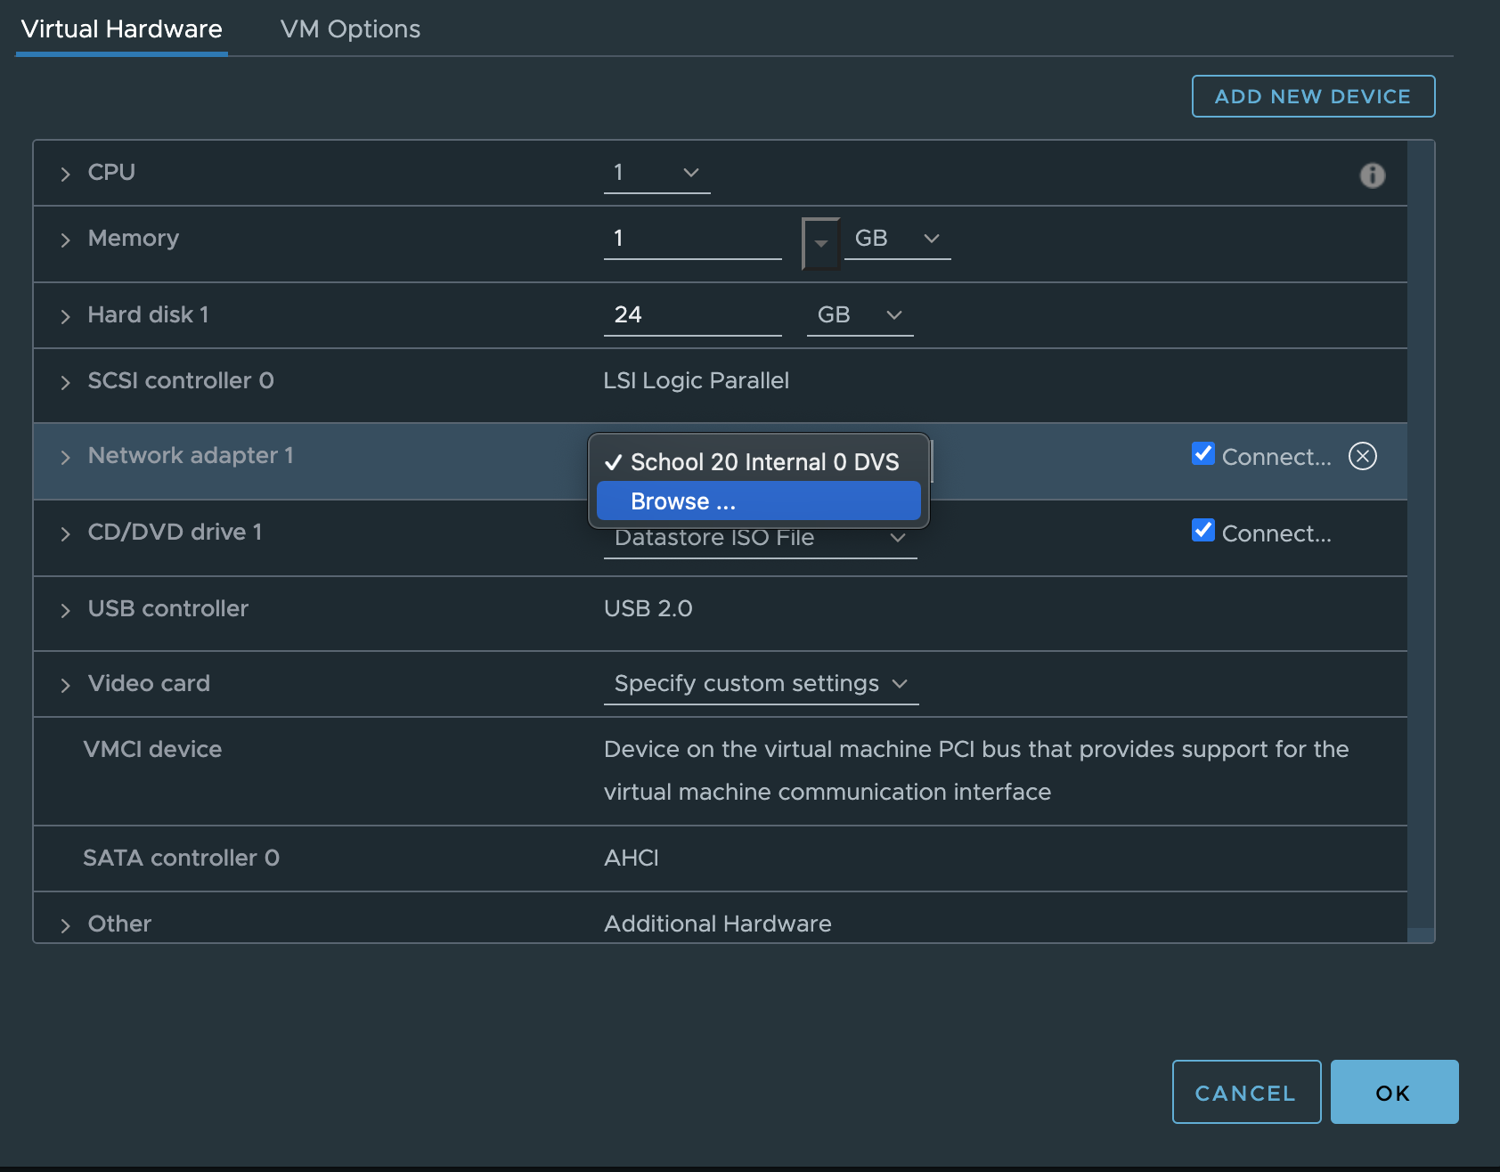
Now that you have made those network changes you can press the green play button to turn on your machine. And launch the virtual machine on a new tab by clicking on Launch Web Console. Once your VM launches you will need to go through a few installation steps. English should be the default, click Next.
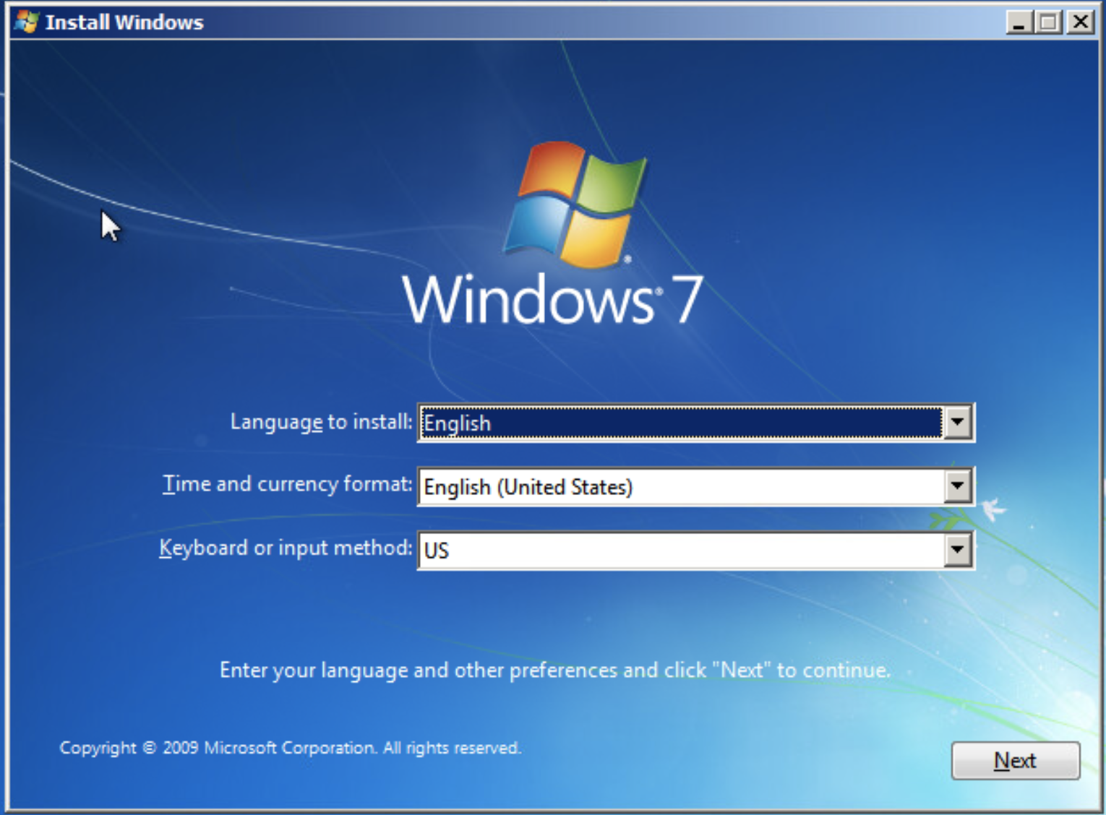
On this screen simply click Install Now.
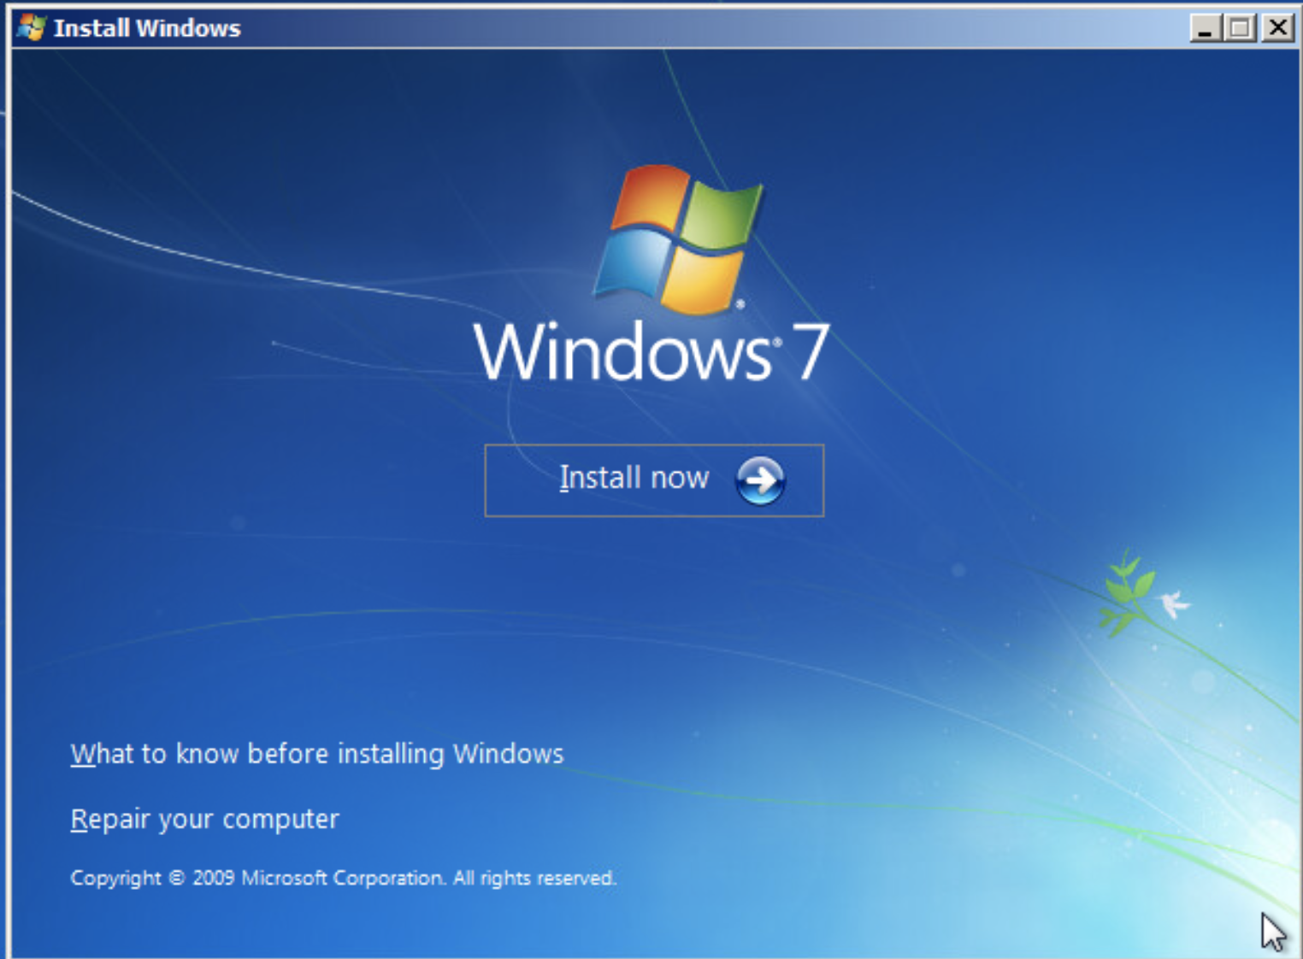
Accept the license terms and click Next.
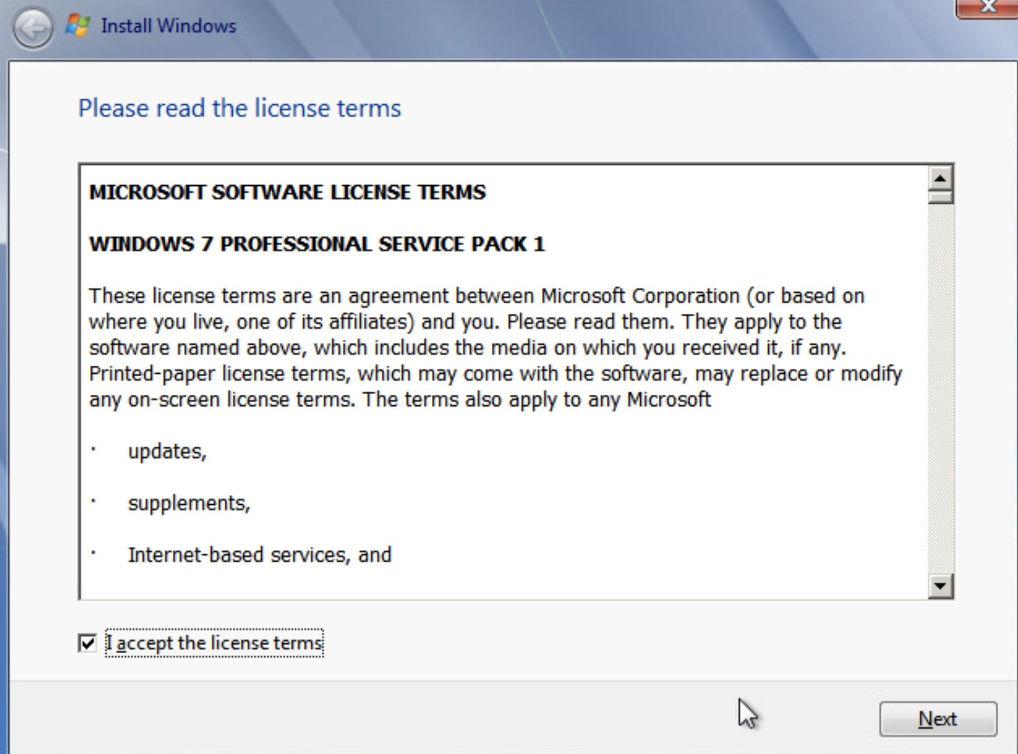
Click on the Custom option to install a new copy of Windows.
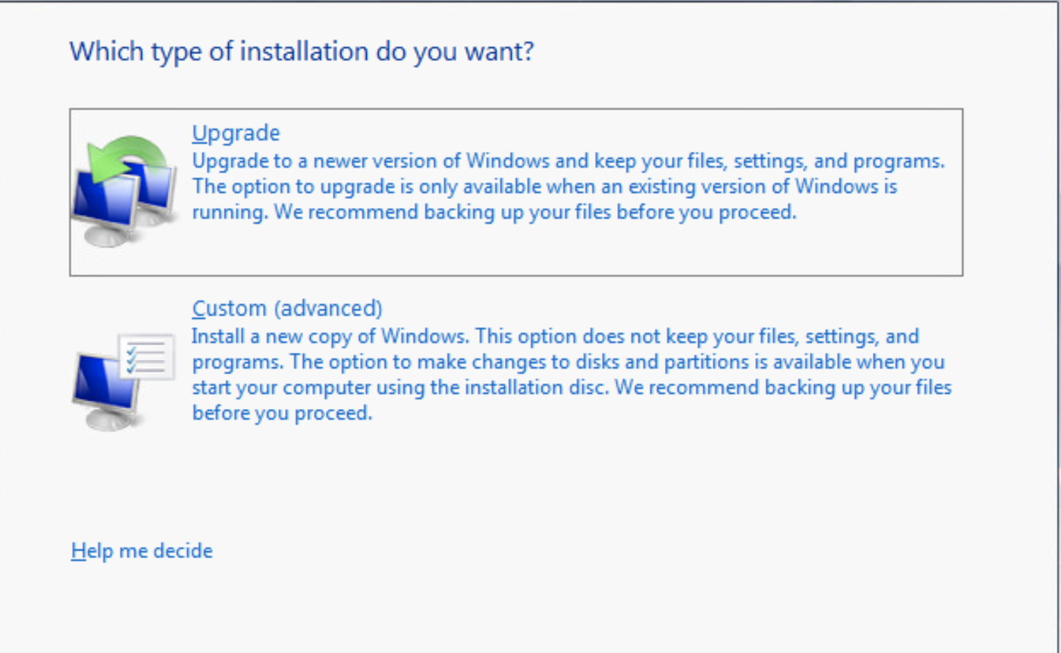
After clicking Custom, you need to select a place where the operating system should be installed. Select Disk 0 and click Next.
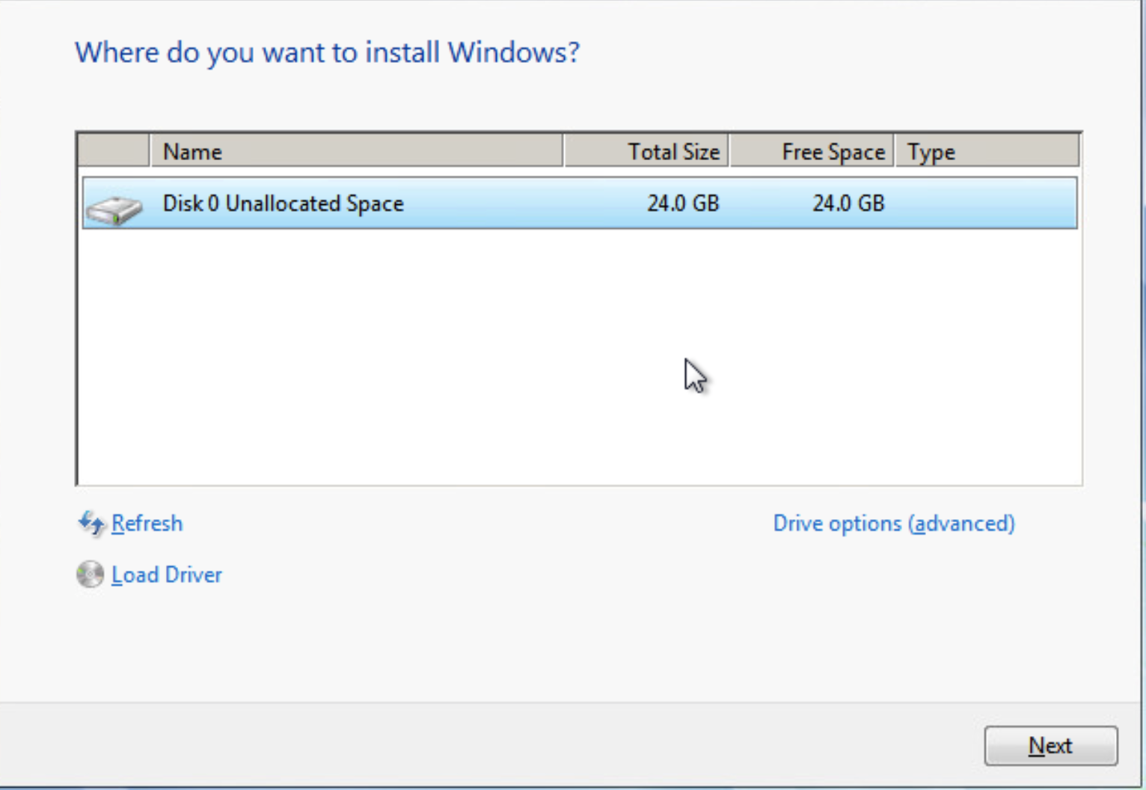
The installation process will take a couple minutes. Go have a sip of water.
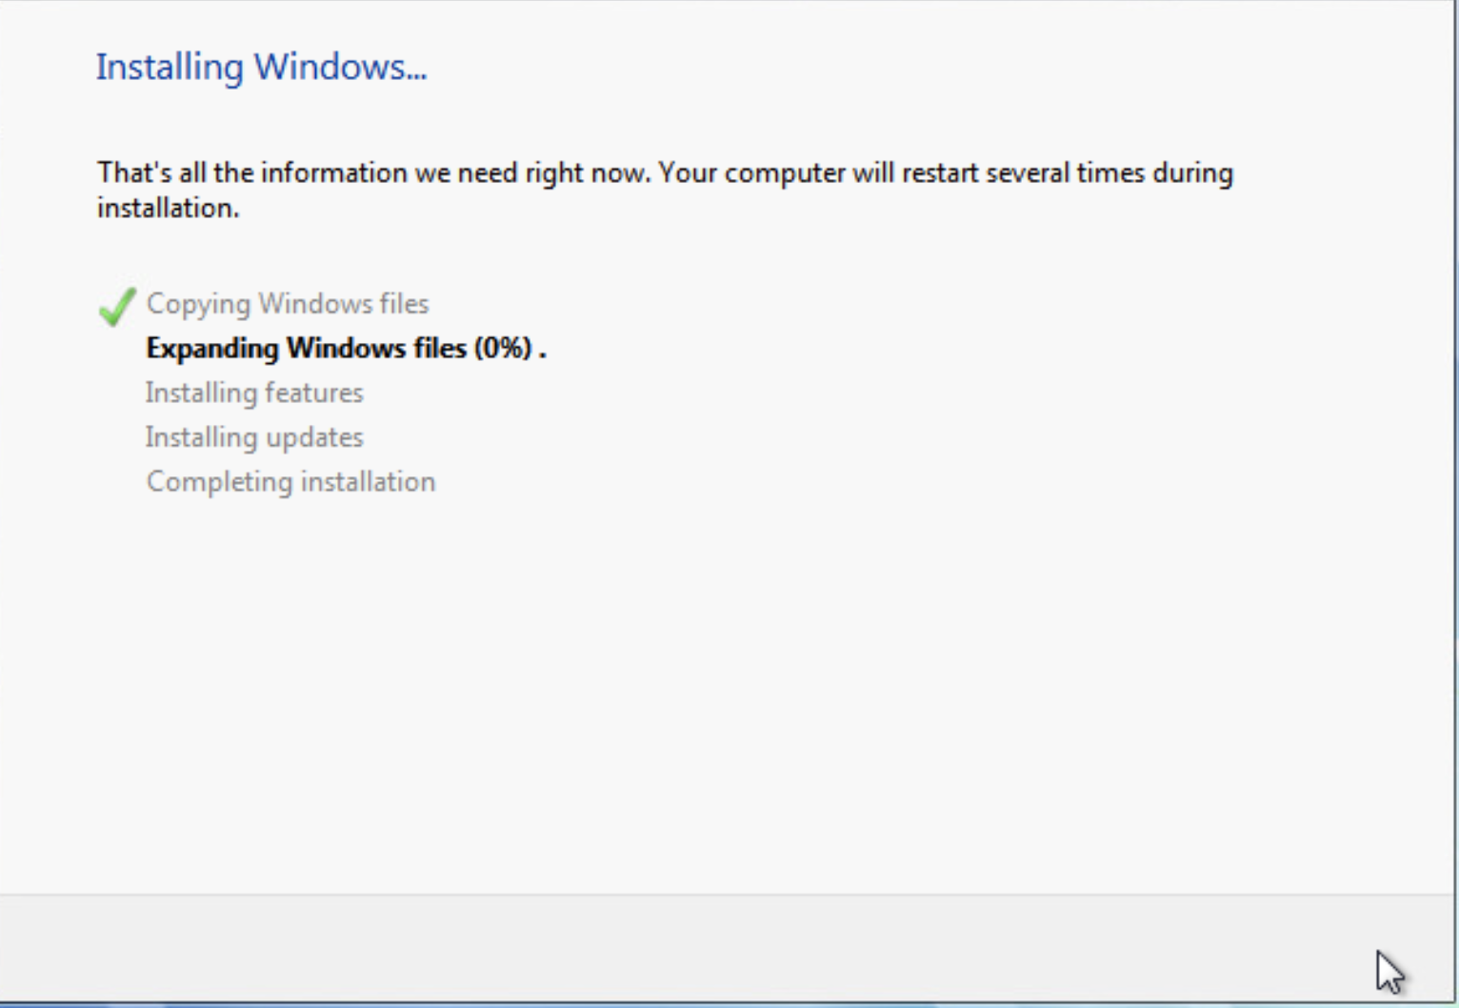
After about 10 minutes you should be presented with the option to name your PC. Again, name it something unique. It will be important later. I named mine WaterNine. After you click next you will be asked to create a password. Make sure you write this one down.
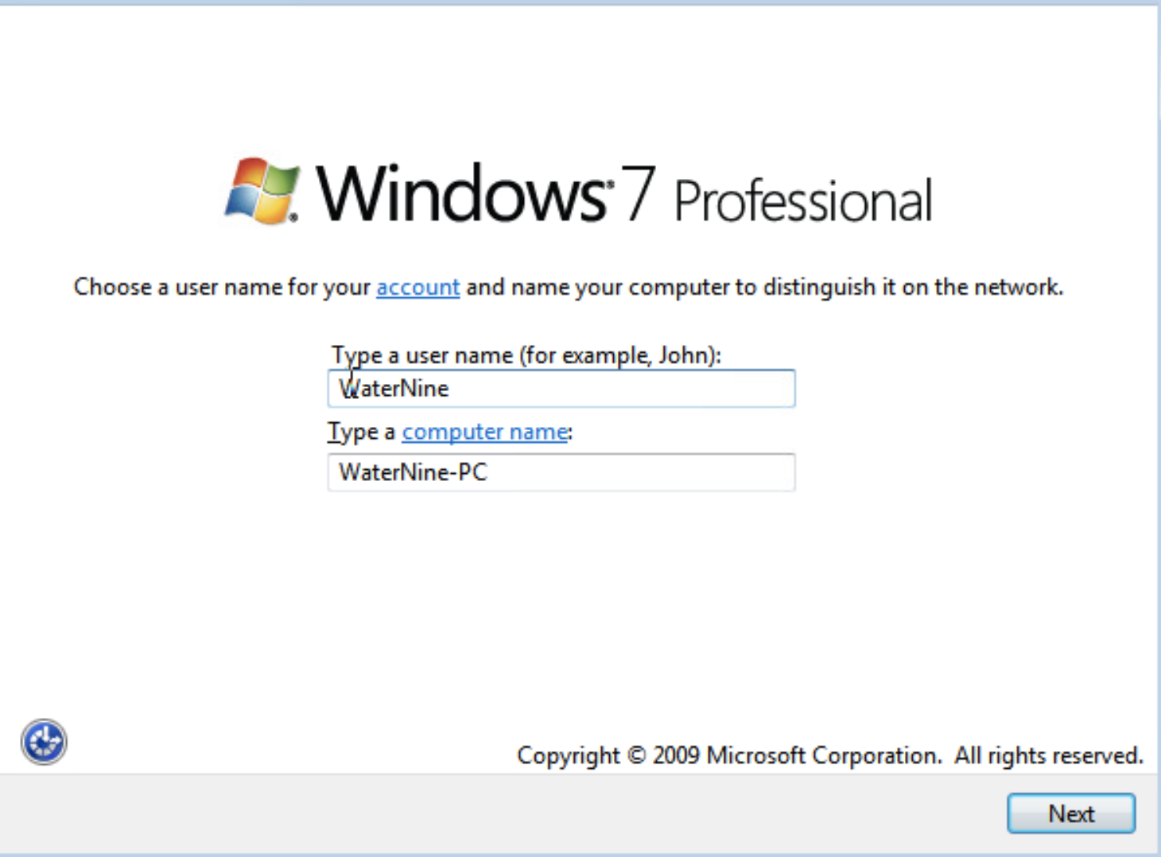
When asked for a product key simply hit the Skip button, this operating system is old enough that Microsoft doesn't care if people use it without paying for it. Which is great! I personally love W7.
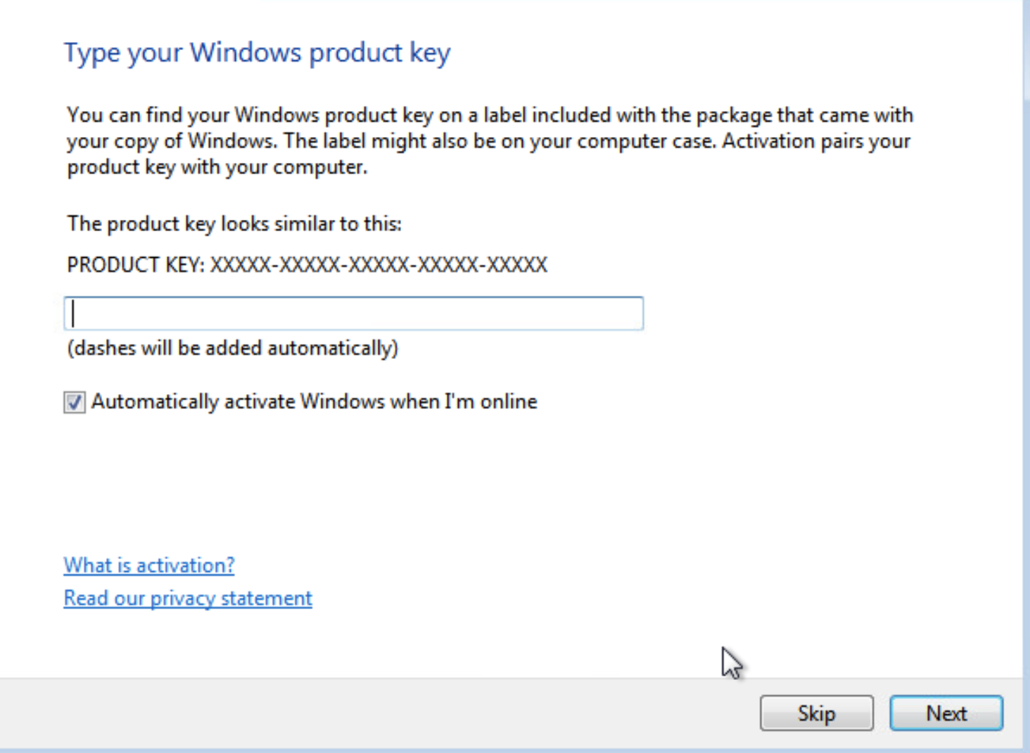
Use recommended settings. After this screen, set the time and date accordingly.
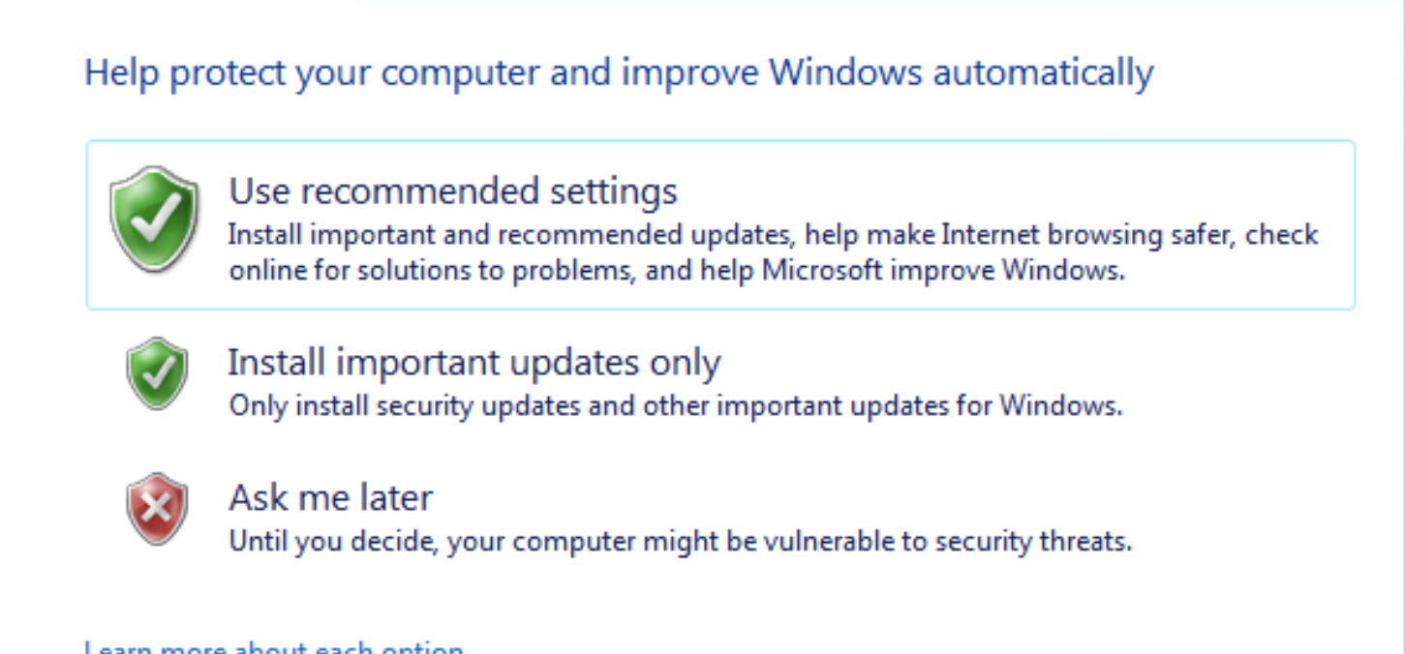
Select public network.
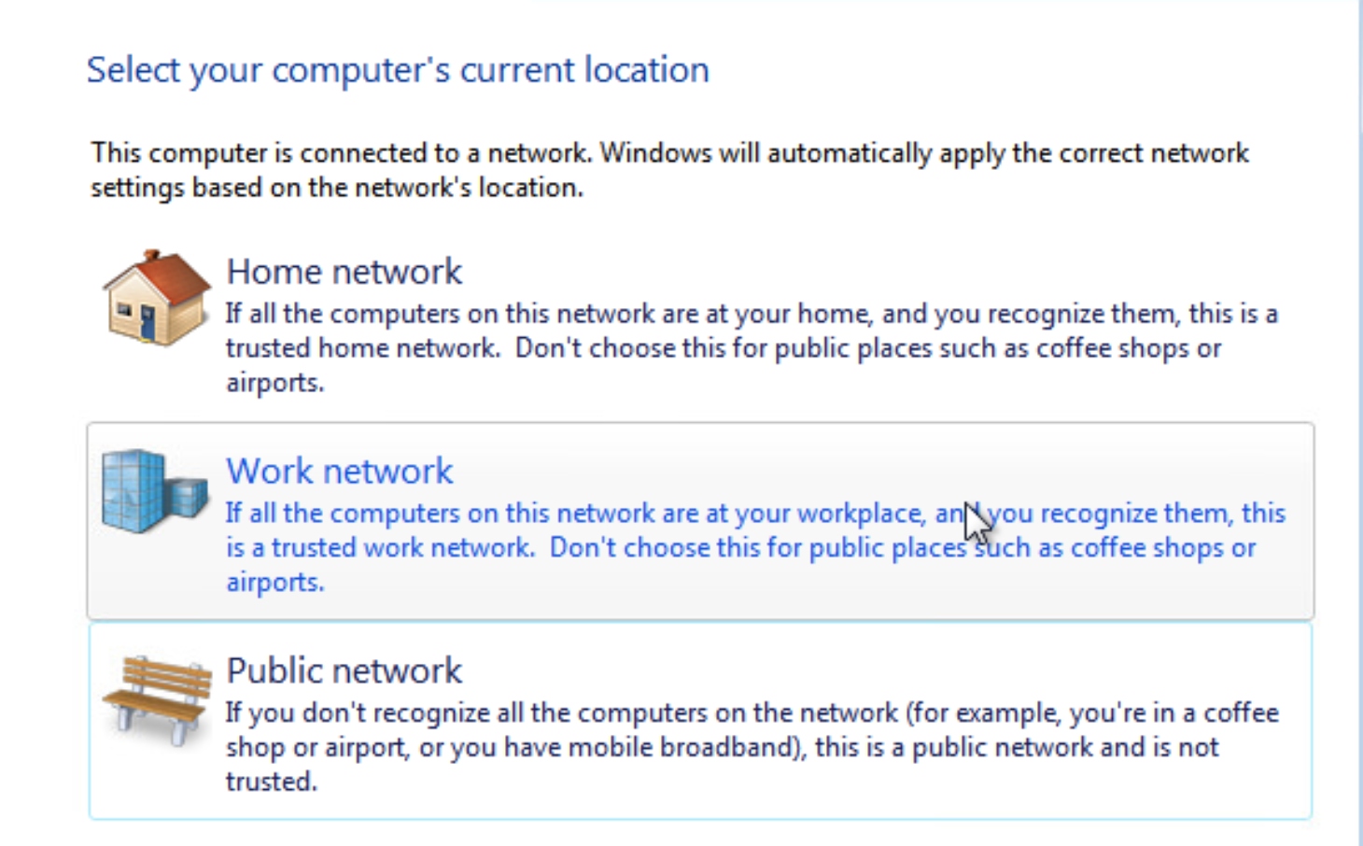
For the attack to work you need to assign the machine an IP address. Follow the video tutorial included along with the module. You may have to download the video in order to view it. After you go through the video you should have an established IP address. Go to the command prompt on your Windows 7 machine and type in the command “ipconfig”. Write down the IPv4 address that you assigned, you will need it soon. The screenshot below shows use of the ipconfig command.
When going through the video you need to use your school’s IP-range to connect to the internet NOT the exact IP you saw in the video. Every school has a different IP-range
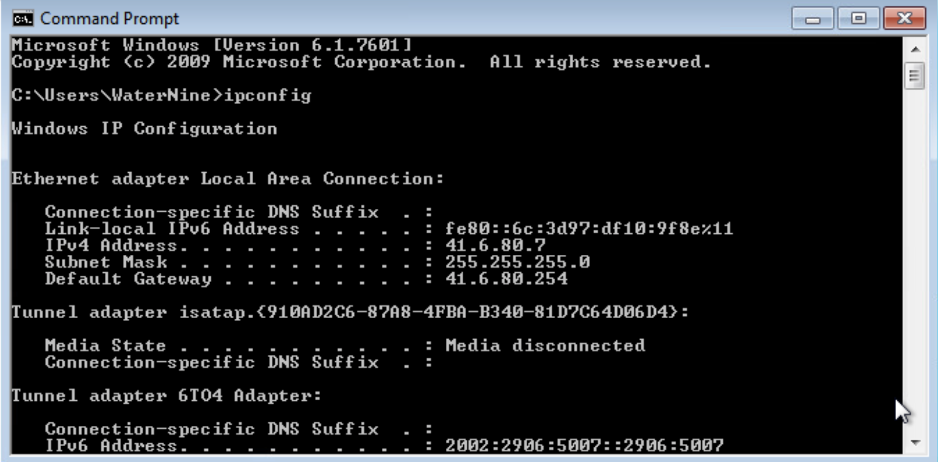

Deactivation
Your current Windows 7 setup is actually not vulnerable to the EternalBlue exploit by default. So we will “break” it before we can attack. Your virtual machines during the cyber security competition will contain a number of misconfigurations such as the ones you will soon observe. So in order to keep the Red Team out of your machines you will need to patch these vulnerabilities up.
The most important vulnerability is that EternalBlue will use port 445 on your windows machine to deliver the payload. As of now the port is not open.
In order to open the port follow the steps in this section.
Open the Start menu and type in Windows Firewall. Click on it and then click on Advanced Settings as shown below.
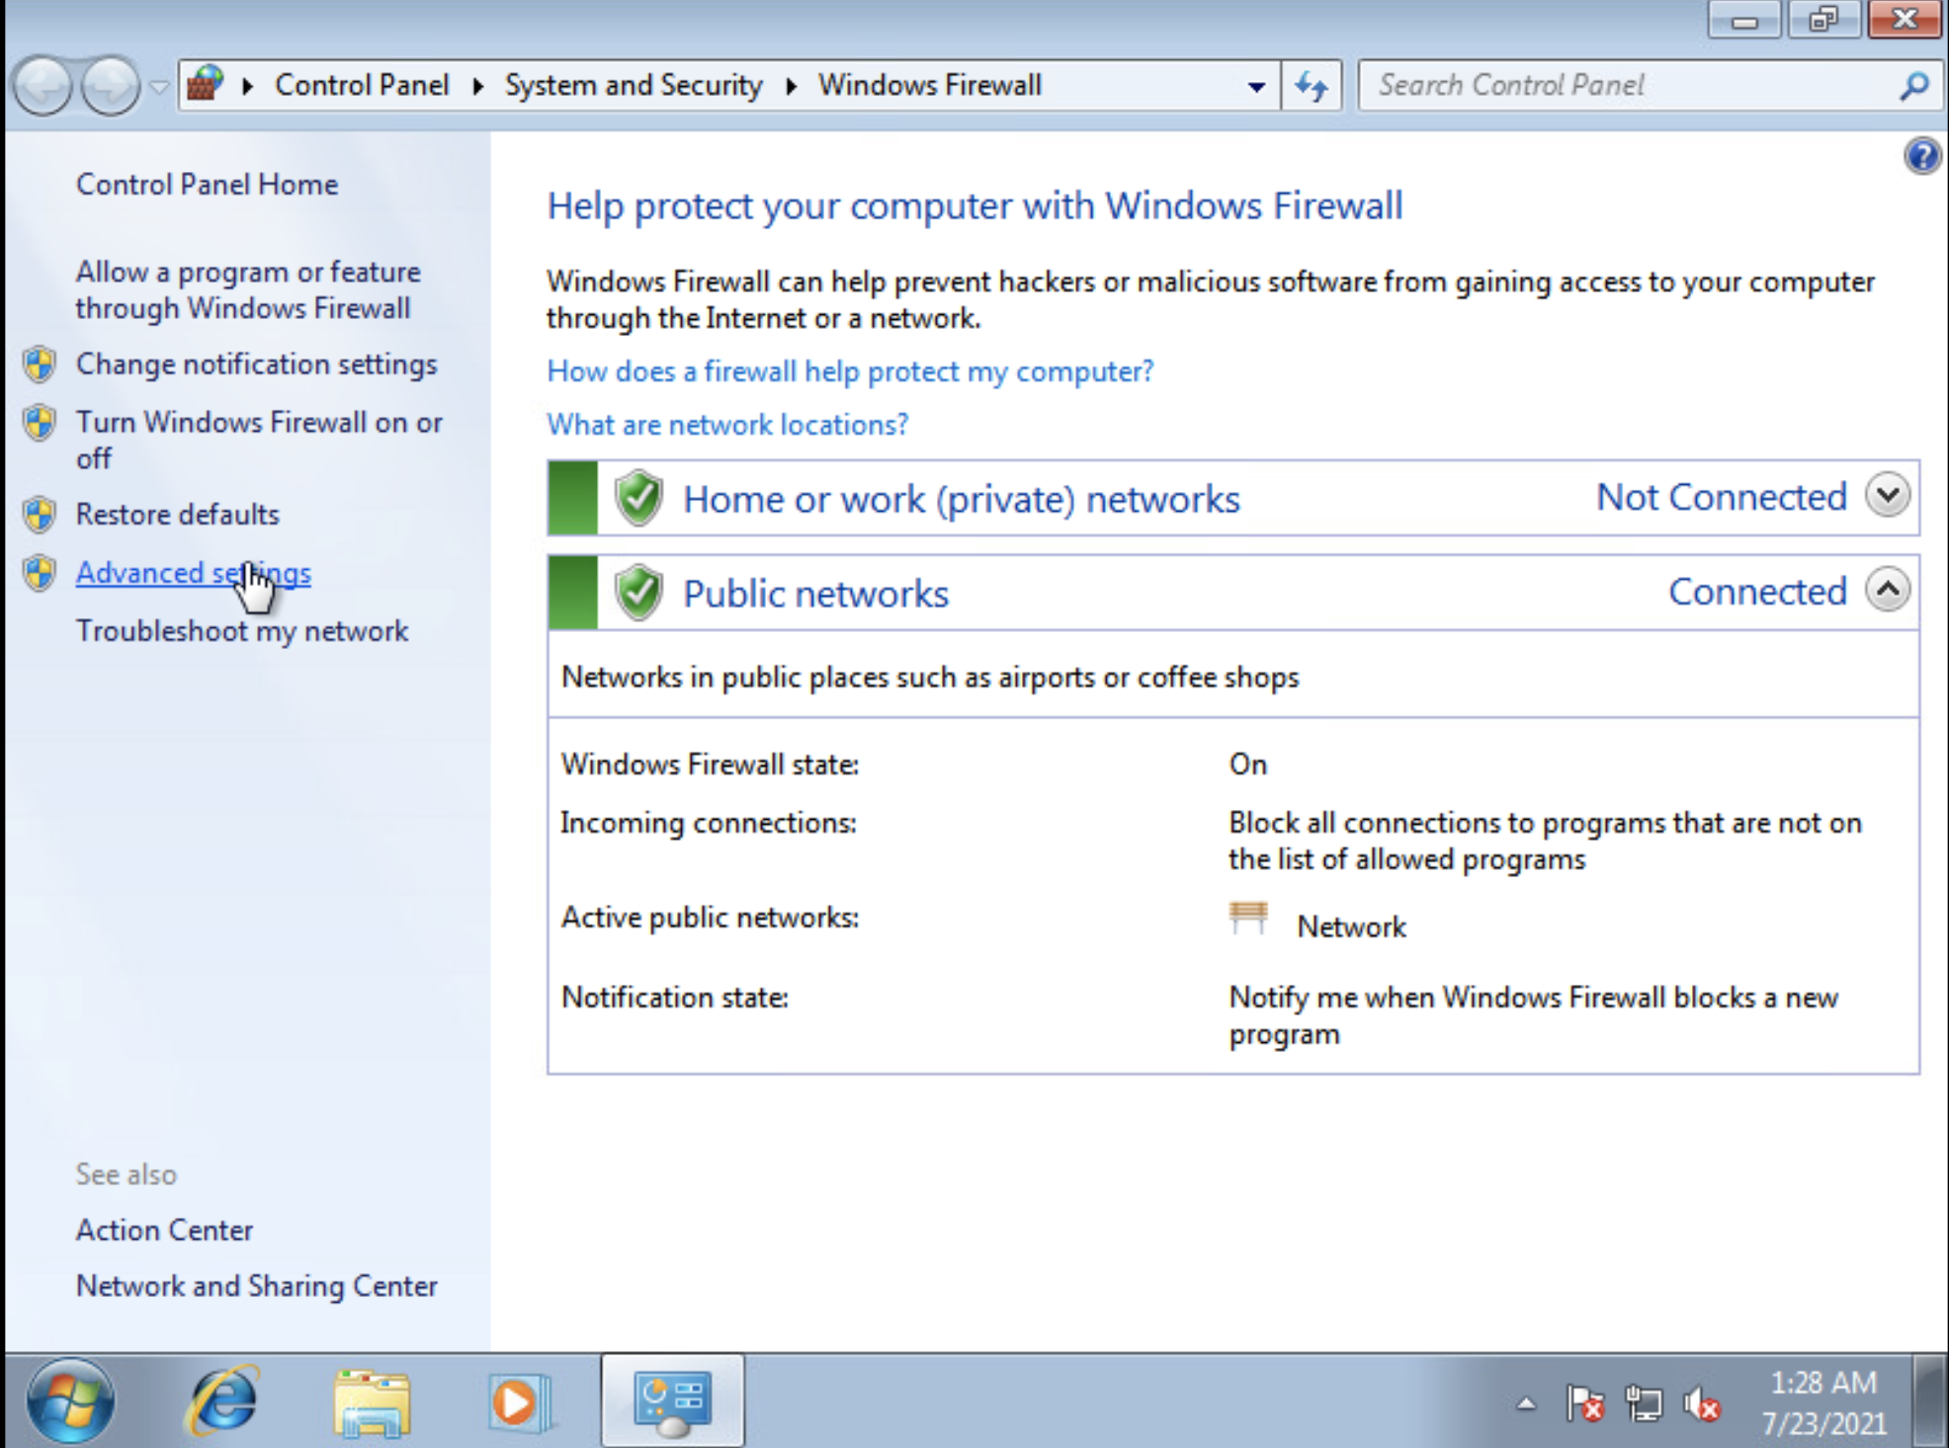
After clicking on Advanced Settings you need to go to the Inbound Rules tab, on the left side of the screen. Then click on the New Rule option on the right side of the menu. We’ll need to add a new rule.
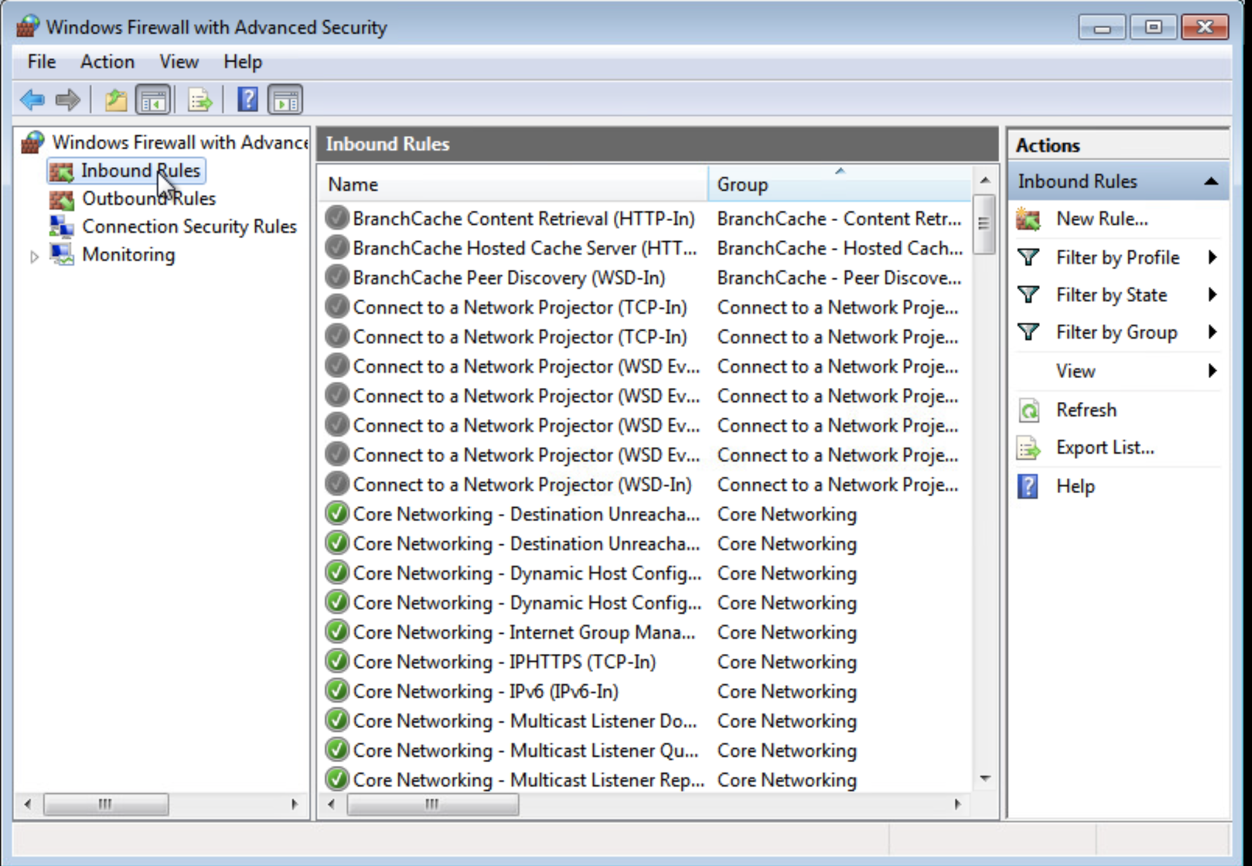
Click on port and click Next.
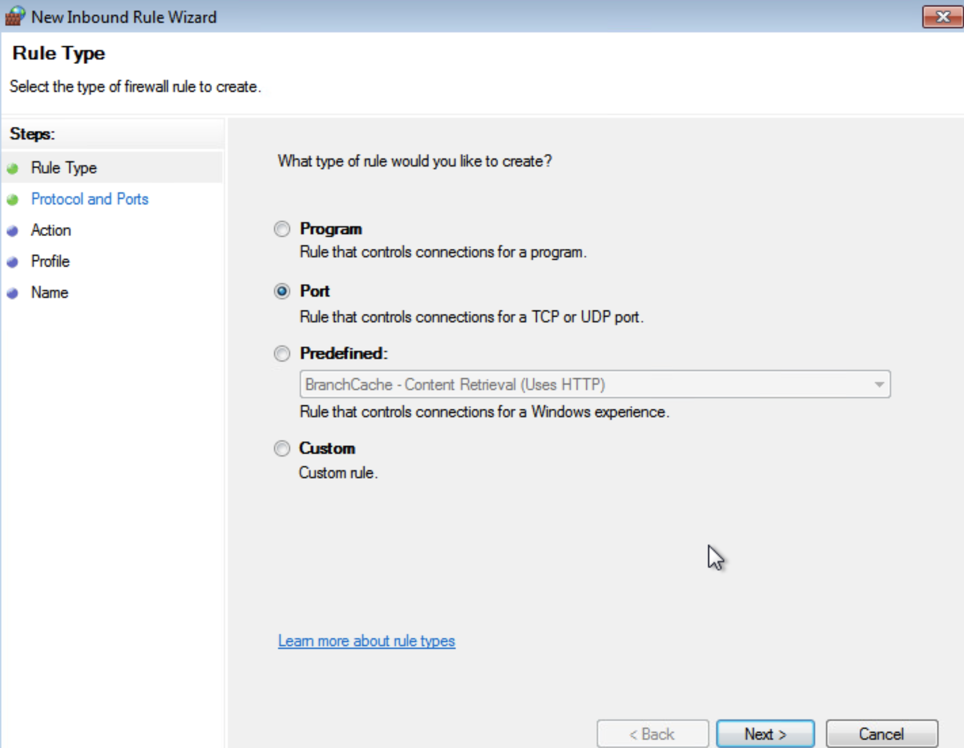
On the next screen we will be specifying the tcp port. Select the following settings and click next.
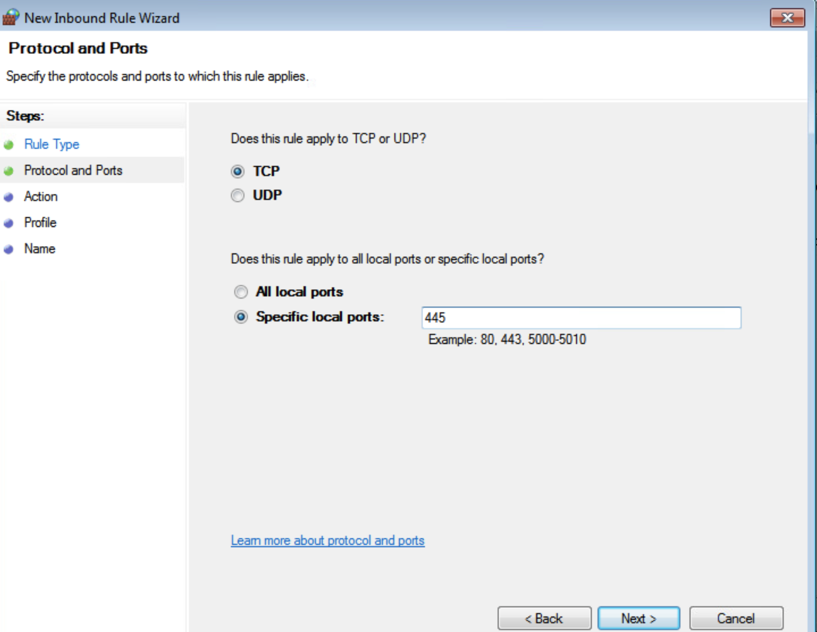
Allow the connection and click Next.
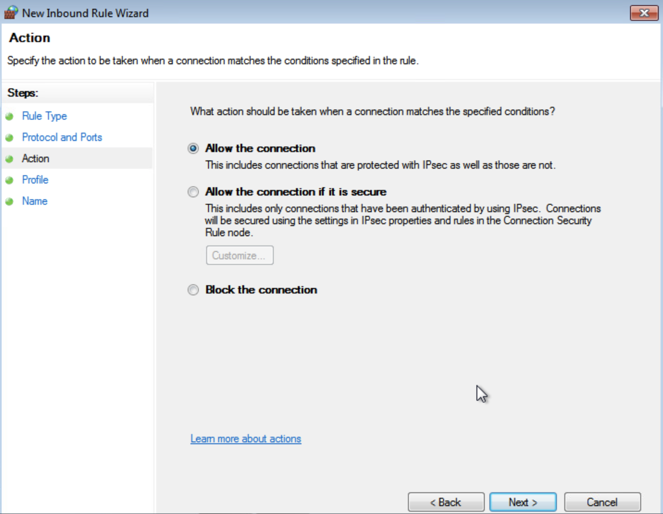
Apply the rule to all.
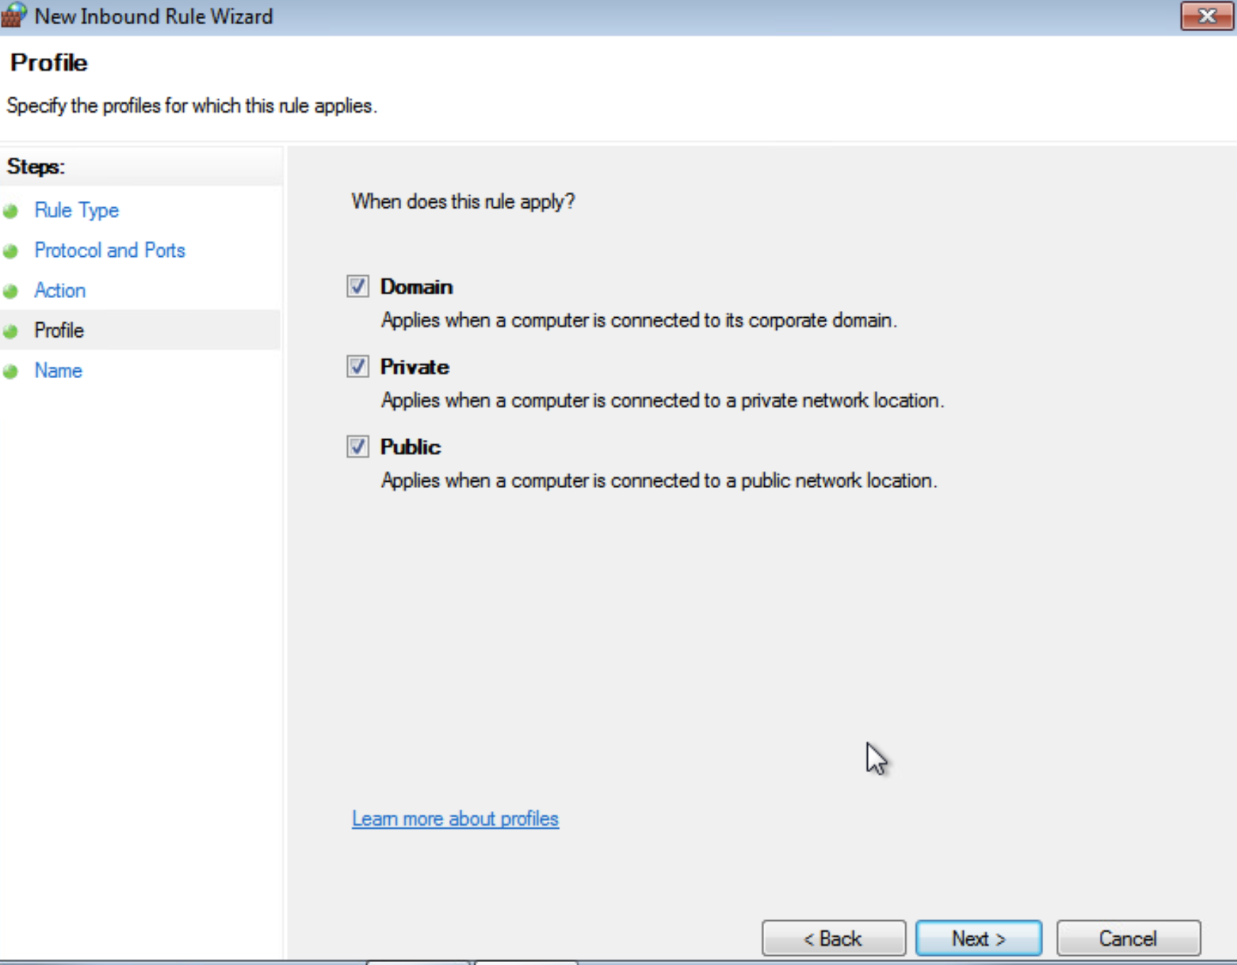
Name the new rule eternalblue and click Finish. Exit out of this and restart the computer. Port 445 is now open.
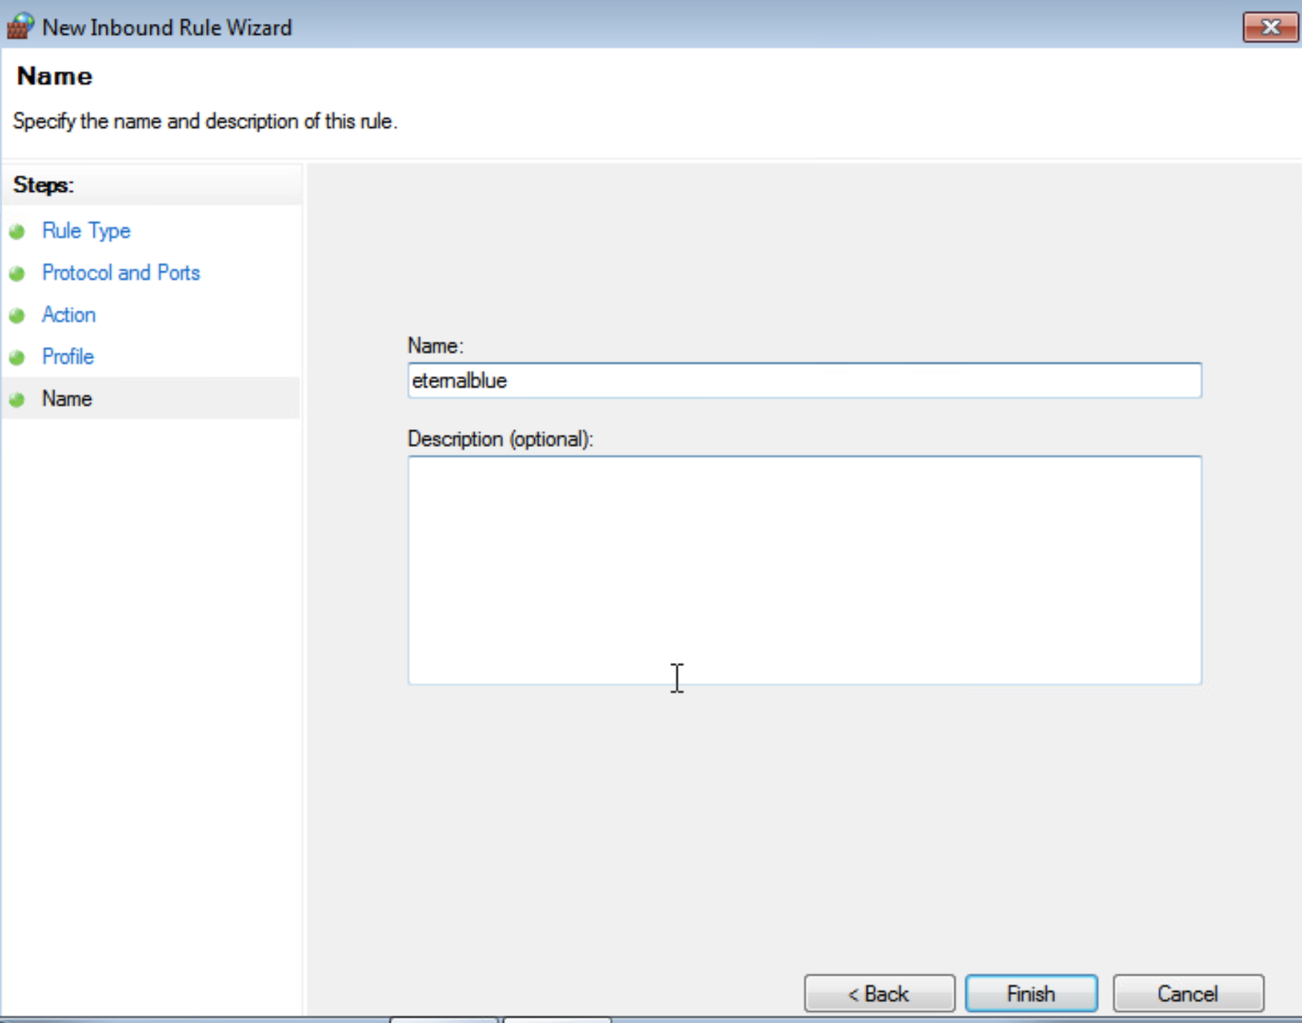

Attack Phase
Alright now we are ready to initiate the attack phase.
Return to your Kali machine and launch the metasploit framework. Click on the upper left corner of the screen to find it.
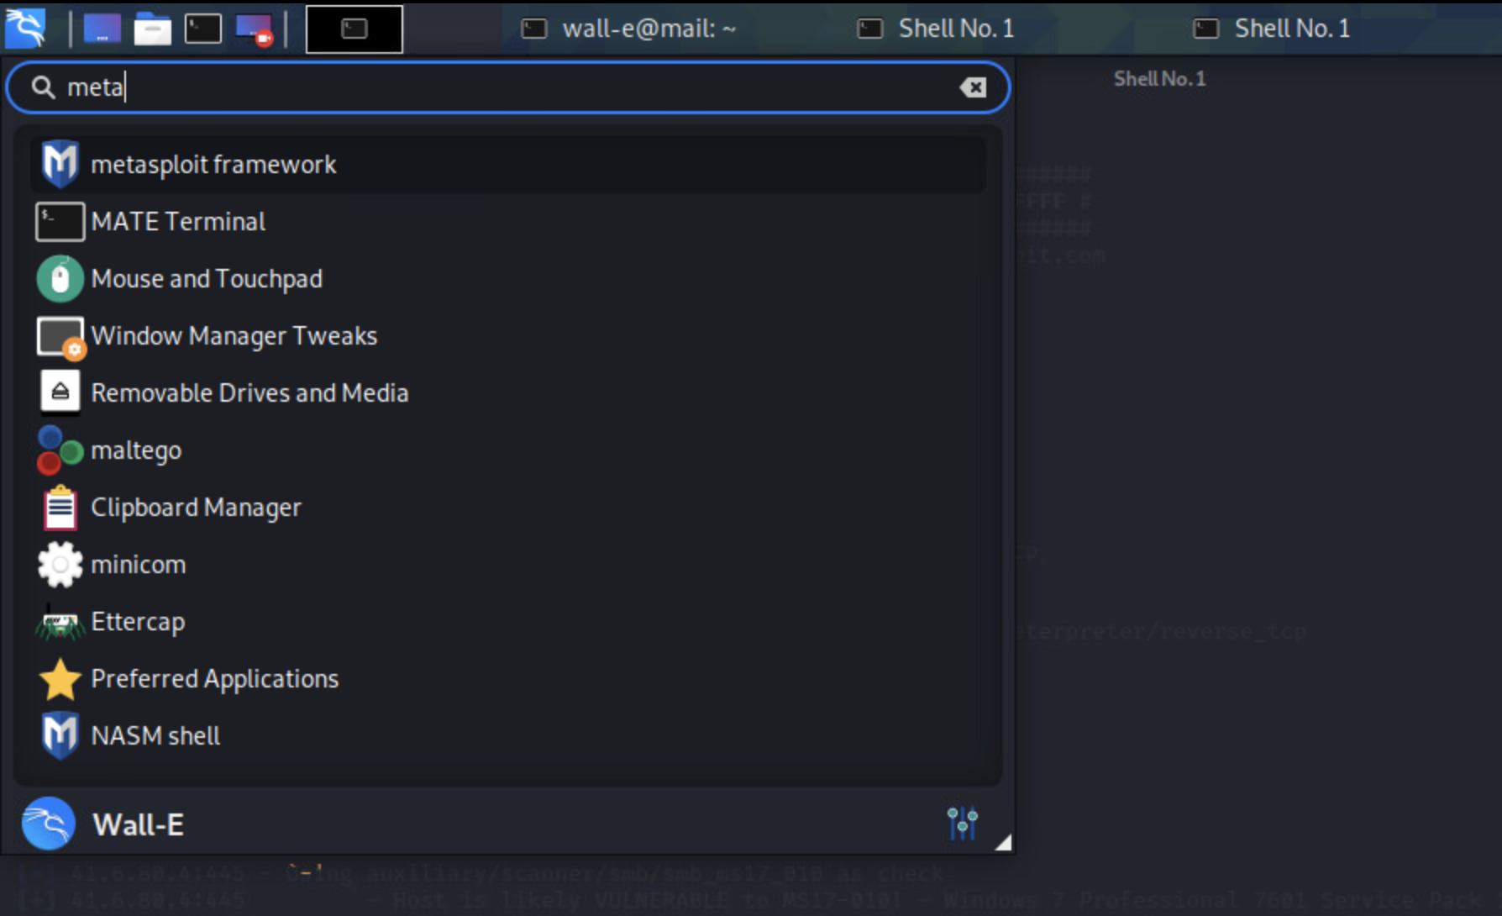

You might need to type in your Kali password to open up metasploit. This is what you should see. It looks similar to a normal terminal.
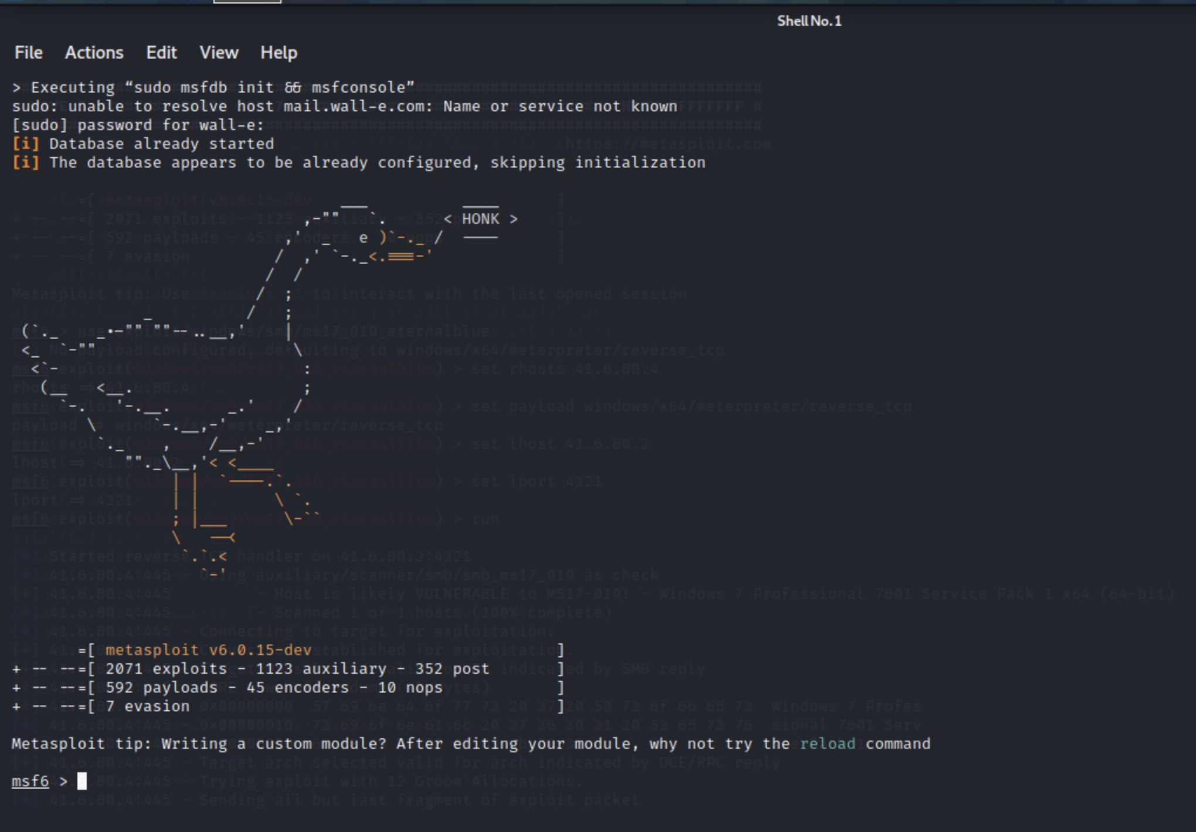
As I mentioned before, metasploit is a library of “attacks” or exploits. We will be using one of these exploits and pointing it at our new Windows machine to gain access to it.
If we run a quick search for the EternalBlue exploit in the metasploit library we will get a number of results. As you can probably guess we will be using the regular EternalBlue exploit.
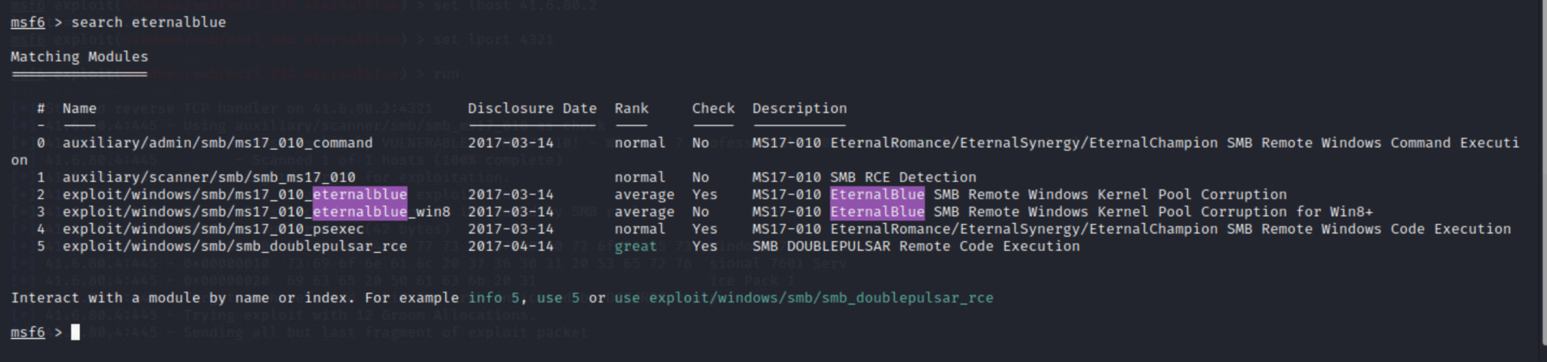
To “use” an exploit we need the following command. Type it in and press enter.
use exploit/windows/smb/ms17_010_eternalblue

If we run the “options” command after selecting an exploit we will see all of the different parameters we need to fill-in before we can successfully use the exploit. It seems like we need to set a target, a payload and a listening host.
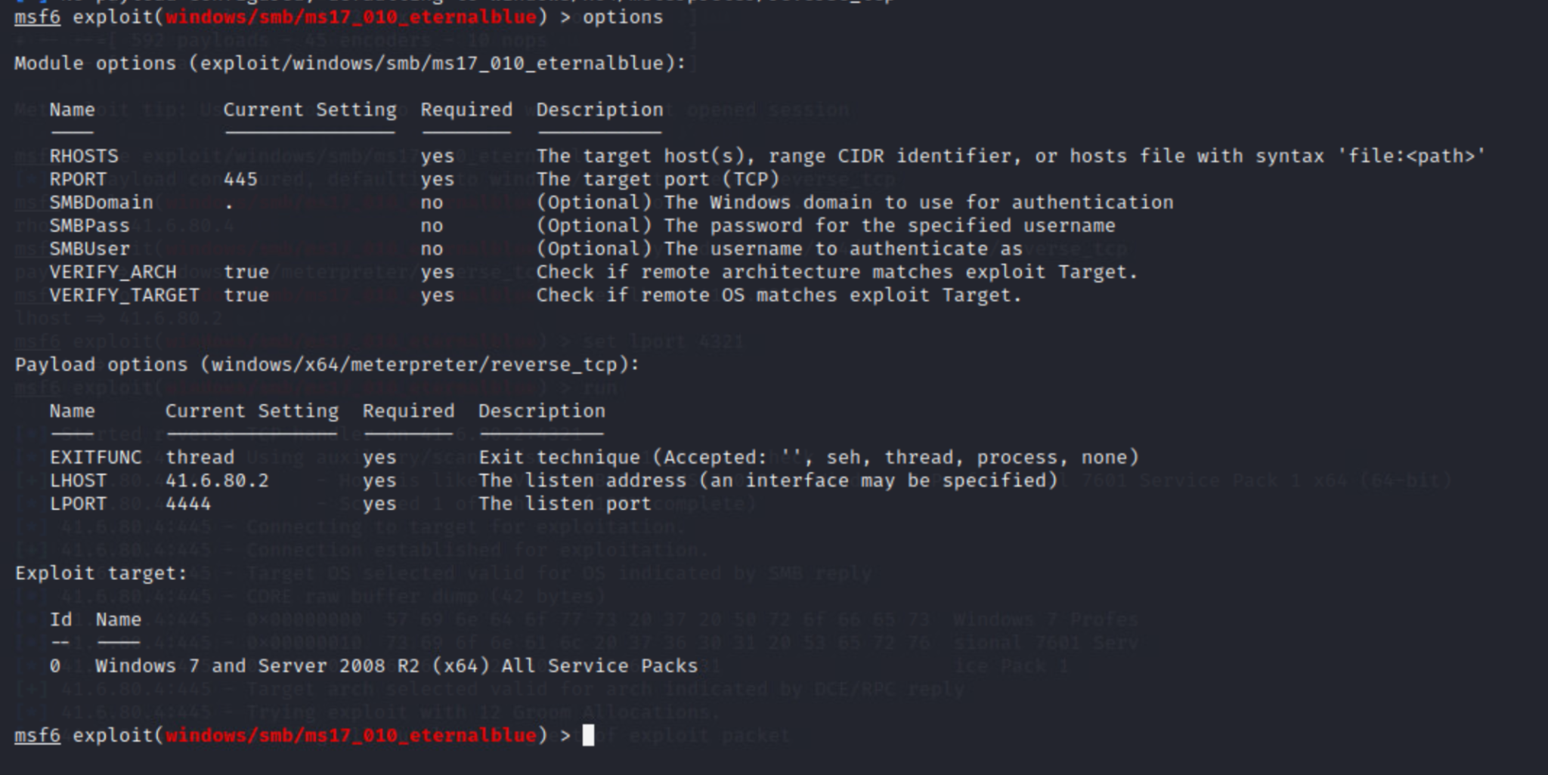
We set the target computer by using the following command, this is where you need the ip address of your windows machine.
set rhosts <Ip-addr>
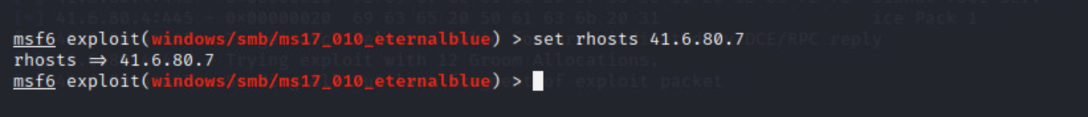
Now we need to set the payload, which is the core of the exploit. Look at the screenshot below to set the payload. You will see what Meterpreter is later, but it is basically a shell from which we will be able to control the target computer.

After setting the payload we need to set a listening host (your Kali VM) and a listening port.
Now for the moment of truth! Run your exploit. With the command “run”. You should get a Meterpreter shell if your exploit was successful. For demonstration’s sake you can see for yourself that EternalBlue does indeed use port 445. Below is an example of an unsuccessful attempt and a successful attempt, respectively. In the first run attempt, the port is closed, the second time around I used the same steps you followed above ^^^ to open it.
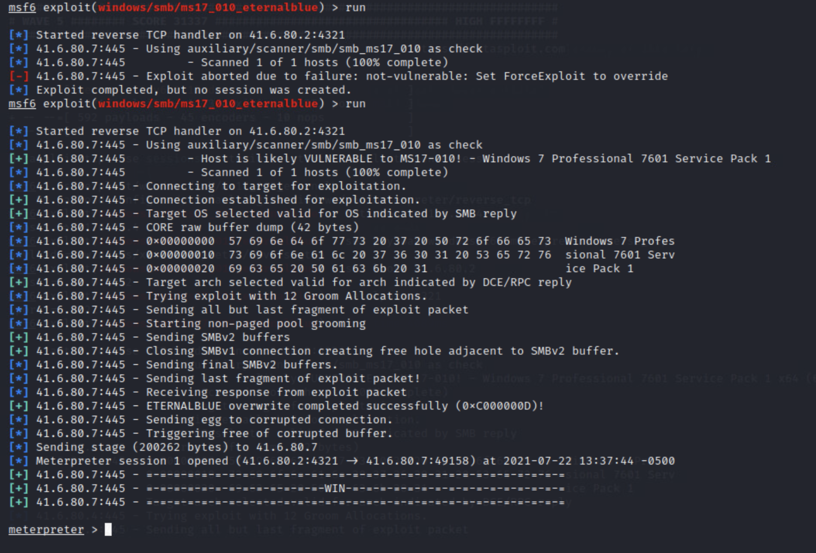

Now, in order for you to visually SEE that you broke into your Windows virtual machine. Use the sysinfo command, within the new Meterpreter shell. What do you see?
Remember how I called my computer WaterNine??? Sysinfo, aka System Information lets us see information about the computer we just broke into.
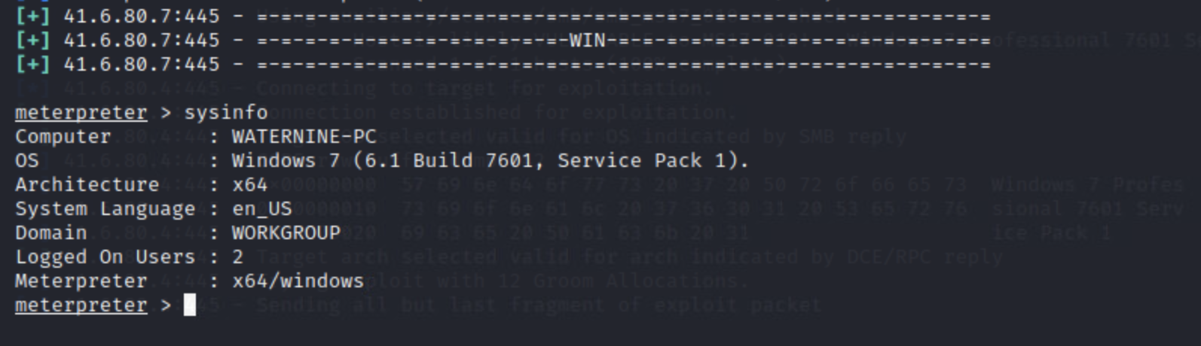
Congratulations! Your first real hack!

