Securing Your Information
Module 1 | Activity 1
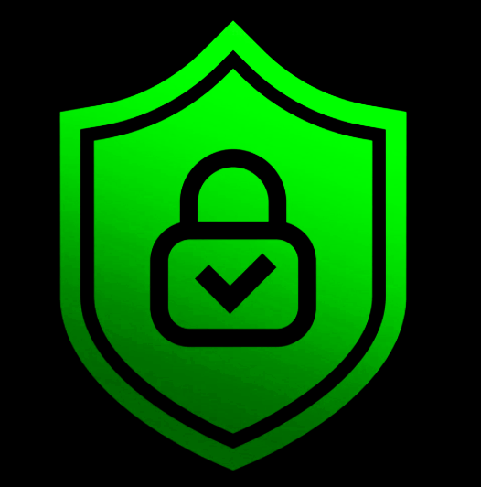
Break up into groups of two or three people. As a group, discuss and answer the questions below. When everyone has completed the prompts, each group will share their responses with everyone else.

- In what ways is technology incorporated into your life? Some example scenarios may include the classroom, work, home, etc.

- Why is it important to keep your information private from the rest of the internet? What are some examples of information oversharing?

- Suppose someone hacked into your computer and encrypted your files. Personally, what information on your computer do you wish you had protected, or had a backup copy of and why?

- Unfortunately, every now and then your information will be compromised, merely based on basic probability. Therefore, rank what you deemed important in question three from most valuable to least.

- How much would you be willing to pay to protect the items you deemed important in the previous question? Would you be willing to pay the attackers who demand payment to get your information back?

Final Notes:
Most of the time if you are a victim of a data leak incident, you weren’t specifically targeted for your information on an individual basis. Malicious hackers usually aim to steal the information of thousands if not millions of users at a time.
When the attackers demand payment to decrypt or unlock your personal files there is no guarantee that you will get your files back. Best practice would be to avoid making yourself a vulnerable target as much as possible. By setting strong passwords, not re-using passwords across platforms, and avoiding the oversharing of information on social media, you will have a greater chance of deterring an attacker.
Another solution would be to have a backup drive or machine that you update regularly in order to reduce the damage magnitude if your primary device is compromised.

